Kumami World — Full Product Specification
Every product, on every tier, the exact data source & API used, and how each result is calculated. INTERNAL reference (names the data provider) — the customer-facing product never surfaces the provider name.
Version 1.18 · 30 Oct 2026 · reflects the dev branch at commit 5bdaf4f · see “Release notes” for what changed.

Contents
Right-click and choose 'Update Field' to build the table of contents.

Release notes
What changed in each version of this document, newest first. Every entry describes how the live product changed (or how the doc was corrected to match it).

v1.18 — 30 Oct 2026
Build version answering Rachelle's request version v1.17 (23 Oct 2026), plus Andrew's points of 29 Oct 2026. Everything below is on the dev branch.

Part 1 — Rachelle's v1.17 asks: what changed
Evidence: screenshots taken 30 Oct 2026 on kumami-dev are in the last column; also in the repo under docs/qa/evidence/v1.18/.
# | Rachelle asked (v1.17) | What we changed | How to verify | Notes | Evidence (30 Oct 2026)
1 | Answer 1 · Plus §5 Calendar — airdrops off the Calendar. Airdrop TGE / claim dates on neither the Plus nor the Pro Calendar; they stay in Airdrops & Whitelist only. | Calendar Plus never shows airdrop claim days, for Plus or Pro users (server filter, calendarEventsForView). Commits f7d014f, 0e565c8. | Plus or Pro user → Plus → Calendar: no purple "Airdrop" events; /api/market/calendar returns 0 airdrop events. | Andrew, 29 Oct 2026 (point 6): airdrops DO show, but only in the new Calendar Pro (Pro users), never in Calendar Plus. See Part 2. | 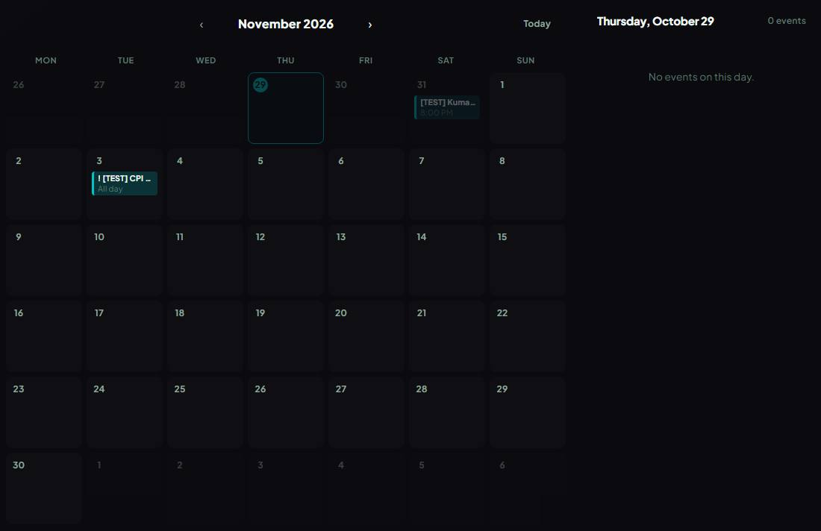  Calendar Plus has no airdrop claim days (0 airdrop events in the response).
2 | Answer 2 · Pro §18 — Flow Radar Pro 7D ×10 approved. Keep the $300M cascade, $500M wave and the 3-event minimum. | No change needed: live since v1.16 (WINDOW_SCALE['7D'] = 10, thresholds unchanged). | Pro → Flow Radar Pro → 7D: verdict uses the ×10 window. | Confirmed in code 30 Oct 2026. | No screen — document or account action.
3 | Answer 3 · Pro §18 — illiquid filter: Binance-volume fallback approved for coins outside netflow-list's top ~100. | No change needed: live since v1.16 (flowLiquidity.isLiquidEnough falls back to Binance 24h volume). | Flow Radar Pro shows no events for coins without real volume. | Confirmed in code 30 Oct 2026. | No screen — document or account action.
4 | Answer 4 · Pro §18 — significance engine (⭐) — definition: 30-day median per coin and event type, ≥ 3×, ≥ 10 events, hover text, Pro only; build after 30 days of data. | Not built yet. The collector has been saving events every minute since 27 Oct 2026, so 30 days exist from about 26 Nov 2026. | — | Stays "(To be developed)" with that reason. | No screen — document or account action.
5 | Answer 5 · Plus §3 — quiet Plus feed: keep the floors (liquidation MED $50M/h, Dry Powder MED $100M) and add an empty state "No major flows in the last {window} — market is quiet". | Floors unchanged. With no HIGH/MED events in the window, Flow Radar Plus (and the Console Flow Radar preview) shows "No major flows in the last hour / 4 hours / 24 hours — market is quiet"; when events exist but the user's filters hide them it says "No events match these filters right now." Commit 5a2c22b. | Plus → Flow Radar Plus → 1H on a quiet hour. | The evidence replays the real response without events (a quiet market can't be ordered up); the live 1H shot is next to it. Review after 2 weeks of collector data, as she asked. | 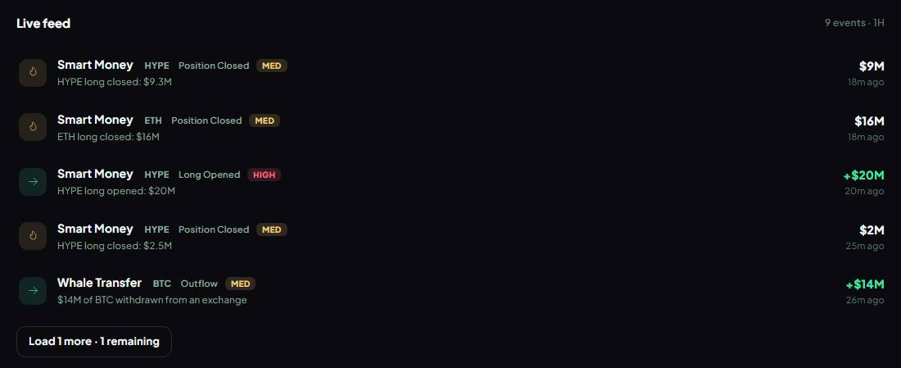  Flow Radar Plus, 1H window, live data: "Live feed 9 events · 1H Smart Money HYPE Position Closed MED HYPE long closed: $9.3M $9M 18m ago Smart Money ETH…  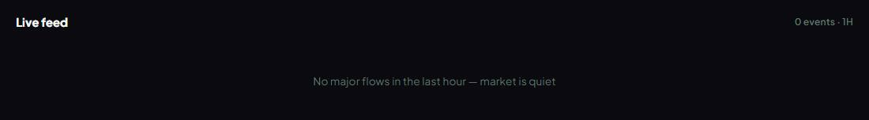  Flow Radar Plus with no HIGH/MED events in the window (real response replayed without events): "Live feed 0 events · 1H No major flows in the last hour —…
6 | Answer 6 · Plus §2.7 — open interest "flat" line scales with the range: 24H ±1% · 7D ±2.5% · 30D ±5%, for OI and price. | OI panel classifies OI and price with the range's band (oiFlatBand); the panel's help text says so. Commit 5a2c22b. | Plus → On-Chain Insights → Show more metrics → Open Interest Trend; switch 24H / 7D / 30D; (?) help text. | API check 30 Oct: BTC 24H "Leverage Building" (±1%), 7D "Stable OI" (±2.5%), 30D "Stable OI" (±5%). | BTC 24h: OI verdict "Leverage Building", flat band ±1%.  BTC 7d: OI verdict "Stable OI", flat band ±2.5%.  BTC 30d: OI verdict "Stable OI", flat band ±5%.  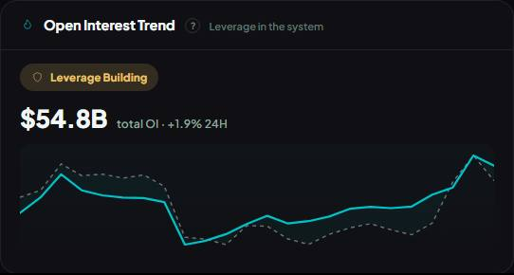  Open Interest panel; its help (?) says "Flat" = OI or price moved less than ±1% (24H), ±2.5% (7D) or ±5% (30D).
7 | Answer 7 — Spot Pulse buckets confirmed. Bullish = REAL BUYING, ACCUMULATION, REVERSAL SETUP; Bearish = DISTRIBUTION, QUIET DISTRIBUTION, COHERENT DECLINE, FORCED DECLINE; SPECULATIVE and BALANCED neither. | No change needed: exactly these sets in rules/spotPulse.ts since v1.16. | Plus → On-Chain Insights → Spot Pulse banner. | Confirmed in code 30 Oct 2026. | No screen — document or account action.
8 | Answer 8 · Plus §3 — Exchange Flow: USDT and USDC only; remove "other Ethereum tokens" from Plus §3. | No code change needed (Dry Powder already USDT + USDC only, DRY_POWDER_TOKENS). The spec text no longer mentions other Ethereum tokens. | Flow Radar Plus → Dry Powder events say USDT/USDC. |  | No screen — document or account action.
9 | Answer 9 — send the Kuma knowledge draft (docs/kuma/kumami-knowledge-v1.16.md) to Rachelle before it's loaded. | Not a website change. Draft unchanged; not loaded into Kuma. | — | Open for Andrew: send the draft to Rachelle. | No screen — document or account action.
10 | Also from v1.16 — refresh speed: whale transfers and Smart Money at 2 min approved. | No change needed: both feeds cached 120 s (cg:whale, cg:hyperliq). | — | Confirmed in code 30 Oct 2026. | No screen — document or account action.
11 | Also from v1.16 — "What's new" page: Rachelle wants to see the customer text first (docs/release-notes/v1.16-whats-new-draft.md). | Not a website change; no What's new page published. | — | Open for Andrew: send the text to Rachelle. | No screen — document or account action.
12 | Plus §1 Console — one confidence rule for every coin (replaces the HYPE-only cap): 0 active signals → "Neutral · Low Signal"; 1–2 → "Leaning Bullish / Bearish" at most (or Low Signal under 0.60); 3–4 → normal floors. | confidenceVerdict applies this to the Global Regime and every coin chip; HYPE 0.70 cap removed. Commit 424aeb5. | Plus → Console → Market Conditions and the 5 coin chips. | 30 Oct: Global Regime "Leaning Bullish" (0.67). Unit tests cover 0 / 1 / 2 / 3 / 4 signals. | 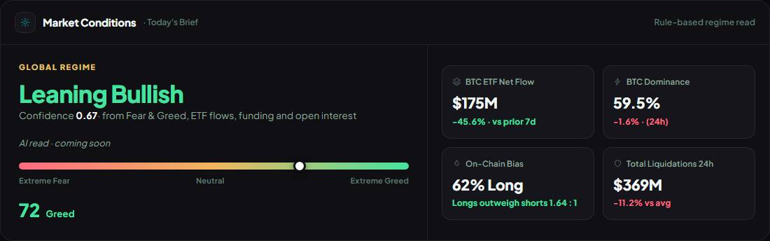  Global Regime "Leaning Bullish" (confidence 0.67) — one confidence rule (0 signals → Neutral · Low Signal; 1–2 → Leaning at most).
13 | Plus §1 — coin chips show "Leaning" with the Global Regime floors (≥ 0.75 full verdict · 0.60–0.75 Leaning · < 0.60 Neutral · Low Signal). | Chips now show the same labels (payload label + color). Commit 424aeb5. | Plus → Console → coin chips. | 30 Oct: BTC Leaning Bullish (0.67) · ETH Leaning Bearish (0.67) · SOL Leaning Bearish (1.00, only 1–2 signals) · BNB Leaning Bearish (1.00) · HYPE Neutral (0.50). | Coin chips use the same floors: BTC Leaning Bullish (0.67) · ETH Leaning Bearish (0.67) · SOL Leaning Bearish (1) · BNB Leaning Bearish (1) · HYPE Neutral…
14 | Plus §1 — Fear & Greed on the Console = Kumami's index: the regime scores Kumami's index with the 0–24 / 25–45 / 46–55 / 56–74 / 75–100 bands; the Console tile shows the same number, label and colour as the Fear & Greed page. | Console reads Kumami's 5-factor index through the same cached payload as the Fear & Greed page; same label and colour. Commits 424aeb5, 08da405. | Plus → Console tile vs Plus → Fear & Greed. | 30 Oct: Console 72 "Greed" (green) = page 72 "Greed". | Console Fear & Greed 72 "Greed" (grey-green) = Fear & Greed page 72 "Greed" (grey-green) — match.
15 | Plus §4 — one index everywhere; one set of labels and colours (0–24 Extreme Fear … 75–100 Extreme Greed; Fear red, Greed green); remove the Console's old cut-offs and reversed colours; chart bands from 75. | One classification used everywhere; old Console cut-offs (Greed from 60, Neutral 40–59) and reversed colours removed; chart bands and legend 0–24 / 25–45 / 46–55 / 56–74 / 75–100. Commit 424aeb5. | Plus → Fear & Greed: gauge, legend, chart bands. | Daily Digest already used the index. | 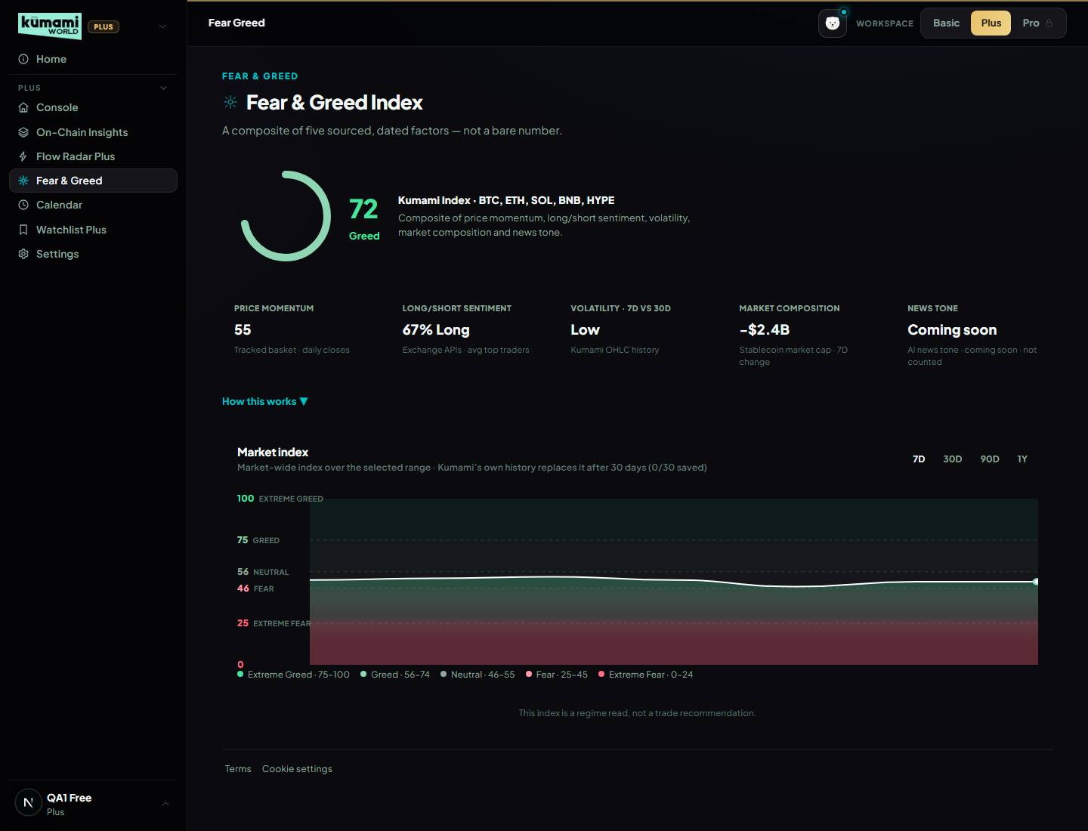  Fear & Greed page: 72 Greed; bands 0–24 / 25–45 / 46–55 / 56–74 / 75–100, Fear red, Greed green.
16 | Plus §4 — own history: save Kumami's score once a day; until 30 days, keep the chart but label it "Market index" (no provider name); after 30 days show Kumami's own history. | The cron collector saves the score once a UTC day (fear_greed_daily/{date}); the chart is titled "Market index" with "n/30 saved" until 30 days exist, then "Kumami Fear & Greed history". Commit 424aeb5. | Plus → Fear & Greed → history chart title. | First day saved on kumami-dev 29 Oct (72 Greed). The page caches 5 min, so the count can lag a few minutes. Production starts saving when this build is live. | 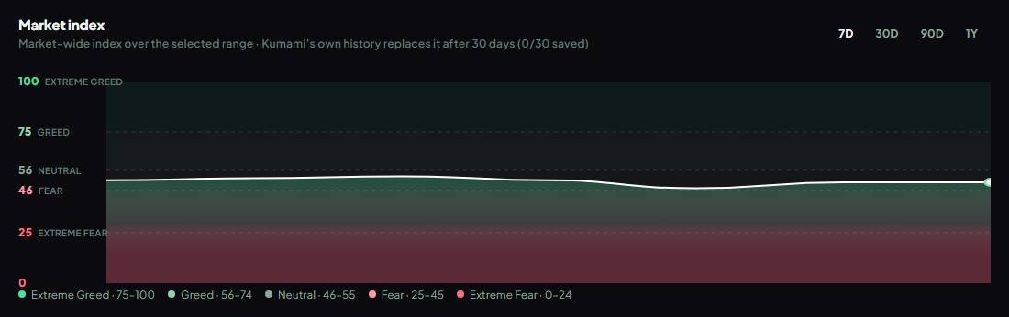  History chart titled "Market index" — 0/30 days of Kumami's own score saved; Extreme Greed band from 75.  fear_greed_daily (kumami-dev) latest saved days: 2026-10-29 = 72 Greed.
17 | Plus §4 — News Tone stays out of the score until the AI is on. | No change needed: News Tone shows "AI news tone · coming soon · not counted". | Plus → Fear & Greed → News Tone tile. | AI still off (Gemini billing open, item 21). | Fear & Greed page: News Tone tile says "AI news tone · coming soon · not counted".
18 | Pro intro · Pro §3 · Pro §4 — Smart Money Tracker and Coin / Token Tracker are cancelled (not "postponed"). | Removed both from the Pro sales page (they were "Coming Soon") and from the Pro member note; the spec says "cancelled". Commit 5a2c22b. | Plus user → Pro page: neither tracker is listed. | Hyperliquid whale data stays in use for Flow Radar and the Digest. | 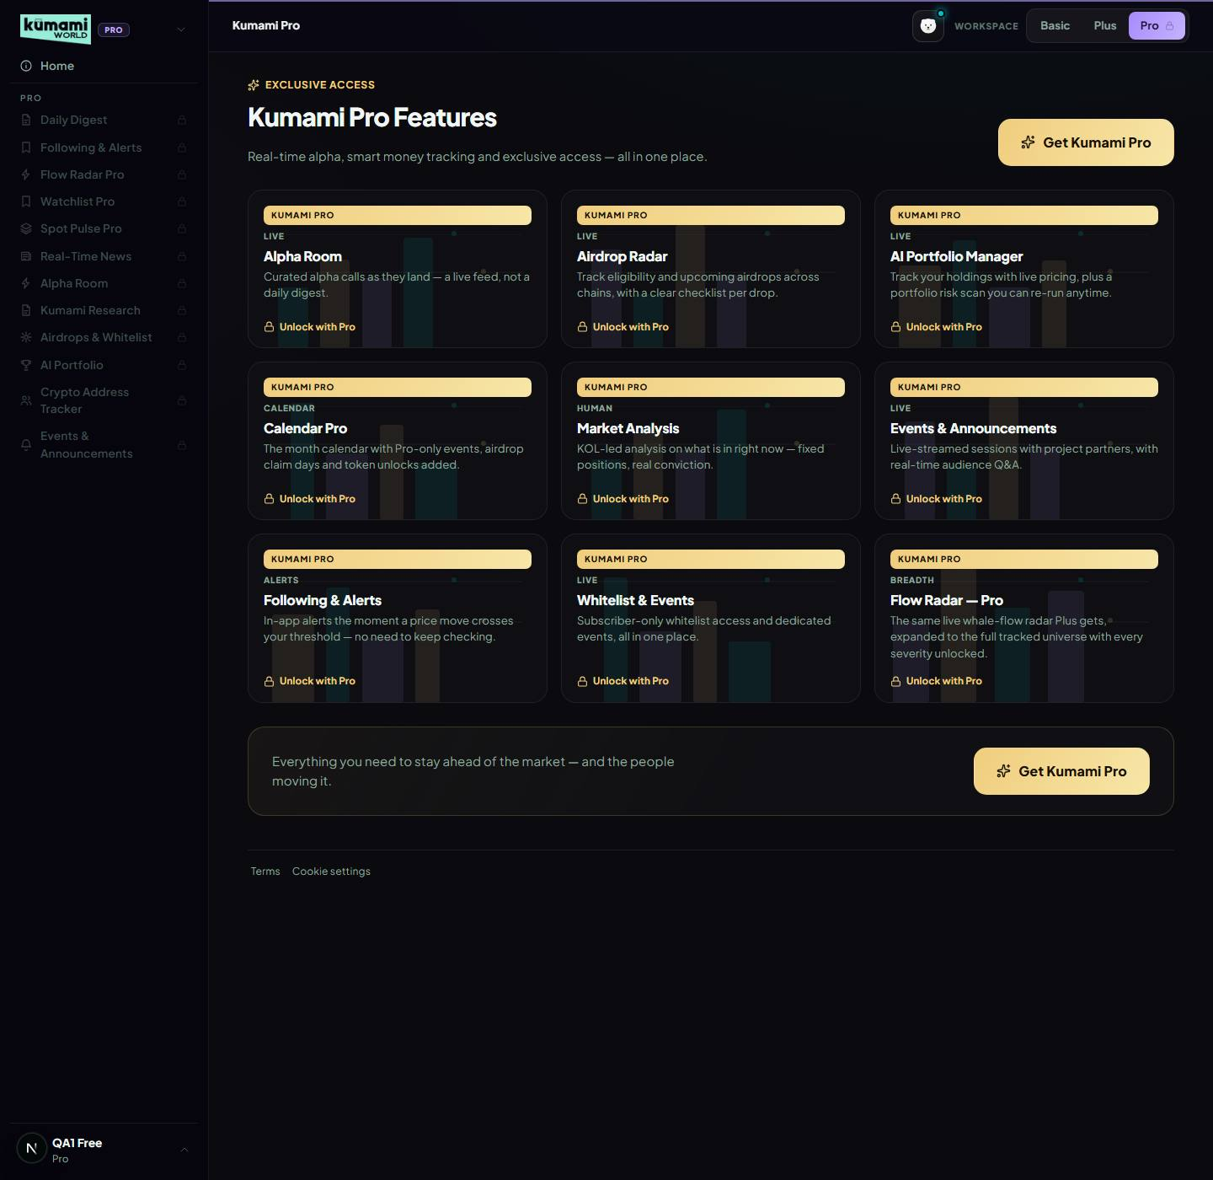  Pro page for a Plus user: "Smart Money Tracker" not listed, "Coin / Token Tracker" not listed; Calendar Pro listed.
19 | Shell — v1.16 shell changes accepted. | No change. | — |  | No screen — document or account action.
20 | Still open — Collector: CRON_SECRET, Cloud Scheduler every 60 s, TTL policy. | Done 27 Oct 2026: CRON_SECRET on the dev site, Cloud Scheduler kumami-collector (kumami-dev, every minute), Firestore TTL on expireAt for flow_events + flow_hourly. | Firestore flow_meta/collector lastRun is under a minute old. | Unblocks Watchlist Pro history, the Plus delay, F&G history (16) and the significance engine (4). | No screen — document or account action.
21 | Still open — Gemini: enable billing and set AI_ENABLED=true. | Not done (Andrew's call). CEO cost page shared 27 Oct. | — | Open for Andrew. | No screen — document or account action.
Evidence: screenshots from 30 Oct 2026 (kumami-dev data, QA accounts: qa1 Plus, qa2 Pro, qa3 admin) in the last column; the full-size images and captions are in docs/qa/evidence/v1.18/. Asks without a screenshot were checked in the code (noted).

Part 2 — Other website changes
Andrew's points (29 Oct 2026), each with its evidence, then the other changes in this build.
- Admin text boxes: bold, italic, underline. 27 long admin text boxes (news, blog, research, games, partners, airdrops, calendar, Kumami Research, education blurb) use the editor the Education admin uses — the formatting shows while typing (toolbar B / I / U, Ctrl+B / I / U), no ** marks. Stored as **bold** *italic* __underline__ so older text keeps working; detail pages show the formatting, cards and SEO tags show plain text (lib/richText, HTML-escaped). Kept plain on purpose: SEO descriptions, AI-module JSON and section markup, Market Analysis HTML.
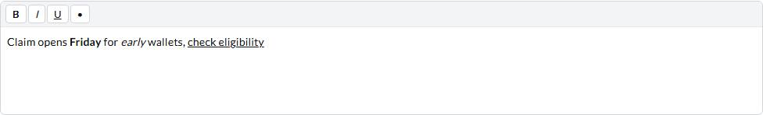
Admin text box: bold, italic and underline show as you type (toolbar B / I / U or Ctrl+B / I / U), no ** marks.
Check: Stored description: "Claim opens **Friday** for *early* wallets, __check eligibility__".
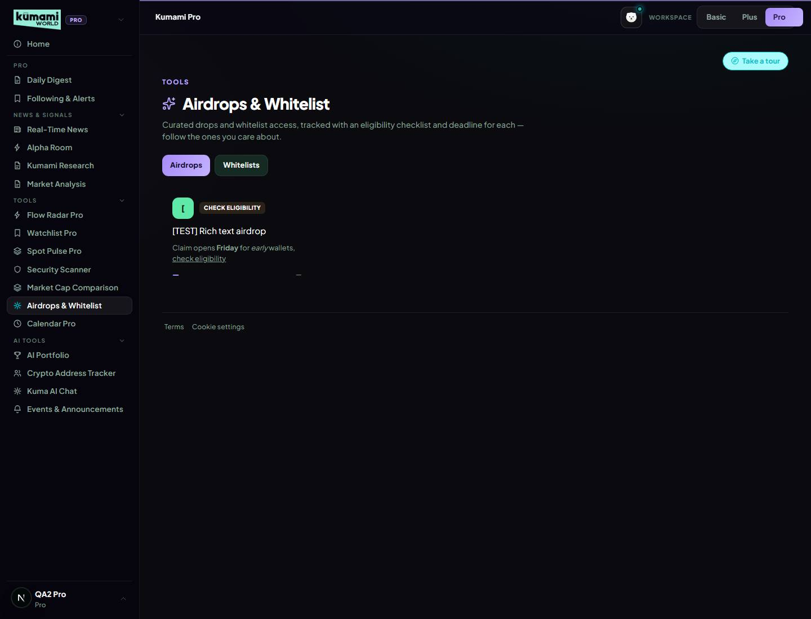
Pro → Airdrops & Whitelist shows the same description with the bold / italic / underline.
- Calendar Plus without category or filters; Calendar Pro; admin flag. Admin calendar form has no Category and a “Who sees this event” choice (Plus and Pro / Pro only). Calendar Plus has no category, asset or impact filters. New Calendar Pro (Pro → Tools) shows Calendar Plus plus Pro-only events, airdrop claim days and token unlocks (Plus §5, Pro §14).
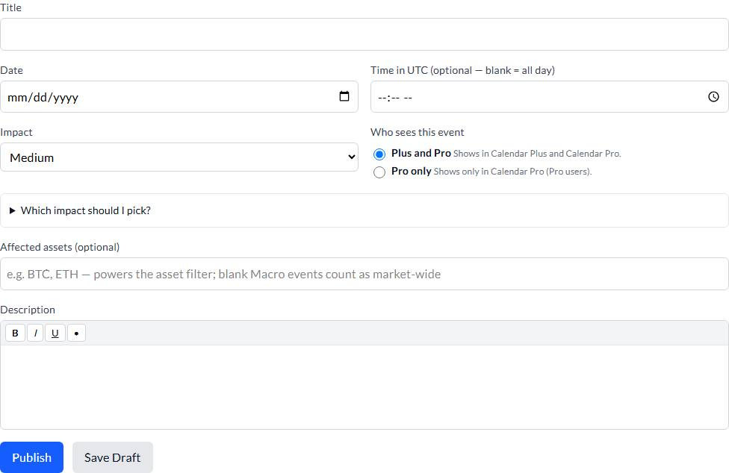
Admin → Calendar: no Category field; "Who sees this event": Plus and Pro (default) or Pro only; the description box shows bold / italic / underline as you type.
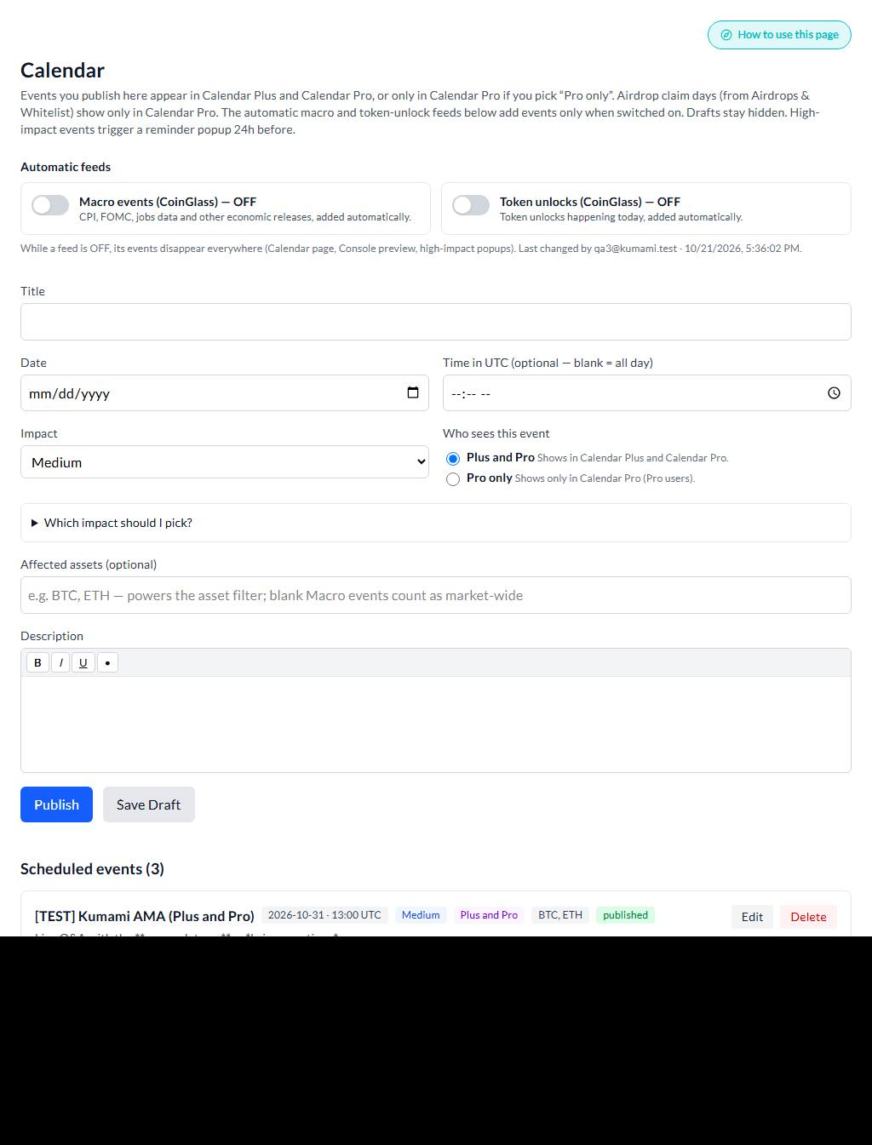
Admin event list: each event shows "Plus and Pro" or "Pro only".
Check: Calendar Pro API for a Plus user: HTTP 403 (expected 403).
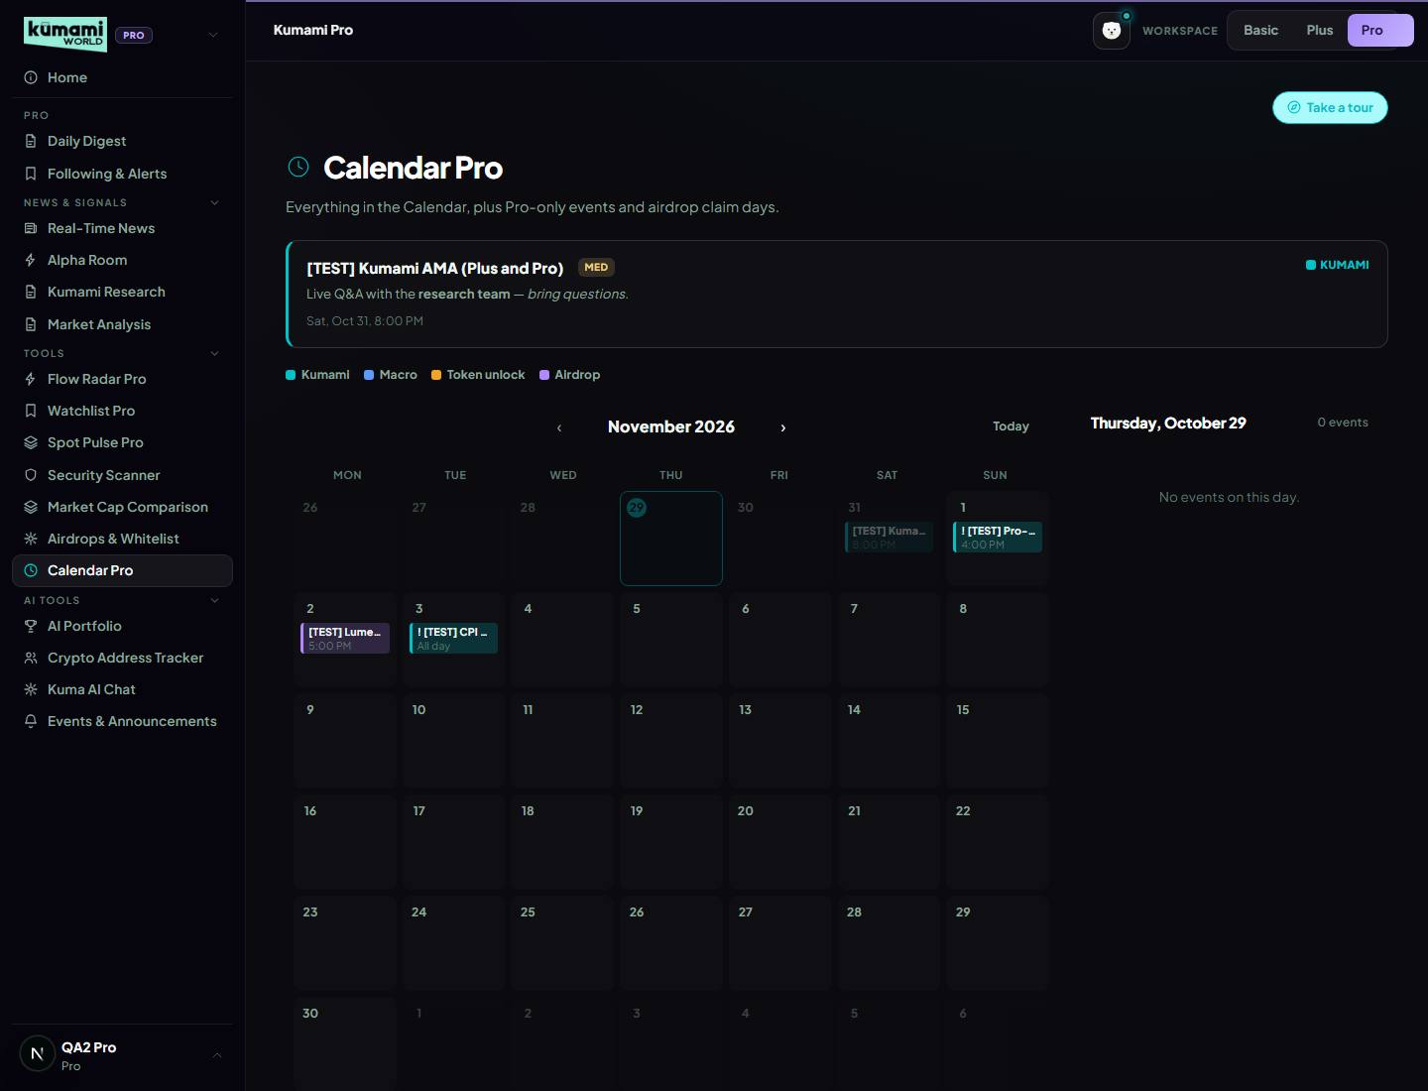
Calendar Pro (Pro user): same UI; "[TEST] Pro-only strategy call" shown with a PRO tag; airdrop "[TEST] Lumen airdrop" shown.
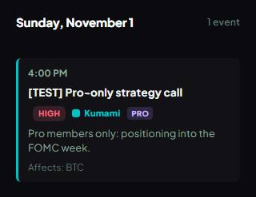
Day panel for the "Pro only" event: PRO tag; description keeps its formatting.
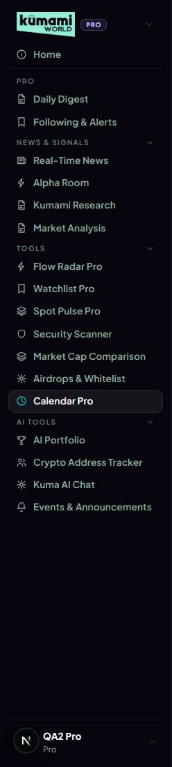
Pro menu → Tools has "Calendar Pro".
- Console mini calendar. The Plus Market Console's Calendar panel is a mini month calendar instead of the next-7-days list (Plus §1.4).
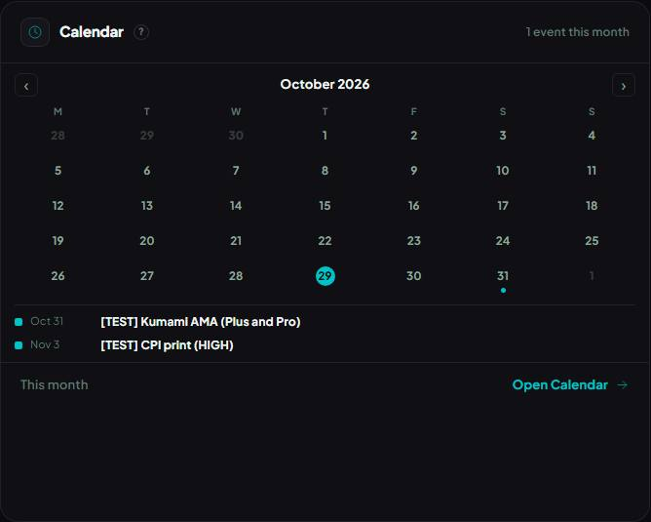
Plus Market Console: mini month calendar (today highlighted, a coloured dot per event kind) with the next 3 events, instead of the "next 7 days" list.
- Colour-coded, Google-Calendar-style calendar. Colour per event kind with a text label, legend, Today button, day panel (Plus §5).
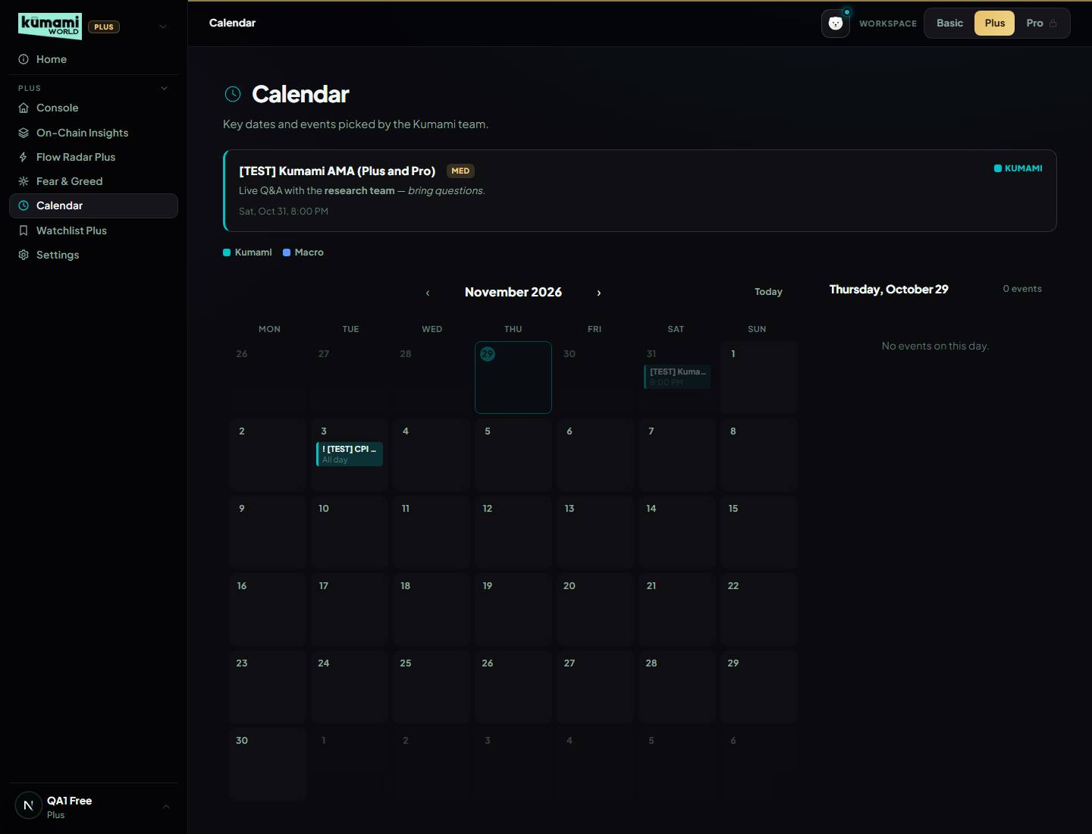
Calendar Plus (Plus user): colour-coded month grid, legend, day panel, no filters. API returns 2 events; "[TEST] Kumami AMA (Plus and Pro)" shown; "[TEST] Pro-only strategy call" hidden; airdrop hidden.
- Following & Alerts like CoinMarketCap. Price rises above / drops below, up / down % in 24h, 24h volume up; Once / Every time; checked on the server every minute, even with the page closed; toast on any Kumami page and browser notification when allowed (Pro §2).
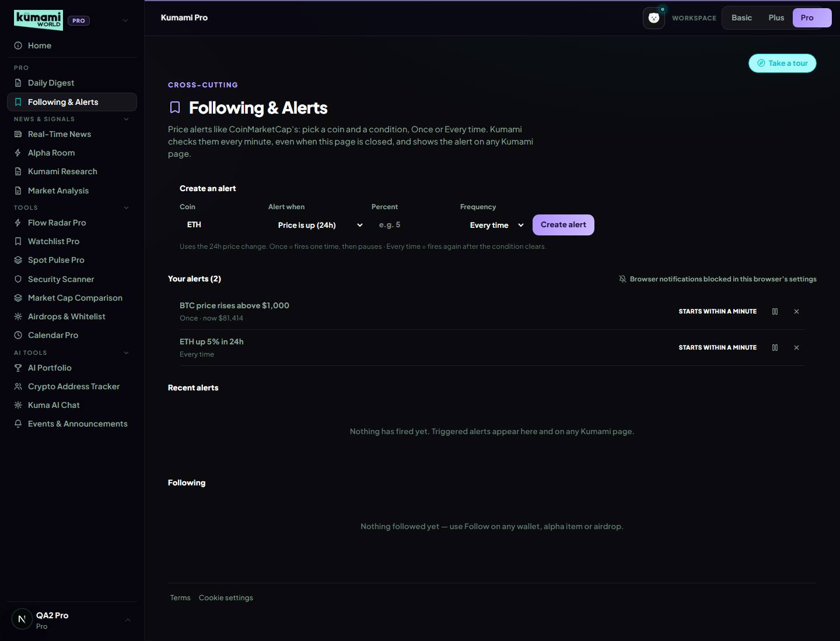
Following & Alerts: CMC-style builder (coin · Price rises above / drops below / up % / down % (24h) / 24h volume up · value · Once / Every time) and the two alerts created.
Check: Collector runs: HTTP 200 then 200; second run checked 2 alerts, fired 1.
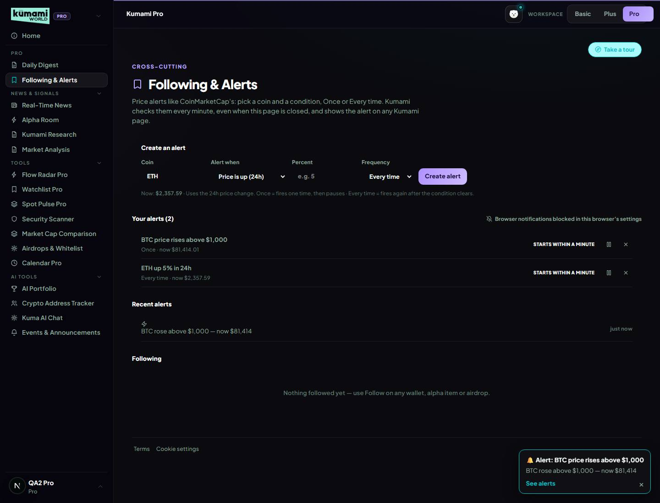
In-app alert on the open page: "🔔 Alert: BTC price rises above $1,000 BTC rose above $1,000 — now $81,414 See alerts ×".
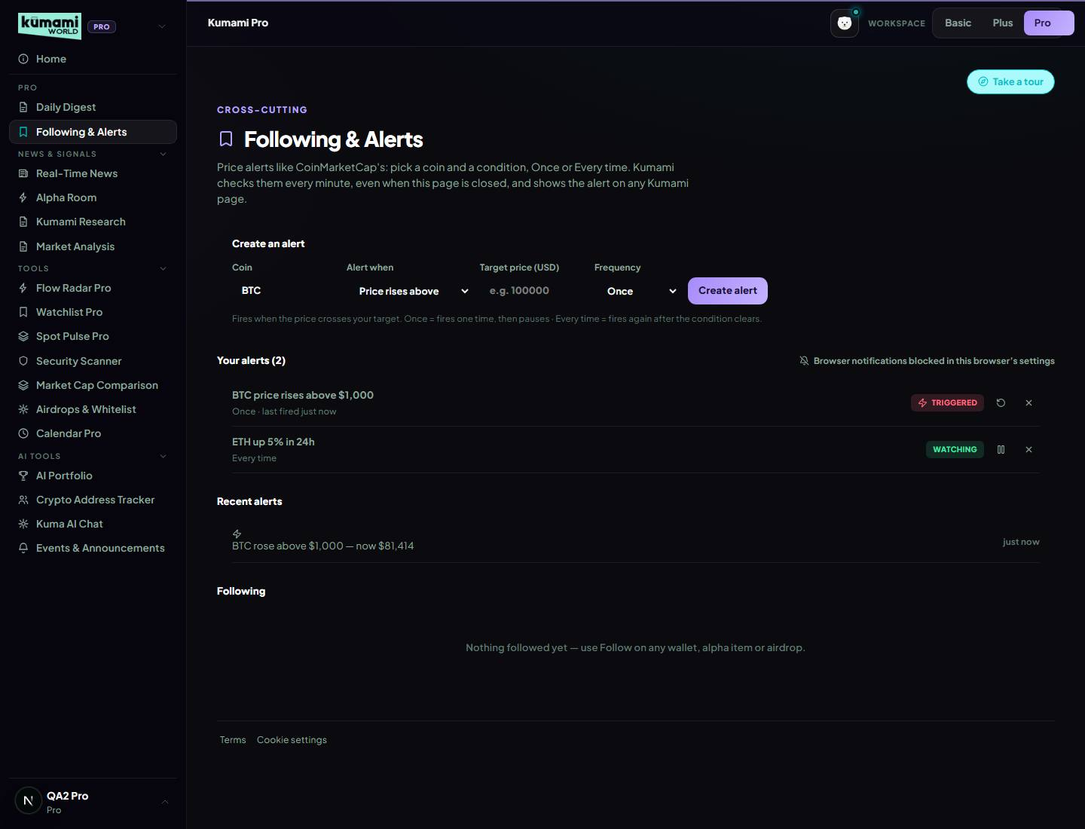
After the trigger: the BTC alert shows "Triggered" (Once → paused, Re-arm button) and "Recent alerts" lists it; the ETH alert keeps watching.
Check: GET /api/v1/me/alerts as a Plus user: HTTP 403 (expected 403 pro_required).
- Airdrops only in Calendar Pro. Airdrop claim days show for Pro users in Calendar Pro, never in Calendar Plus (Plus §5, Pro §14).
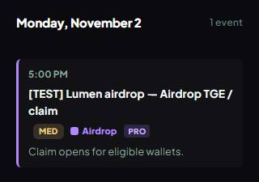
Calendar Pro day panel for the airdrop claim day: purple "Airdrop" tag + PRO tag.
Check: Pro user on Calendar Plus: 0 airdrops (expected 0); Pro-only event hidden.
- Kuma AI on the dev website (27 Oct). KUMA_CALLBACK_SECRET and APP_BASE_URL added to the dev site's App Hosting settings, 5 settings cleaned of pasted comment text; chat errors now show the server's reason and code. Worked on local dev; Andrew to confirm a reply on the dev website.
- Collector live (27 Oct). Cloud Scheduler calls the collector every minute; the collector also saves the daily Fear & Greed score and checks price alerts. Run lease so two servers never write the same minute; shared live price connection per browser (25 Oct work).
- QA. 888 unit tests; Playwright: smoke 28/28, admin-content + access matrix 100/100, calendar suites pass, v1.18 evidence spec (qa/features/v118-evidence.spec.ts).

Questions for Rachelle
- 1. Calendar: airdrop claim days now show in Calendar Pro (Andrew's call, 29 Oct) instead of nowhere (your answer 1) — OK? And token unlocks are Pro-only — OK?
- 2. Calendar admin: there is no Category any more, so new token sales can't be created with Venue / Raise / Link. Add those as optional fields on every event?
- 3. Alerts: delivery is in-app plus browser notification. Do you want email or Telegram next?

Needs Andrew
- Gemini: billing + AI_ENABLED=true (AI read, News Tone, sentiment alerts).
- Send Rachelle the Kuma knowledge draft and the What's new text (her v1.17 answers 9 and “Also from v1.16”).
- Confirm Kuma replies on the dev website.
- Before production: nothing new in App Hosting for the production site; the collector on the dev site already writes the shared Firestore (price_alerts, fear_greed_daily are new collections, server-only).
- Not re-audited in this version: Basic §1–8, Plus §6–8, Pro §1, §5–13, §15–17, §19–23, except where noted above.

v1.16 — 22 Oct 2026
Build version answering Rachelle's request version v1.15 (19 Oct 2026). Everything below is on the dev branch. Reviewed with Andrew one ask at a time on 22 Oct 2026; QA: docs/qa/2026-10-21-v120-release.md plus the evidence run of 22 Oct.

Part 1 — Rachelle's v1.15 asks: what changed
Evidence: the screenshots from 22 Oct 2026 (dev data) are in the last column; full-size, with the same captions, on the evidence page https://claude.ai/artifact/JHmF9dzREBjwzj1QYER6o1 and in the repo under docs/qa/evidence/v1.16/.
# | Rachelle asked (v1.15) | What we changed | How to verify | Notes | Evidence (22 Oct 2026)
1 | Console §1.1 scoring. F&G 0–24 +1.5 · 25–45 +1 · 46–55 0 · 56–74 −1 · 75–100 −1.5; ETF 7-day sum counts only beyond ±$100M; funding > +0.10% −1, < −0.05% +1, else 0; OI up + price up +1, OI up + flat 0, OI up + down −1. Confidence = agreeing ÷ non-zero signals. | Built exactly as asked (rules/regime.ts, 17 Oct). Funding read ×100 too big — fixed. | Open /world/console: the Global Regime shows a verdict + confidence and isn't stuck on "Neutral · Low Signal" unless signals disagree. F&G under 25 pushes it bullish, over 75 bearish. 46 unit tests cover every band edge (regime.test.ts, all pass 22 Oct). Live per-coin breakdown: run a test server with MARKET_DEBUG=1 and read the [regime] log line. | The Console's Fear & Greed number (and the one the regime scores) is CoinGlass's market index. The Fear & Greed page's big score is Kumami's own 5-factor index, and its history chart is CoinGlass's index again — so the Console and the page show different numbers. The Console also uses older label cut-offs (Greed from 60, Neutral 40–59; the page uses 56 / 46–55) and opposite colours (Console: Extreme Fear green; page: red). Andrew, 22 Oct 2026: keep as is for now. Option for later: use Kumami's index everywhere, one set of labels and colours, and label the chart "Market index (CoinGlass)". | 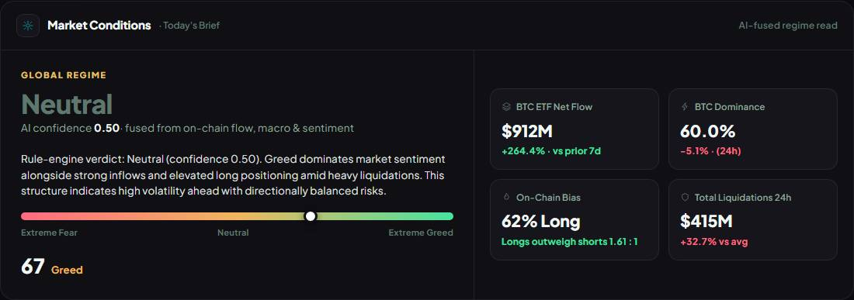  Global Regime "Neutral", confidence 0.5, Fear & Greed 67 (CoinGlass index).
2 | Console §1.3 HYPE chip: confidence capped at 0.70, so it shows "Leaning …" at most (no ETF, futures mostly on Hyperliquid). | Cap built (live/console.ts, unit-tested). | Open /world/console: the HYPE chip's confidence never goes above 0.70; BTC/ETH can reach 1.00. | Chips never say "Leaning" — every chip shows only Bullish / Neutral / Bearish (Neutral under 0.60), so HYPE at 0.70 still reads "Bullish"/"Bearish". The chip also says "AI conf" though it's plain maths, not AI. Andrew, 22 Oct 2026: keep as is. Option for later: chips use "Leaning …" between 0.60 and 0.75 like the Global Regime, and "AI conf" → "Confidence". | Coin chips. HYPE confidence 0.7 (cap 0.70); max of the others 1.
3 | Console §1.4: the Flow Radar preview delay is 15 min (v1.14 text said 30). | Delay is 15 min for every account (gating.ts, FREE_TIER_DELAY_MINUTES default 15; no override in App Hosting or .env.local). Rebuilt 22 Oct 2026 (Andrew's idea): every event is stored once with the time it became visible (flow_events.plusAt); Plus and the Console preview show stored events at least 15 min old from the last 24h. Replaces the per-minute copies, which only existed while someone was on the site and were kept 1 hour. The Console and Flow Radar pages store events themselves (once a minute across servers) until the Cloud Scheduler collector is on. Merged to dev 2296898. | Open /world/console or /world/flow-radar (Plus): "Delayed 15m", events show straight away (no "starting" wait), none newer than 15 min. With Flow Radar Pro open in another tab, a new core-coin HIGH/MED event appears on Pro first and on Plus ~15 min later. QA 22 Oct: Flow Radar spec 3/3 incl. a new check that every Plus event is 15+ min old; 810 unit tests pass. | Andrew hasn't tested Flow Radar's reliability yet (real-time or delayed). Liquidation and Dry Powder events are hourly and keep updating (peak / latest net), so a Plus row can show an amount that grew within the last 15 min — the event itself is still 15+ min old. Without the Cloud Scheduler job, events are only stored while someone is on the site; the job fills the gaps. The "Delayed 15m" label is fixed text. | 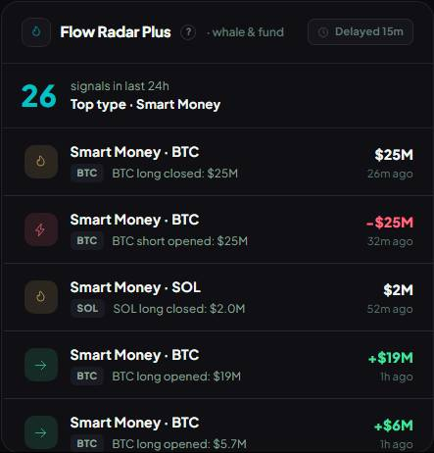  Console Flow Radar preview: "Delayed 15m", HIGH/MED events of the 5 core coins, from saved history.
4 | Console §1.5 badge: a team-added HIGH event starting within 6h shows as a badge at the top ("CPI in 4h — expect volatility"). | Built (panels/ConsoleEventBadge.tsx, rule in rules/calendarEvents.ts): only HIGH events added by the team in /admin/pro-calendar, with a start time, starting within the next 6h. Countdown updates every minute ("in 35m", then "in 4h"); the badge disappears when the event starts. Two or more → the soonest plus "+N more". Tap → Calendar. | As superadmin, add a [TEST] HIGH event in /admin/pro-calendar starting in ~2h (not all-day). Open /world/console as any user: the badge reads "[TEST] … in 2h — expect volatility". Change it to MED → the badge goes. Delete the test event afterwards. | All-day events never show (they have no start time). | 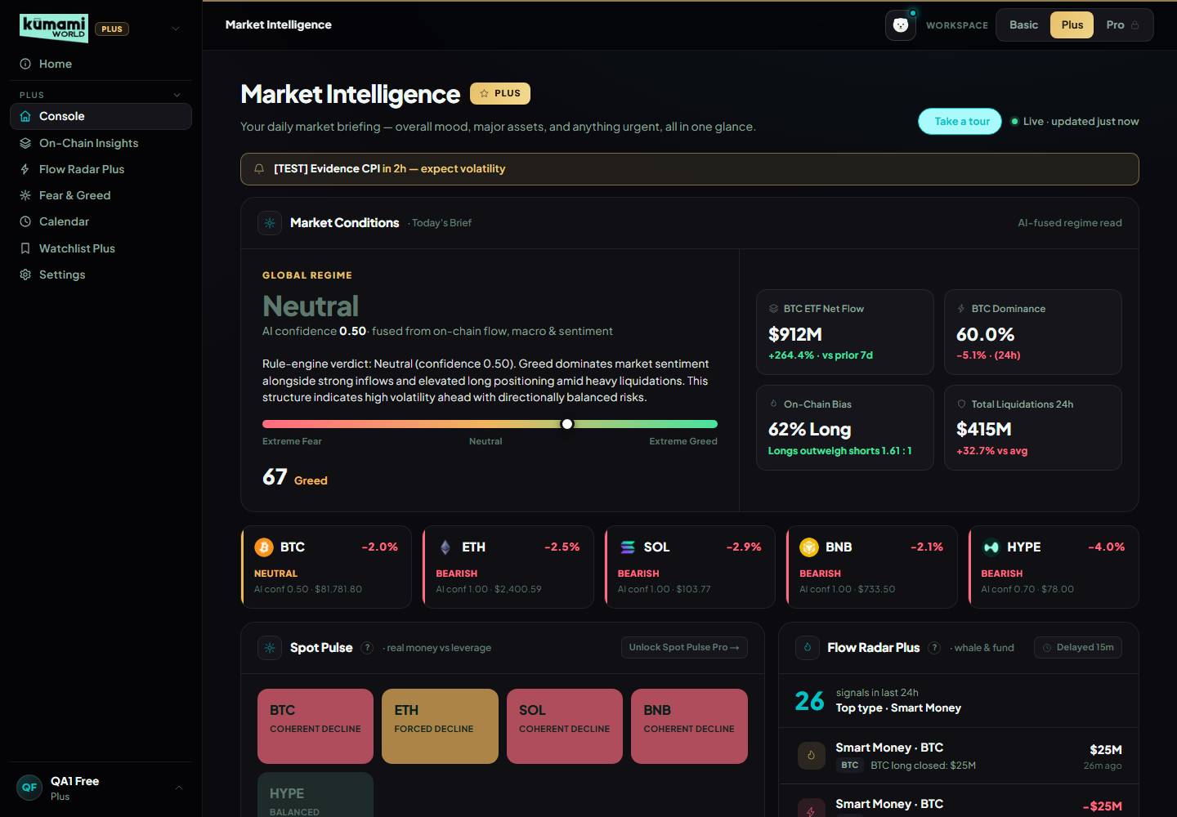  Badge for a [TEST] HIGH event 2h ahead: "[TEST] Evidence CPI in 2h — expect volatility".
5 | On-Chain §2 switcher: replace AVAX with HYPE (v1.14 said "(adjusted)" but nothing changed). | Switcher is BTC, ETH, SOL, BNB, HYPE (onchain/page.tsx); HYPE panels load real data (funding, liquidations, long/short, OI, Hyperliquid whale positions). Bug found in review, fixed 22 Oct 2026 (5e1de2f): the ETF Flow panel only has Bitcoin and Ethereum ETF data, and SOL/BNB/HYPE silently showed the Bitcoin ETF numbers. Now only BTC and ETH show an ETF panel; other coins' middle row has two panels (CVD, US Demand Premium). | /world/onchain → buttons BTC/ETH/SOL/BNB/HYPE, no AVAX. HYPE: panels fill, no ETF Flow panel. BTC/ETH: ETF Flow panel shown. QA 22 Oct: On-Chain test passes, incl. the new ETF-panel checks. | The US Demand Premium panel is always BTC's Coinbase premium (its subtitle says "(BTC)"). Exchange Netflow is thin for HYPE (little exchange-balance data). Andrew chose to hide the ETF panel rather than label it "Bitcoin ETFs". | 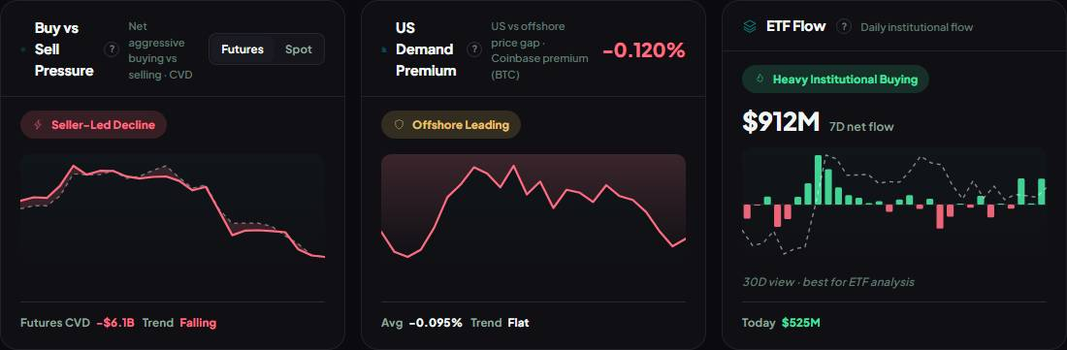  BTC: middle row has CVD, US Demand Premium and ETF Flow (1 ETF panel).  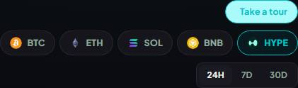  Coin switcher: BTC, ETH, SOL, BNB, HYPE — no AVAX.  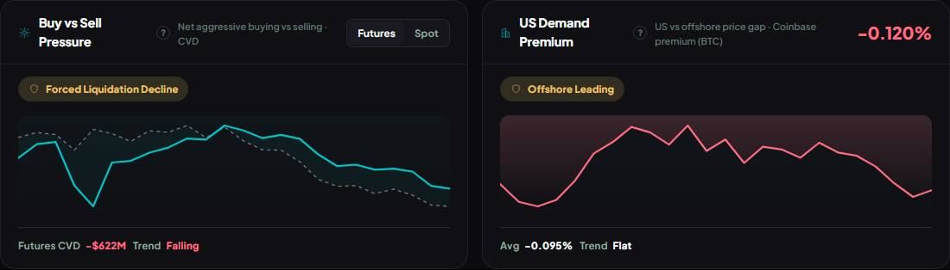  HYPE: no ETF Flow panel (0 ETF panels) — two panels in the middle row.
6 | On-Chain §2.1 funding bands: > +0.15% Overheated Long · +0.05% to +0.15% Crowded Long · −0.05% to +0.05% Neutral · −0.10% to −0.05% Crowded Short · < −0.10% Extreme Short; remove Mild Short Bias; close v1.14's gaps. | Built exactly (rules/funding.ts); Mild Short Bias removed; every rate lands in one band (±0.05% → Crowded, +0.15% → Crowded Long, −0.10% → Crowded Short). Kept "Persistently" (extreme 3 cycles) and "· Rising Fast". Bug fixed: funding was read ×100 (normal funding showed Overheated). | /world/onchain Funding Rate tile on BTC and HYPE: the label matches the % per the table; a normal day (~+0.01%) says Neutral; never "Mild Short Bias". Automated: On-Chain test checks label vs rate. |  | 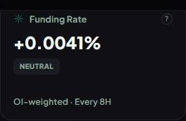  BTC Funding Rate tile: "Funding Rate ? +0.0041% NEUTRAL OI-weighted · Every 8H".  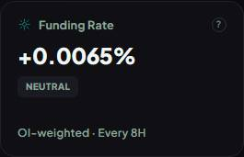  HYPE Funding Rate tile: "Funding Rate ? +0.0065% NEUTRAL OI-weighted · Every 8H".
7 | On-Chain §2.2 Exchange Netflow opens on 7D by default (data updates once a day, so 24H usually shows "Updates daily"). | On the default 24H range the Netflow panel shows the 7-day balance change, labelled "· 7D (updates daily)"; 7D/30D ranges use their own. A zero change still says "Updates daily", never "$0". Only this panel switches. | /world/onchain BTC on 24H: Netflow reads e.g. "Coins leaving exchanges · 7D (updates daily)" with a real $; 30D → "· 30D". On-Chain test checks the label (passed 22 Oct). |  | 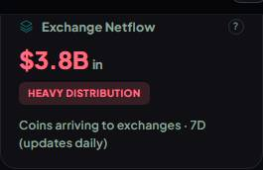  Exchange Netflow on the 24H page range: "Exchange Netflow ? $3.8B in HEAVY DISTRIBUTION Coins arriving to exchanges · 7D (updates daily)".
8 | On-Chain §2.7 OI: flat OI + price up → Trend Without Leverage (grey-green); flat OI + price down → Decline Without Panic (grey). | Built exactly (rules/oi.ts). "Flat" = under ±1% change over the selected range, for OI and price. Full 3×3 table in the spec. | /world/onchain → Show more → Open Interest panel shows one of the 9 reads; the new two appear when OI moved < 1% while price moved more. Unit tests cover all 9. | The ±1% "flat" line is our choice — Rachelle gave no number (question for her). | 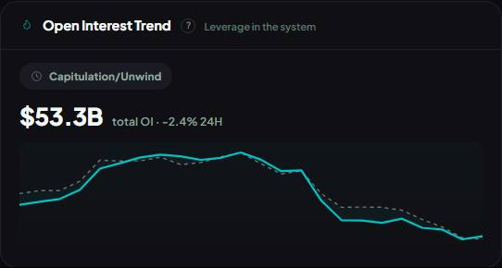  Open Interest panel: "Capitulation/Unwind".
9 | Spot Pulse §2.9 data + directions: 3 calls per coin, 1H × 2016 bars (84 days), fixed exchange lists (spot: Binance, OKX, Coinbase, Bybit, Bitget; futures + Hyperliquid); flow UP/DOWN only beyond 0.5× the coin's normal swing (past windows: 4H 42 · 24H 30 · 7D 11); price bands 4H ±0.75% · 24H ±1.5% · 7D ±4%; < 8 past windows → "Not enough history" (BALANCED, left out of the market verdict). | Built exactly (rules/spotPulse.ts, live/spotPulse.ts), incl. per-bar flow (not cum delta), timestamp normalising, HYPE price fallback to Hyperliquid. Found in review, fixed 22 Oct 2026 (ba3645e): hovering a tile showed nothing useful (browser tooltip only — slow, none on touch, no directions). Each tile now has a hover card (Plus and Pro): price, spot flow and futures flow for the window, each marked UP / FLAT / DOWN, plus the thresholds. | /world/onchain (Plus) and /world/pro?tab=spotpulse (Pro): hover a tile → card with Price / Spot flow / Futures flow and UP/FLAT/DOWN; on 7D a ±1% price move reads FLAT. Switch 4H/24H/7D. QA 22 Oct: Spot Pulse tests 4/4 (desktop + mobile) incl. the hover card. | Touch screens have no hover: tapping a tile opens that coin's On-Chain view. | 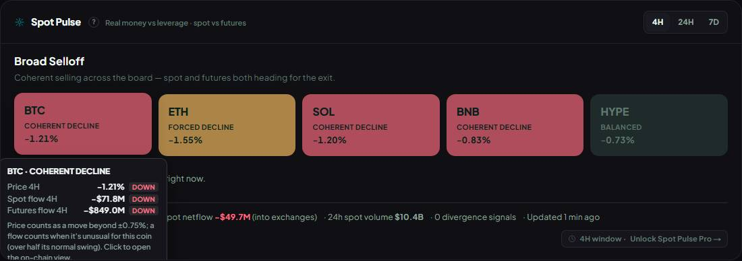  Hover card on BTC (4H): price DOWN, spot DOWN, futures DOWN → COHERENT DECLINE.  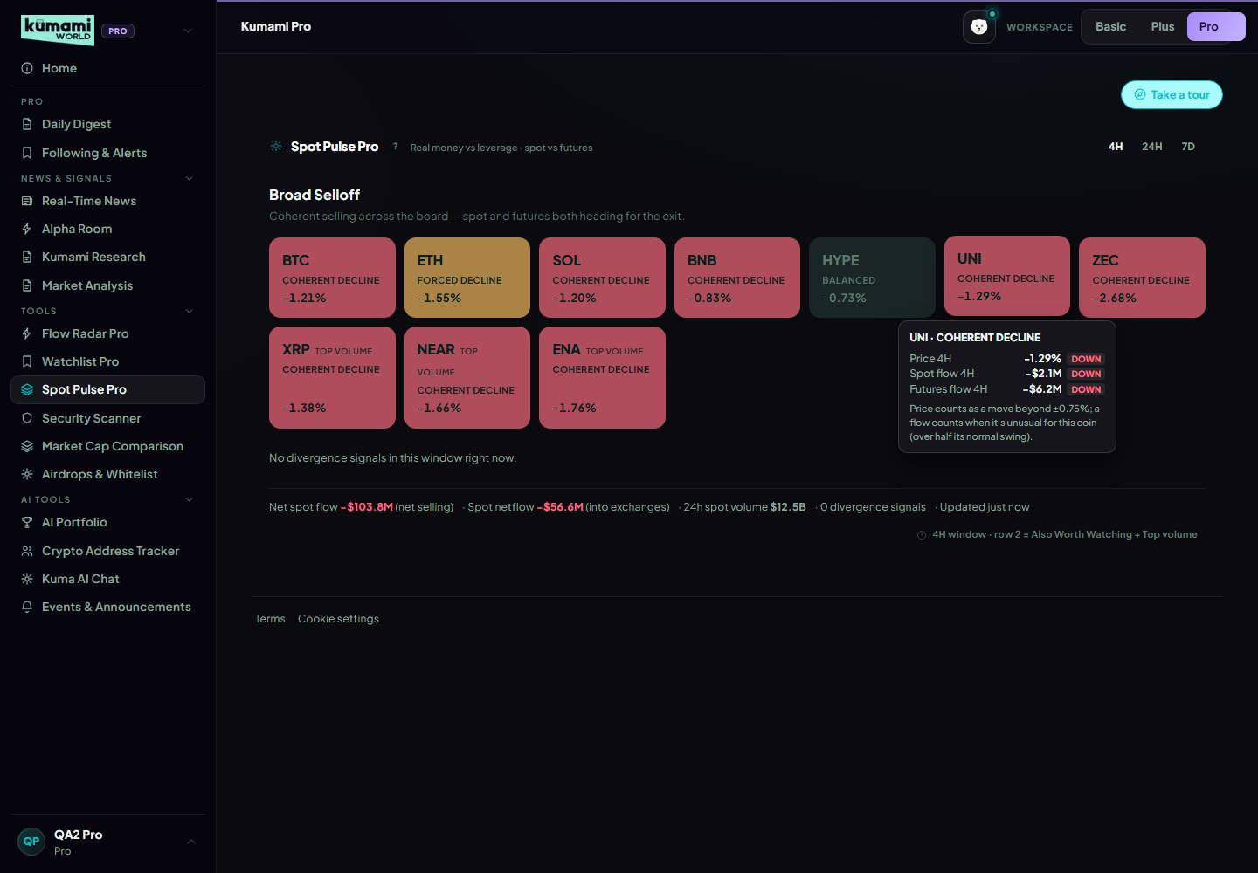  Spot Pulse Pro (10 tiles): the hover card works on Pro too.
10 | Spot Pulse §2.9 per-coin verdict, first match wins, all 27 combinations: UP·UP·flat/down → REAL BUYING; UP·UP·UP r > 0.4 → REAL BUYING, r ≤ 0.4 → SPECULATIVE; UP·FLAT·UP → SPECULATIVE; UP·DOWN → DISTRIBUTION; FLAT·UP → ACCUMULATION; FLAT·DOWN → QUIET DISTRIBUTION (new); DOWN·UP → REVERSAL SETUP; DOWN·DOWN → COHERENT DECLINE; DOWN·FLAT·DOWN → FORCED DECLINE; else BALANCED. r = abs(spot Δ) ÷ abs(futures Δ). | Built exactly in this order (verdictFor() in rules/spotPulse.ts), incl. QUIET DISTRIBUTION; REVERSAL SETUP tiles glow; not-enough-history coins read BALANCED. | Hover a tile → its 3 directions → find the row in the table; the verdict matches. Check a few tiles on 4H/24H/7D. Unit tests cover the combinations. | QUIET DISTRIBUTION needs flat price + spot selling, so it's rare. | 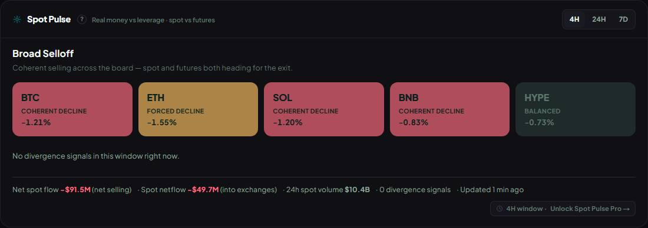  4H tiles: BTC COHERENT DECLINE (DOWN/DOWN/DOWN) · ETH FORCED DECLINE (DOWN/FLAT/DOWN) · SOL COHERENT DECLINE (DOWN/DOWN/DOWN) · BNB COHERENT DECLINE…  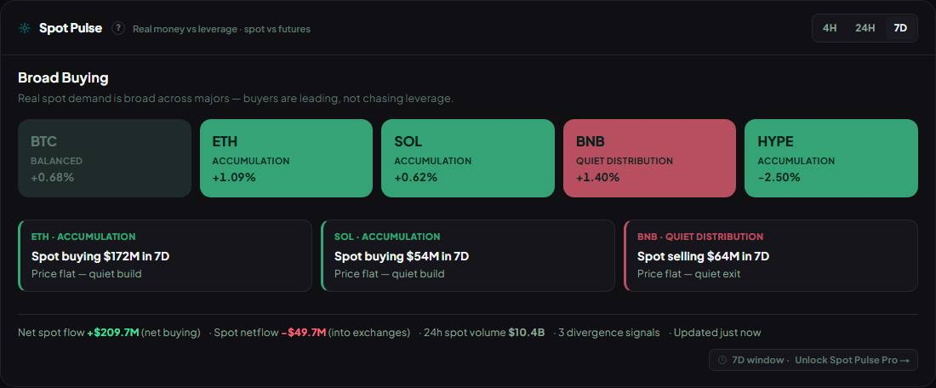  7D tiles: BTC BALANCED (FLAT/FLAT/FLAT) · ETH ACCUMULATION (FLAT/UP/DOWN) · SOL ACCUMULATION (FLAT/UP/DOWN) · BNB QUIET DISTRIBUTION (FLAT/DOWN/DOWN) · HYPE…
11 | Spot Pulse §2.9 market verdict (shares of tiles with data; < 4 → Not enough data): ≥ 60% bullish and ≤ 20% bearish → Broad Buying; ≥ 40% DISTRIBUTION + QUIET DISTRIBUTION → Distribution Wave; ≥ 40% COHERENT + FORCED DECLINE → Broad Selloff; ≥ 40% ACCUMULATION with no distribution → Selective Accumulation; ≥ 40% SPECULATIVE → Speculation Dominant; else Mixed Market. Bearish checked before speculation. | Built exactly (computeMarketVerdict()), bearish before speculation; No data / Not enough history tiles don't count. Bullish = REAL BUYING, ACCUMULATION, REVERSAL SETUP; bearish = DISTRIBUTION, QUIET DISTRIBUTION, COHERENT DECLINE, FORCED DECLINE; SPECULATIVE and BALANCED are neither. | Market banner above the tiles on /world/onchain (5 tiles) and /world/pro?tab=spotpulse (10): count the tiles and check the table (5 tiles: 3 bullish + ≤ 1 bearish → Broad Buying; 2 distribution → Distribution Wave). | The bullish/bearish lists are our choice — Rachelle didn't define them (question for her). | 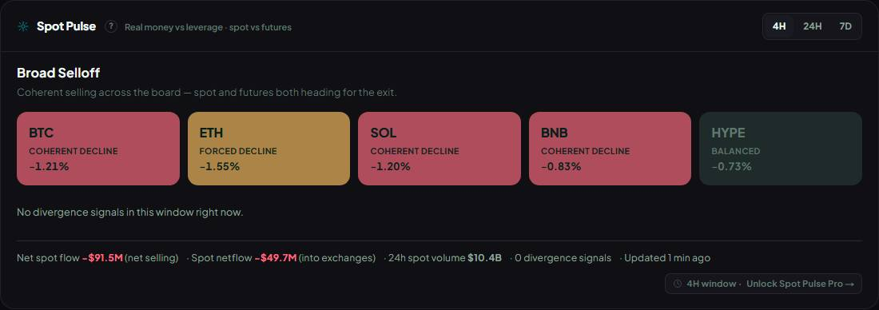  4H market verdict: Broad Selloff — from COHERENT DECLINE, FORCED DECLINE, COHERENT DECLINE, COHERENT DECLINE, BALANCED.
12 | Spot Pulse §2.9 cards, footer, refresh: divergence cards add QUIET DISTRIBUTION at +4 (rest unchanged); footer 24h spot volume = taker buy + sell from /api/spot/netflow-list (STARTUP plan, no coins-markets needed); one shared computation every 2 min, Plus reads a 60 s cache, Pro 15 s; tile shows "Updated n min ago". | Cards: QUIET DISTRIBUTION +4, others unchanged (DISTRIBUTION +5, SPECULATIVE with spot share < 0.2 +4, ACCUMULATION +4, REVERSAL SETUP +3, REAL BUYING with > $50M spot +2; BTC/ETH ×1.3, Pro row 2 ×1.2), top 3 shown. Footer 24h spot volume from netflow-list; each tile shows its own. Refresh: 2-min shared data, Plus 60 s / Pro 15 s cache, "Updated n min ago", "Data delayed" chip after 5 min. Found in review, fixed 22 Oct 2026 (1c6e191): the footer counted every scored coin while only 3 cards showed — it now counts the cards; with no cards the panel says "No divergence signals in this window right now." | /world/onchain Spot Pulse: switch to 7D — up to 3 cards between the tiles and the footer (22 Oct: ETH + SOL Accumulation, BNB Quiet Distribution); footer "N divergence signals" = number of cards; on a window with no cards (22 Oct 4H/24H, all coins declining) the empty line shows. Footer "24h spot volume $…B"; "Updated …" stays ≤ 2 min. QA 22 Oct: Spot Pulse 4/4 incl. count = cards. | Cards only come from DISTRIBUTION, QUIET DISTRIBUTION, ACCUMULATION, REVERSAL SETUP, SPECULATIVE (thin spot) and big REAL BUYING — a market that is simply falling (COHERENT/FORCED DECLINE) makes none. | 4H: no cards — "No divergence signals in this window right now." and footer count 0.  7D: 3 alert cards; footer count = cards; banner Broad Buying.  Empty-state line ("No divergence signals in this window right now.") not captured: at screenshot time every window had at least one card. Covered by the Spot…
13 | Flow Radar §3 scope + Whale Transfer: Plus = 5 core coins, HIGH + MED, 15-min delay for everyone (fix the "30-minute" text); unique key per event; whale transfers every 60 s keyed by tx hash, deposit to exchange = Inflow (bearish), withdrawal = Outflow (bullish), exchange↔exchange and wallet↔wallet not counted, HIGH ≥ $100M · MED $10–100M (no LOW, API floor $10M); no BNB Chain / Hyperliquid coverage. | Built (rules/flowRadar.ts, live/flow.ts); 30-min text gone; unique ids (tx hash), the collector stores each once. The whale feed is fetched at most every 2 minutes (shared cache), and only while someone is on the site or the Cloud Scheduler collector is on — not every 60 s as asked. | /world/flow-radar (Plus): "Delayed 15m", only the 5 coins (+ market-wide Dry Powder), HIGH/MED. Whale Transfer chip: rows say Inflow/Outflow, none under $10M, HIGH from $100M; BNB/HYPE rarely appear. QA: Flow Radar test checks ids, directions and the $10M floor. | Whale history only builds while someone is on the site until the Cloud Scheduler collector is on. | 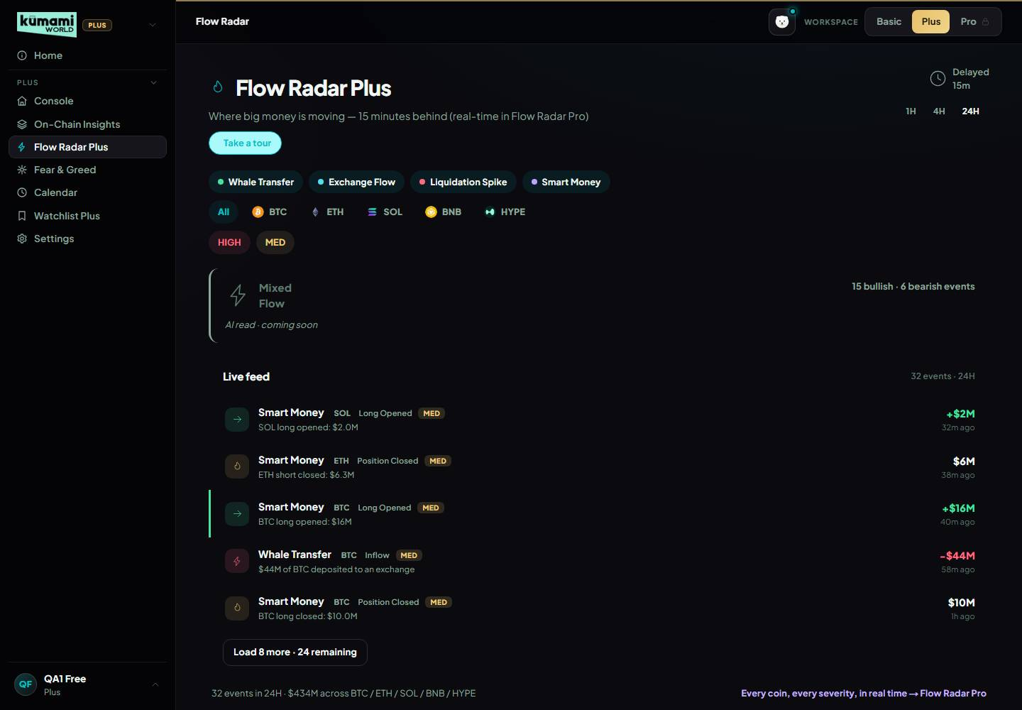  Flow Radar Plus: 32 events, newest is 32 min old (≥ 15), only HIGH/MED, 5 core coins + Dry Powder.  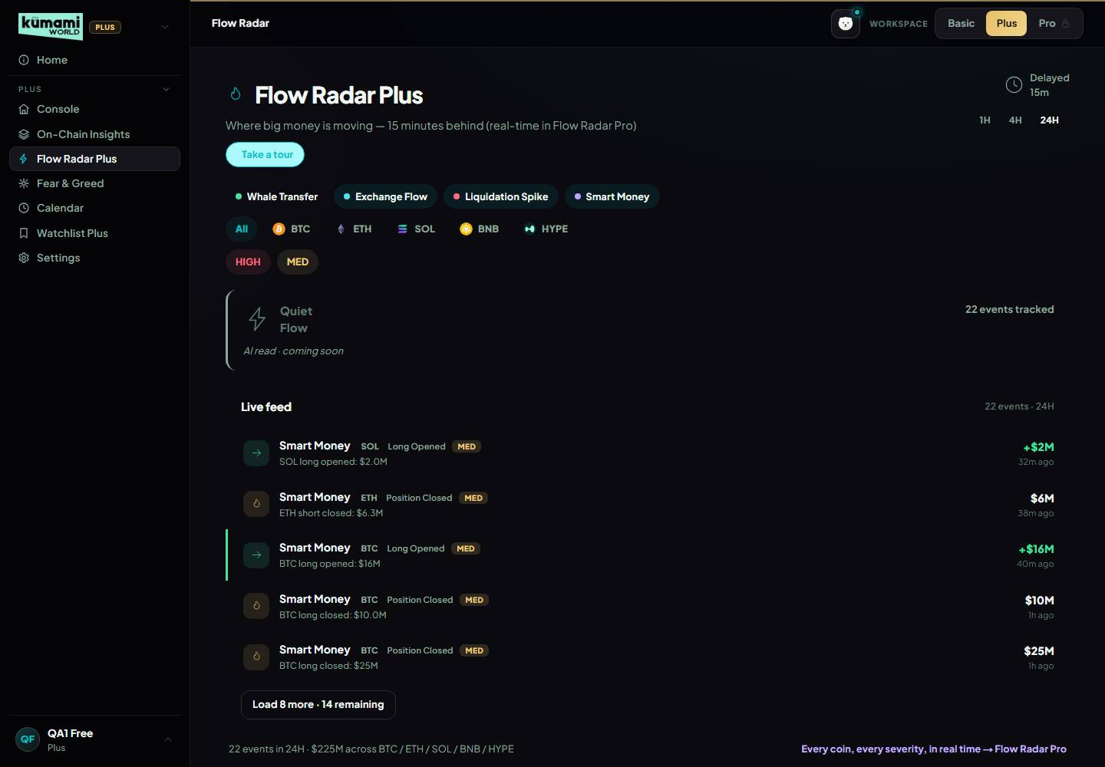  Whale Transfer filter: 10 rows, directions Inflow/Outflow.
14 | Flow Radar §3 Exchange Flow → "Dry Powder" (new): /api/exchange/chain/tx/list for USDT and USDC every 2 min, min $1M; net per exchange + token over a rolling 60 min; stablecoins onto exchanges = Dry Powder In (bullish), off = Dry Powder Out (bearish); other Ethereum tokens: inflow bearish, outflow bullish; HIGH ≥ $500M · MED $100–500M · LOW (Pro) $25–100M; one event per exchange + token per hour, updated to the latest net; market-wide (every asset filter, counted in the verdict band, not in any coin's Watchlist accumulation); Ethereum-only. | Built for USDT and USDC (live/flow.ts, rules/flowRadar.ts): 60-min net per exchange, Dry Powder In/Out, 500/100/25M bands, one event per exchange + token + hour, market-wide (every filter, verdict band, not in Watchlist per-coin totals). Not built: other Ethereum tokens (inflow bearish / outflow bullish) — one more data call per token and no token list given. | /world/flow-radar Exchange Flow chip: Dry Powder In/Out rows with exchange + amount; with the ETH chip on they still show; Plus nothing under $100M, Pro LOW from $25M. Quiet days may have none. Unit + Flow Radar tests pass. | Question for Rachelle: which other Ethereum tokens (if any) should Exchange Flow track? | 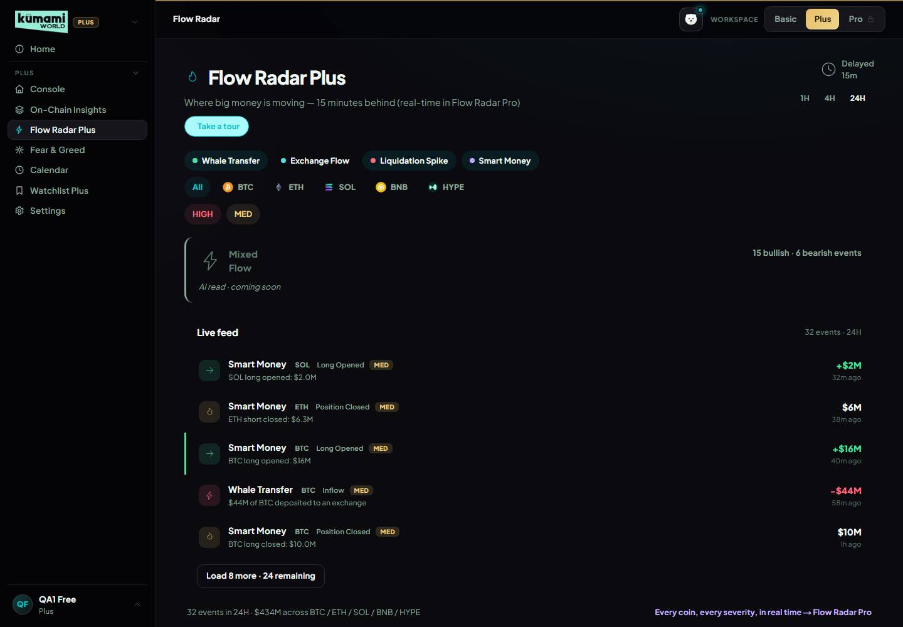  Exchange Flow filter: 0 Dry Powder rows (none on Plus right now — needs $100M+ net in an hour).
15 | Flow Radar §3 Liquidation Spike + Smart Money. Liquidations: coin-list per exchange (Binance, OKX, Bybit, Bitget, Hyperliquid) every 5 min, summed per coin; > 70% longs Long Flush (bearish), < 30% Short Squeeze (bullish), else Two-sided Flush (neutral); HIGH ≥ $200M/h · MED $50–200M/h · LOW (Pro) $10–50M/h; one event per coin per hour at its peak; v1.14 labelled every liquidation "Sell Pressure". Smart money: Hyperliquid whale-alert every 60 s (~200 latest positions ≥ $1M); Long Opened bullish, Short Opened bearish, closed neutral (v1.14 called opened shorts "Accumulation"); HIGH ≥ $100M any / ≥ $25M BTC-ETH / ≥ $10M others · MED ≥ $5M BTC-ETH / ≥ $2M others · LOW (Pro) ≥ $1M. | Both built exactly (live/flow.ts, rules/flowRadar.ts); "Sell Pressure" / "Accumulation" labels gone; one liquidation event per coin per hour (liq-COIN-hour) kept at the peak. Refresh: liquidations 5 min as asked; smart money 2 min (not 1); both only while someone is on the site or the collector runs. | /world/flow-radar: Liquidation Spike chip → Long Flush / Short Squeeze / Two-sided Flush with "% longs" matching (> 70% = Long Flush), no "Sell Pressure"; Smart Money chip → Long Opened / Short Opened / Position Closed, Short Opened is red. Pro: LOW rows (liq from $10M, smart money from $1M). Flow Radar test checks liq direction vs long share. | Smart money refreshes every 2 min, not 1. Quiet days: $50M+/h liquidations are rare, so Plus may show few. | 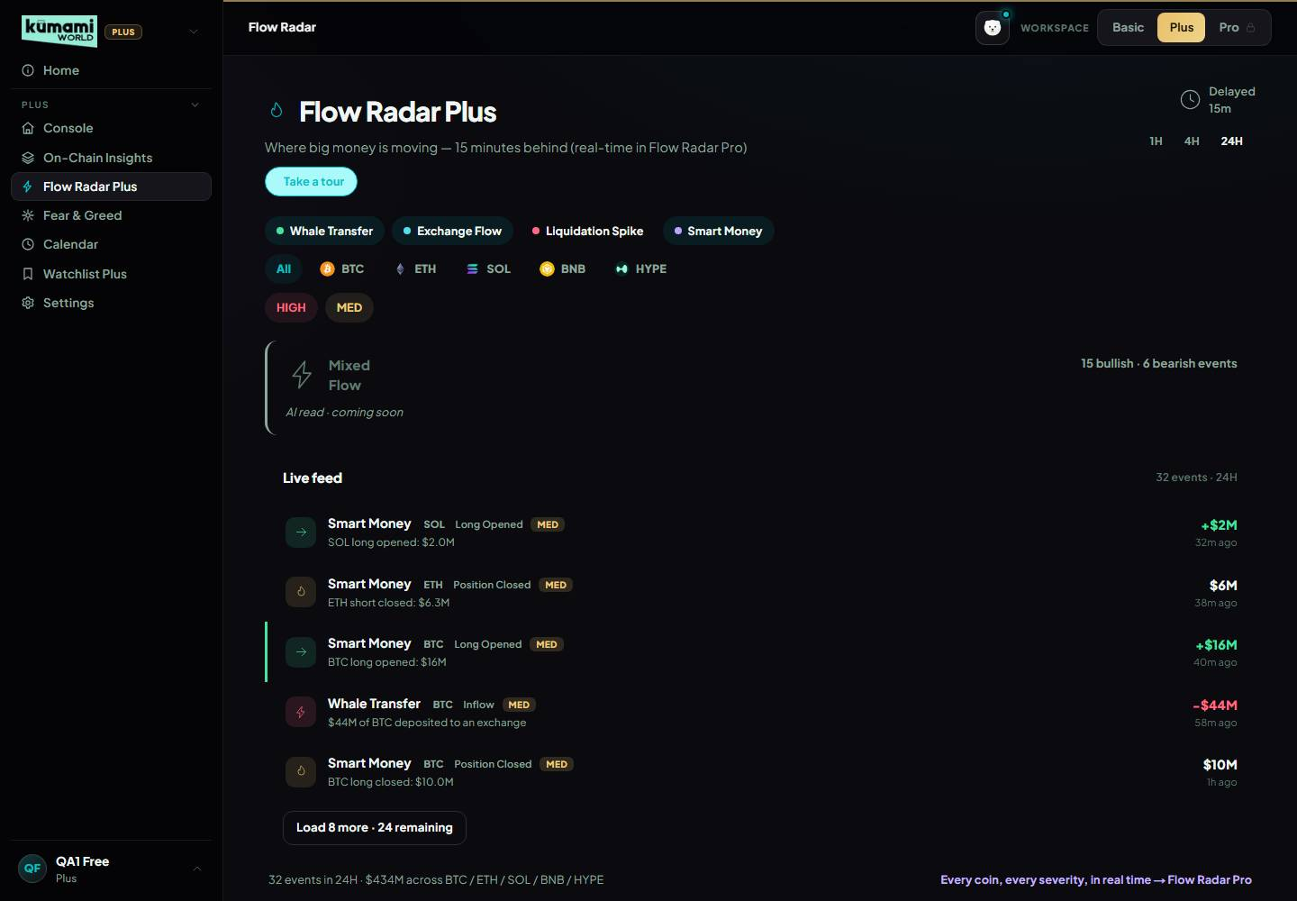  Liquidation Spike filter: 0 rows (none on Plus right now).  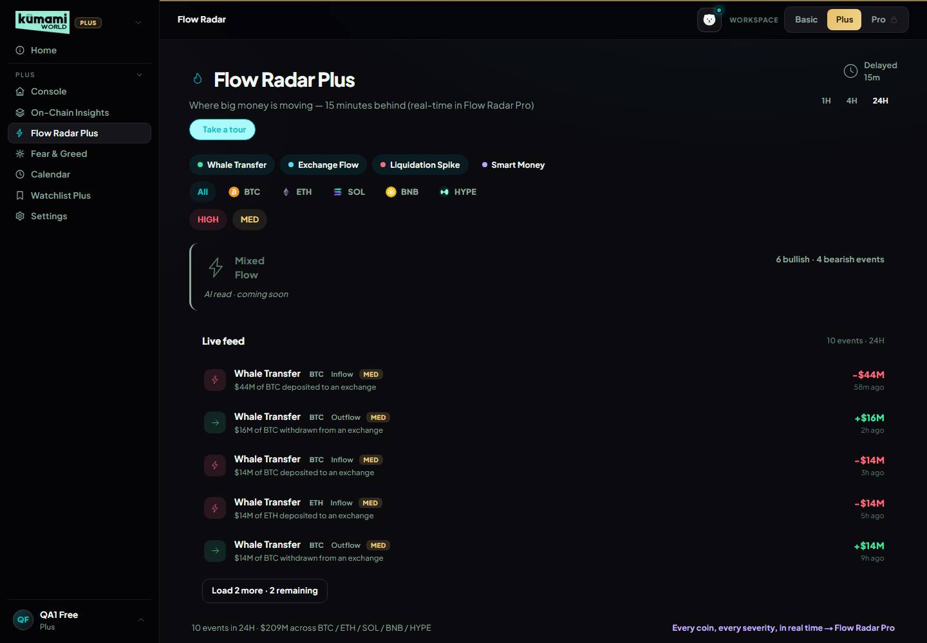  Smart Money filter: 22 rows (Long Opened/Position Closed/Short Opened).  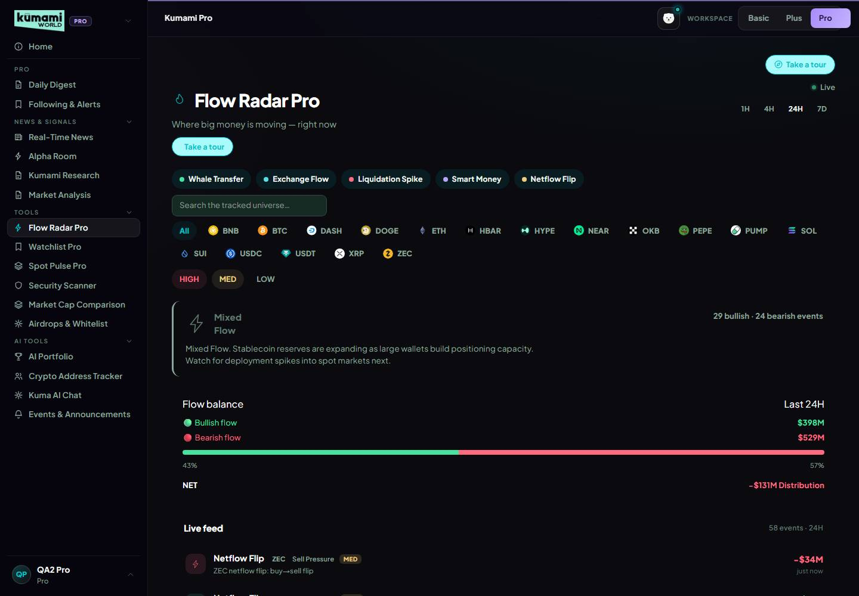  Flow Radar Pro (real-time): 93 events, 35 LOW (Pro only) — exchange_flow, liq_spike, smart_money.
16 | Flow Radar §3 buckets + verdict band. Bullish: Outflow, Dry Powder In, Short Squeeze, Long Opened. Bearish: Inflow, Dry Powder Out, Long Flush, Short Opened. Neutral (shown, not counted): Two-sided Flush, closed positions. Verdict, first match: liquidation cascade → Distribution Wave (bearish ≥ 1.5× bullish) → Broad Accumulation (bullish ≥ 1.5× bearish) → Mixed Flow → Quiet Flow. Dollar thresholds scale 1H ×0.5 · 4H ×1 · 24H ×2.5. | Built (rules/flowVerdict.ts, flowDirections.ts): buckets exactly; verdict in her order with the 1.5× rule and window scaling. Dollar amounts kept from v1.14: cascade > $300M liquidations (side with more decides); Distribution Wave > $500M bearish, ≥ 3 bearish events, bearish ≥ 1.5× bullish; Broad Accumulation mirror; Mixed Flow ≥ 3 bullish and ≥ 3 bearish events; else Quiet Flow. Pro 7D ×10 (Andrew, 21 Oct). | /world/flow-radar: band shows one of the 5 verdicts + stat line; switch 1H/4H/24H (1H needs half the $ of 4H, 24H 2.5×); with the Liquidation Spike filter, a 4H cascade means liq rows > $300M. Unit tests cover each verdict, 1.5× and scaling. | $300M / $500M and the 3-event minimum are v1.14 values (confirm with Rachelle); 7D ×10 is Andrew's decision (question for her). | 1H verdict band: "Quiet Flow" — 4 events tracked.  4H verdict band: "Mixed Flow" — 10 bullish · 4 bearish events.  24H verdict band: "Mixed Flow" — 15 bullish · 6 bearish events.  Pro 7D verdict band (thresholds ×10): "Mixed Flow".
17 | Flow Radar §3 cross-signal outlines (now on Plus too, same rules on Pro) + AI sentence under the verdict band. Outlines: (1) Whale Outflow + Spot Pulse REAL BUYING or ACCUMULATION → green "Spot Pulse confirming"; (2) Long Flush + Bearish regime → red "Regime confirming", Short Squeeze + Bullish regime → green; (3) Long Opened + 2 or more bullish whale events in 24h → green "Watchlist confirming", bearish mirror → red; (4) fallback: Outflow + Fear or Extreme Fear → green "Regime shift confirming". AI sentence: part of the AI layer. | Outlines: all 4 rules built (rules/flowCrossSignal.ts) on Plus and Pro; rule 1 reads the Spot Pulse 4H tiles, rule 2 the Console coin chips, rule 3 the last-24h whale counts, rule 4 Kumami's Fear & Greed label; hover a row for the reason. AI line: Gemini rewrite per window, cached 30 min, only with no filter on. Changed 22 Oct 2026 (Andrew, hard rule — no template stand-ins): the AI layer is off until Gemini billing (AI_ENABLED); the spot under the band says "AI read · coming soon" — the old template sentence is gone. | /world/flow-radar: outlined rows, hover → "Spot Pulse confirming" / "Regime confirming" / "Watchlist confirming" / "Regime shift confirming". Under the verdict band: "AI read · coming soon". Evidence 22 Oct: a red "Watchlist confirming" BTC Short Opened row; 7 outlined events. | Pro coins outside the 5 core coins rarely get outlines (rules 1–2 only know the core 5). AI needs Gemini billing; switch on with AI_ENABLED=true. | Outlined row — "Watchlist confirming — confirmed by another Kumami panel". 9 outlined events in the feed.  Under the band: "AI read · coming soon" — AI off until Gemini billing, no template sentence.
18 | Fear & Greed §4 (Backlog → AI News Tone): no logic change; News Tone keeps using the Intelligence engine's headlines (the page is removed, the engine keeps running); the AI classifies those headlines instead of the keyword count; history chart stays the raw index; CoinGlass sources instead of CoinGecko/DefiLlama accepted. | Built 21 Oct with AI-scored headlines + keyword fallback. Changed 22 Oct 2026 (Andrew, hard rule): AI off, keyword fallback removed — News Tone shows "Coming soon" and is left out; the composite re-weights over the signals with real data (any missing signal is now left out instead of counted as a neutral 50). Headlines still from the Intelligence engine; history chart = raw index. | /world/fear-greed: News Tone tile "Coming soon", no %; "How this works" explains left-out signals; the big score comes from the other 4. | The score can move a few points vs before. AI needs Gemini billing (AI_ENABLED=true). | 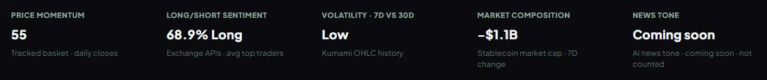  News Tone: "AI news tone · coming soon · not counted". Composite 62 (Greed) from Price Momentum, Long/Short Sentiment, Volatility · 7D vs 30D, Market…  How this works: missing signals are left out, nothing filled in.  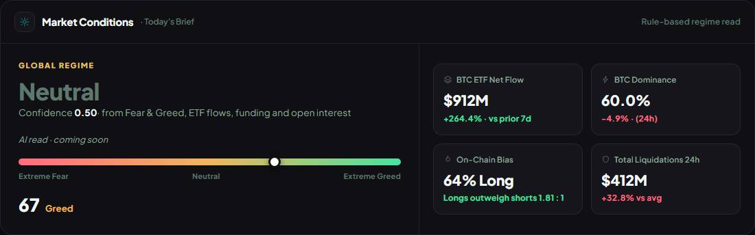  Console: "AI read · coming soon" under the regime; "Confidence" (not "AI confidence").
19 | Calendar §5 (Adjusted): manual-first (automatic feeds stay off; team adds macro, unlocks, listings, token sales / TGE in /admin/pro-calendar); new categories Listing and Token sale / TGE (a sale needs project, ticker, date + time UTC, venue, raise or FDV, link); an Airdrops & Whitelist entry with a TGE/claim date shows automatically; importance guide (HIGH / MED / LOW lists); HIGH + MED by default, max 3 per day cell; D-1 popup, attention popup and Console badge run on team-added HIGH events; backlog: day/week/list toggle, Today / This Week / Next 30D filter, "Add to my events". | Built: manual-first; Listing + Token sale / TGE categories; a token sale can't be published without venue, raise and link (the form names what's missing), shown in the event tooltip; importance guide in the admin form; HIGH + MED by default, LOW one tap away; max 3 per day cell + "+N more"; D-1 popup, attention popup and Console badge only on team-added HIGH. Airdrop TGE/claim dates: Pro only (Andrew, 21 Oct). Backlog items not built. | /admin/pro-calendar: categories, guide, Token sale without venue refused. /world/calendar (Plus): HIGH+MED default, LOW toggle, busy day "+N more". /admin/pro-airdrops TGE date → shows for Pro, not Plus. | Question for Rachelle: airdrops for Plus too? Backlog: day/week/list toggle, Today/This Week/Next 30D filter, "Add to my events". | 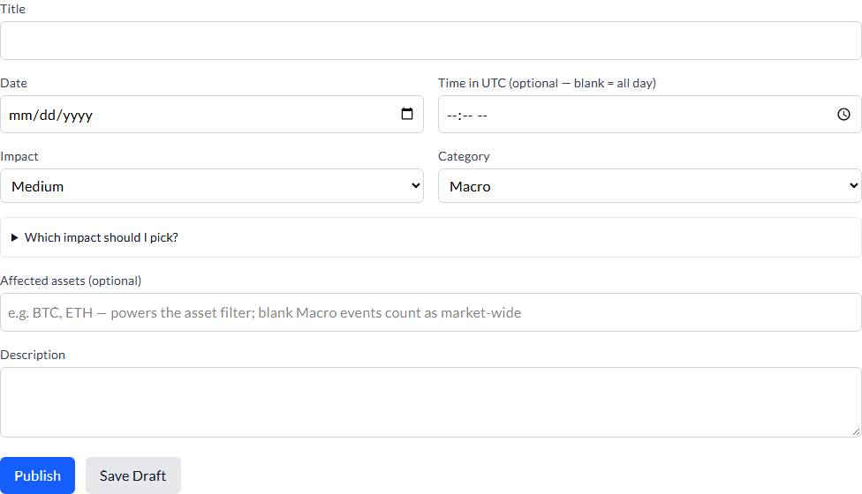  Admin /admin/pro-calendar: category list incl. Listing and Token sale / TGE; importance guide in the form.  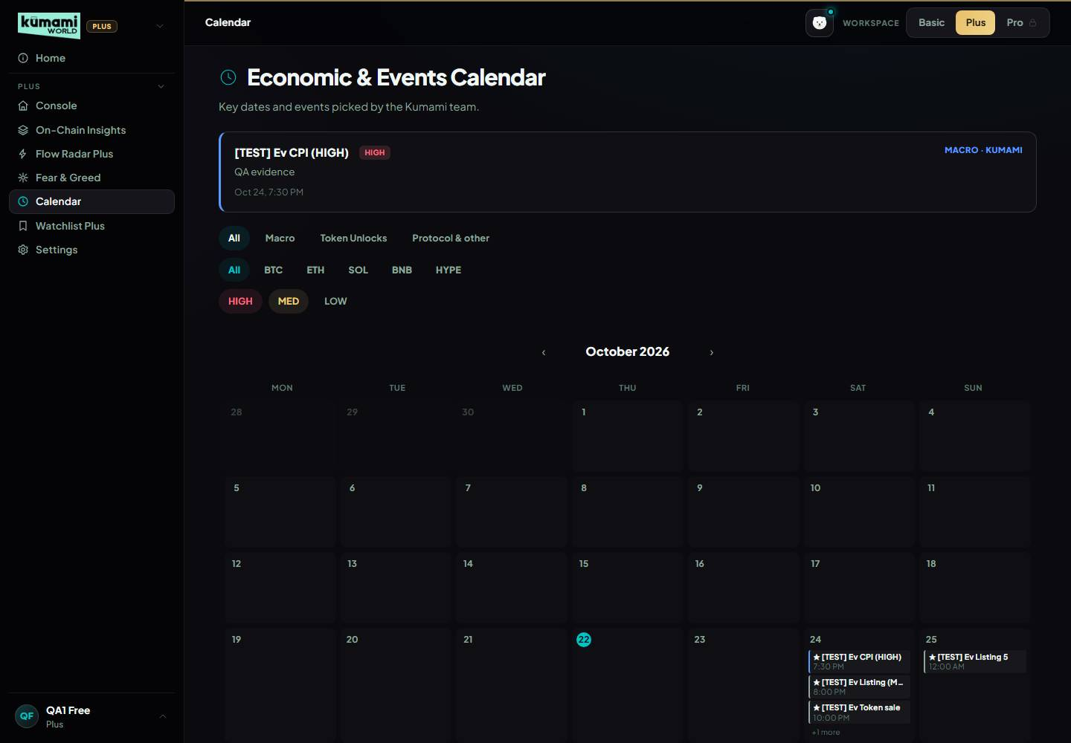  Plus: a test day with 6 team events (1 HIGH, 4 MED, 1 LOW) — LOW hidden by default, the cell shows 3 + "+N more". API: 6 test events, 0 airdrop dates (Plus…  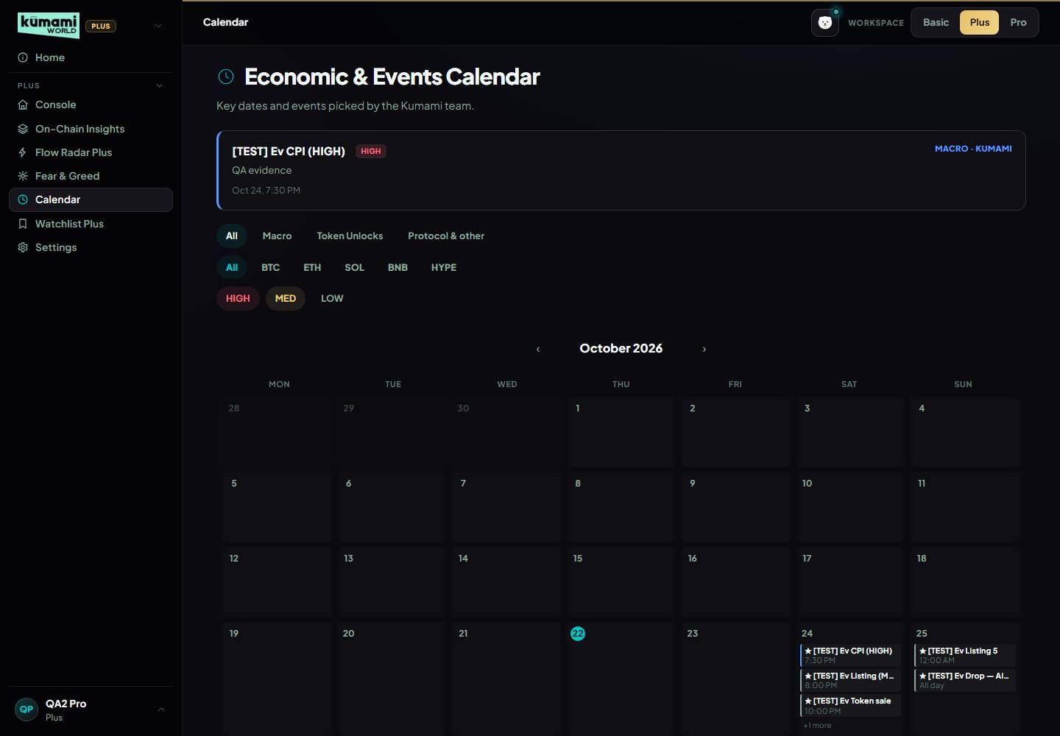  Pro: a test day with 6 team events (1 HIGH, 4 MED, 1 LOW) — LOW hidden by default, the cell shows 3 + "+N more". API: 7 test events, 1 airdrop dates (Pro sees…  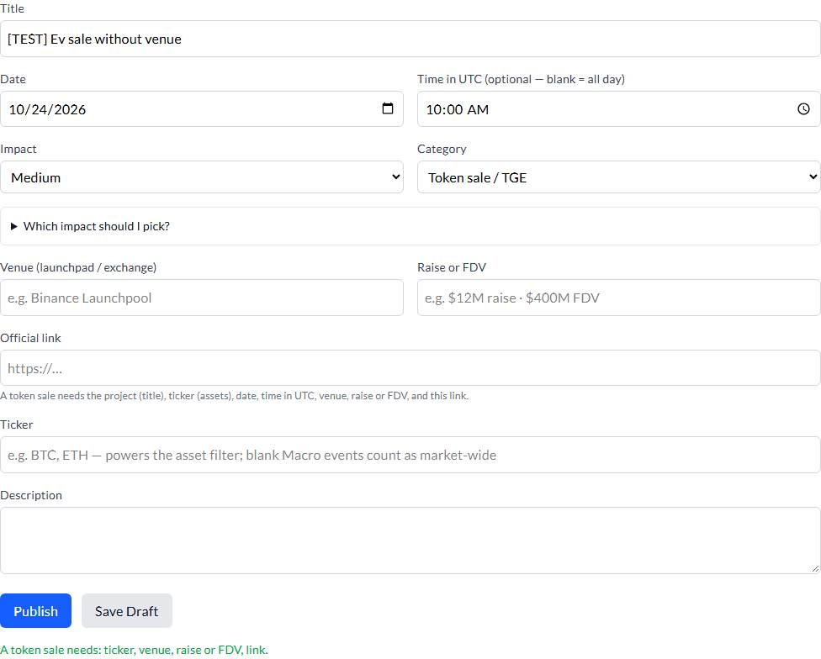  Admin: Token sale / TGE without venue, raise and link → refused: "A token sale needs: ticker, venue, raise or FDV, link.". Categories include Listing and…  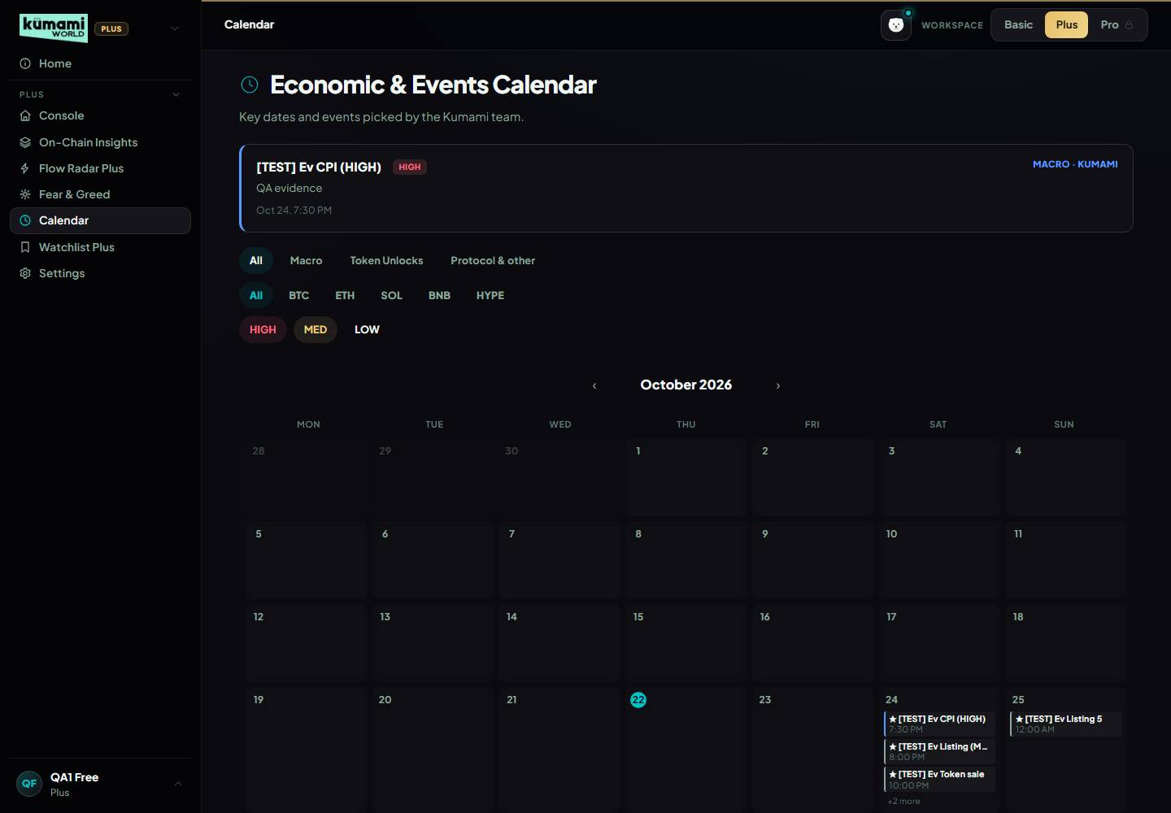  Plus with LOW switched on: the LOW test event is now counted in the day cell.
20 | Watchlist Plus §6 (Adjusted) — also Section A of Watchlist Pro: the 5 core coins, fixed (no adding here); Signal column uses the corrected §3 directions; "Short Heavy" fires below −0.05% (v1.14 used < 0%); the regime tag reads real OI (aggregated history, already cached for §2.7) so "Coiling" can fire (v1.14 estimated OI from price); "Near Liquidation Zone" stays blocked; backlog: 7-day sparkline. | Built (rules/watchlistTags.ts, live/watchlist.ts): 5 fixed coins; Short Heavy below −0.05%; Coiling from real 24h OI (OI up > 1% while price within ±0.5%); Signal column from the corrected directions; funding ×100 bug fixed (no more "Overheated" on normal funding). Sparkline not built; Near Liquidation Zone still blocked. | /world/watchlist (Plus): 5 rows, no add; "Short Heavy" only below −0.05% funding (compare the On-Chain Funding tile); no "Overheated" on ~+0.01%; Coiling only on OI-up / flat-price days. Watchlist test checks no Overheated on normal funding. |  | 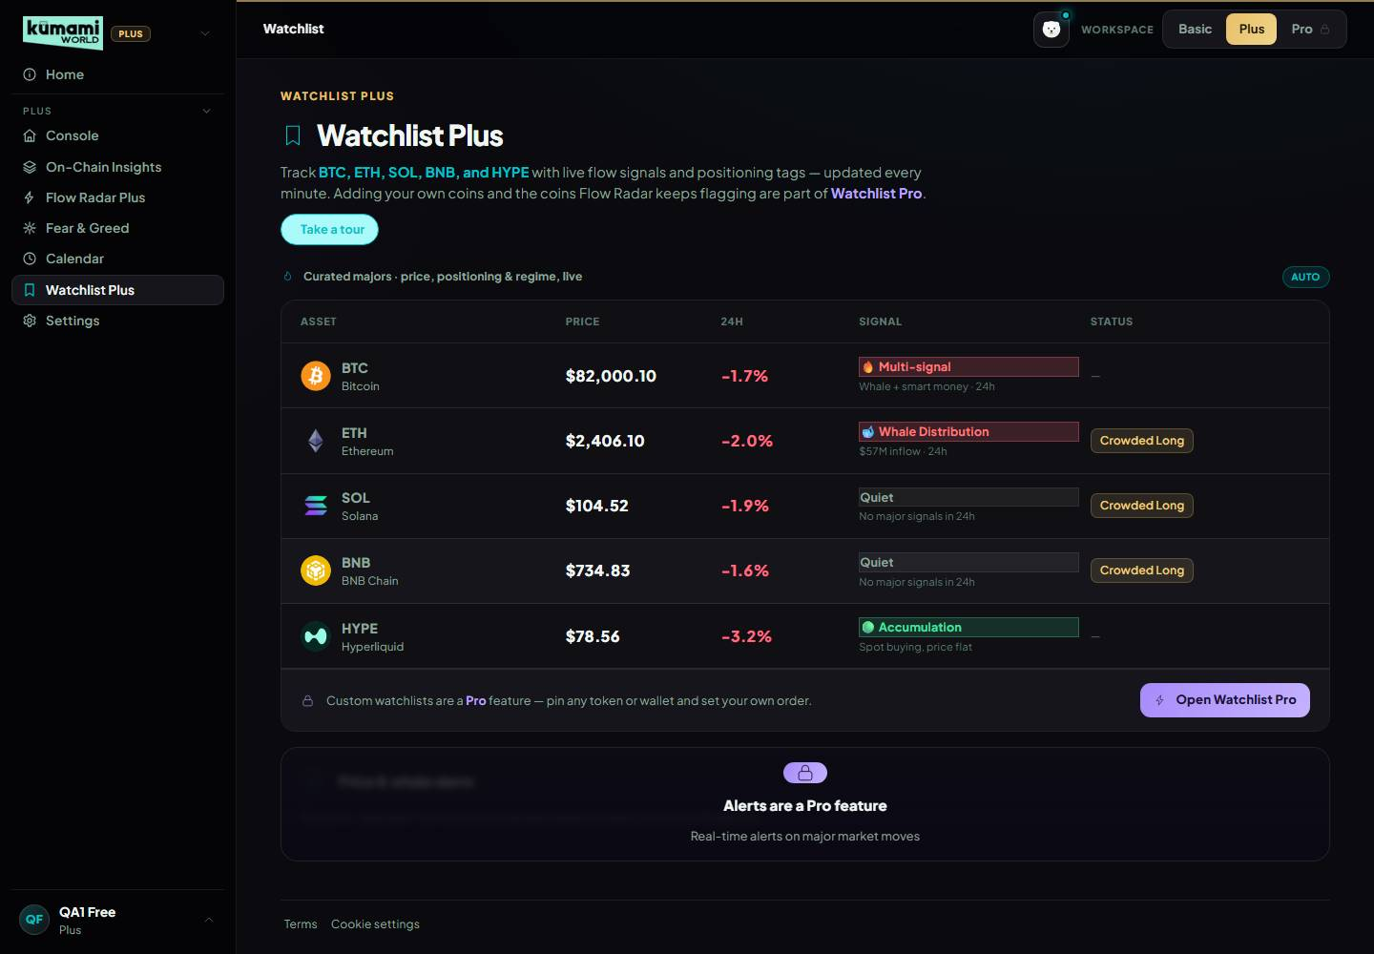  Watchlist Plus: BTC [no tag] · ETH [Crowded Long] · SOL [Crowded Long] · BNB [Crowded Long] · HYPE [no tag].
21 | Pro §1 Daily Digest (Adjusted): remove the outdated "once market data is live" disclaimer; add three lines — Smart Money (top 3 Hyperliquid position opens in 24h), Watchlist (today's Also Worth Watching coins), today's Fear & Greed read. Pro §2 Following & Alerts (Adjusted): fix the price-alert symbol list — MATIC and RNDR renamed on Binance (POL, RENDER), HYPE missing, check every symbol still has a live stream; backlog: volume and sentiment alerts. | Digest (pro/tabs/DailyDigest.tsx): disclaimer gone; Smart Money (Flow Radar Pro), Also Worth Watching (Watchlist Pro) and Fear & Greed (Kumami's index, same as the Fear & Greed page) sections, each with data or an honest empty line, tap → the tool. Alerts (lib/pro/useLivePrices.ts): HYPE added, POL and RENDER replace MATIC and RNDR (old alerts keep working), every symbol checked against Binance on 20 Oct, TON dropped (halted) — 30 coins. Volume/sentiment alerts not built. | Pro /world/pro?tab=digest: no "once the market data…" text; 3 sections. /world/pro?tab=following: add a HYPE or POL price alert → live price ticks; MATIC/RNDR/TON not offered. | Fear & Greed line now excludes News Tone (AI off). | 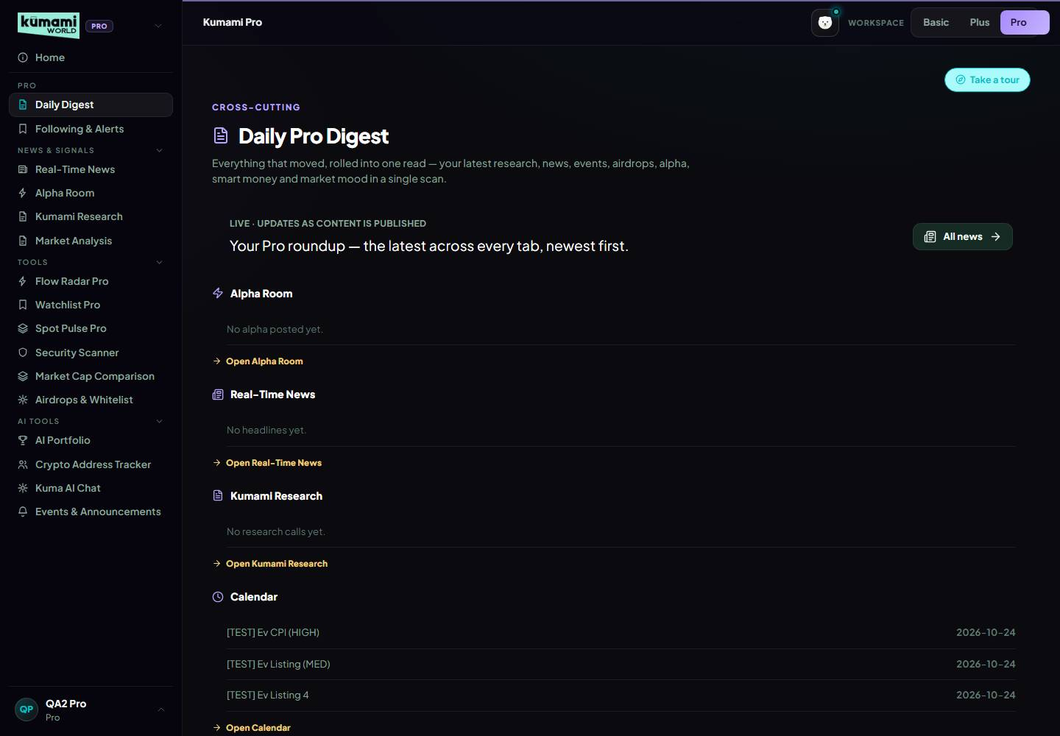  Daily Digest: Smart Money, Also Worth Watching and Fear & Greed sections; old disclaimer present: no.  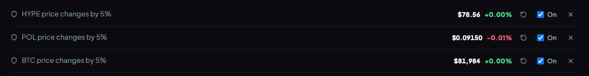  Price alerts for HYPE, POL (MATIC's new name) and BTC with live Binance prices — HYPE $78.56, POL $0.0915, BTC $81,984 within 9 s ("connecting…" shows until…
22 | Pro §5 Spot Pulse Pro (Revised) — same engine as Plus §2.9: 10 tiles (15 s cache); row 1 = 5 core coins; row 2 = the 5 Watchlist Pro Section C coins, empty slots filled with the top 24h spot-volume coins from netflow-list (no core, stablecoins or wrapped tokens), labelled "Top volume"; same share-based market verdict (separate 10-tile thresholds dropped); fixes v1.14's contradiction about row 2. | Built (live/spotPulse.ts, api/market/spot-pulse): 10 tiles, 15 s cache, row 2 = Also Worth Watching coins then "Top volume" fillers, one market-verdict rule for 5 and 10 tiles. The hover card (item 9) works on Pro too. | Pro /world/pro?tab=spotpulse: 10 tiles; row-2 tiles marked "Top volume" where no Also Worth Watching coin qualifies; banner follows the same table as item 11 (with 10 tiles, 4 make 40%). | While Also Worth Watching is still building its 3-day history, row 2 is mostly "Top volume" coins. | 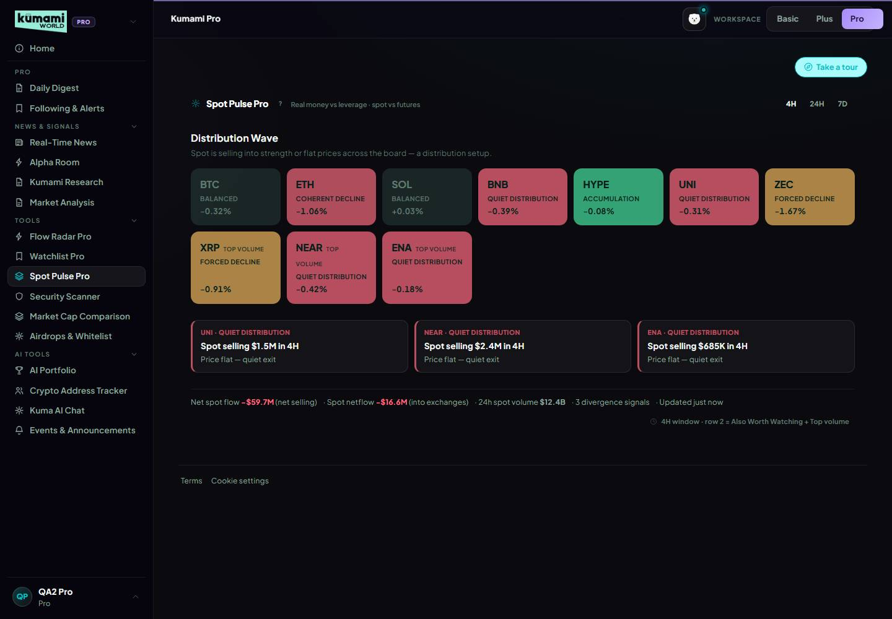  Spot Pulse Pro: 10 tiles — row 1 BTC, ETH, SOL, BNB, HYPE; row 2 UNI (Also Worth Watching), ZEC (Also Worth Watching), XRP (Top volume), NEAR (Top volume),…
23 | Pro §18 Flow Radar Pro — illiquid filter (new): hide events on coins under $1M 24h spot volume (netflow-list) or missing from that list; core coins and stablecoins never hidden (v1.14 thought this needed the Standard plan). | Built (rules/flowLiquidity.ts, live/binance.ts): under $1M 24h spot volume → hidden; core coins and stablecoins never hidden. Andrew's decision (21 Oct): netflow-list only covers the top ~100 coins, so a coin missing from it is checked against its Binance USDT volume instead of always being hidden. | Pro /world/pro?tab=flowradar: every non-core coin shown is a liquid one (none under $1M daily spot volume); BTC/ETH/SOL/BNB/HYPE and stablecoin rows always show. | Question for Rachelle: OK with the Binance-volume fallback, or the strict top-100 rule? | 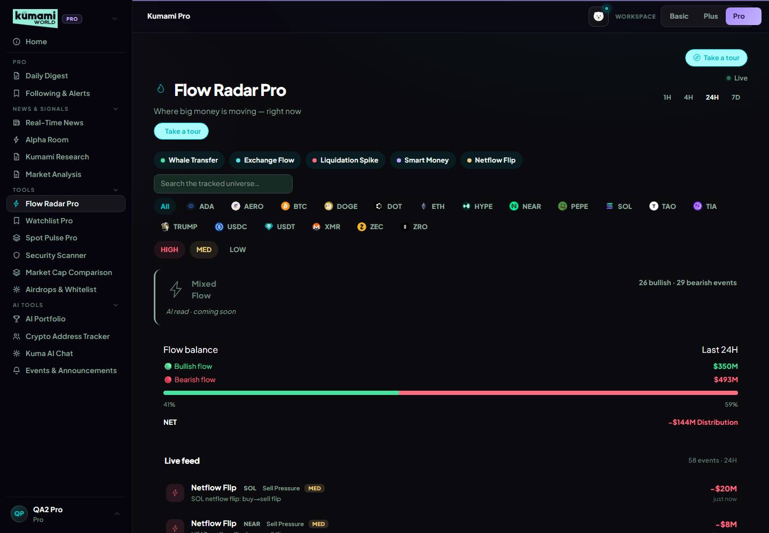  Flow Radar Pro: real-time (delayed=false), 91 events; non-core coins shown, all past the ≥ $1M spot-volume filter: NEAR, DOGE, ADA, TIA, DOT, PEPE, AERO,…
24 | Pro §18 Flow Radar Pro — the rest: real-time, every coin, LOW severity, Flow Balance panel (unchanged bands, built from the corrected buckets); Netflow Flip unchanged; Large Limit Order still blocked; fix the text "Plus already ships without delay" (Plus is 15 min); significance engine = next big build; backlog: "+ Custom" asset picker (up to 10), event counts on the filter chips. | Built: real-time feed (no delay chip), every liquid coin, LOW events, 7D window (×10 thresholds, Andrew 21 Oct), Flow Balance from the corrected buckets, Netflow Flip chip unchanged; the wrong "Plus already ships without delay" text is gone. Fixed 22 Oct (hard rule, 62d6aae): Flow Balance with no bullish/bearish flow said 50/50 — it now says "No bullish or bearish flow in the last 24h." Not built: significance engine (waiting for Rachelle's definition), "+ Custom" picker, chip counts; Large Limit Order blocked. | Pro /world/pro?tab=flowradar: no "Delayed" chip; LOW rows; Flow Balance shows bullish $ / bearish $ / net with a bar (or the empty line); Netflow Flip chip present. | Significance engine needs Rachelle's definition (question in the doc). | 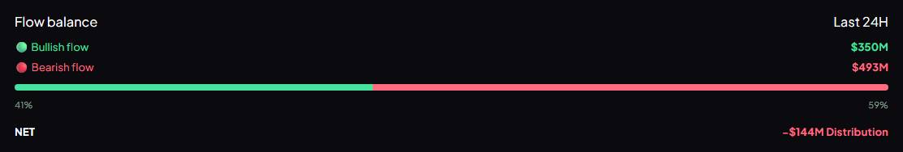  Flow Balance (Pro, last 24h): "Flow balance Last 24H 🟢 Bullish flow $350M 🔴 Bearish flow $493M 41% 59% NET −$144M Distribution".  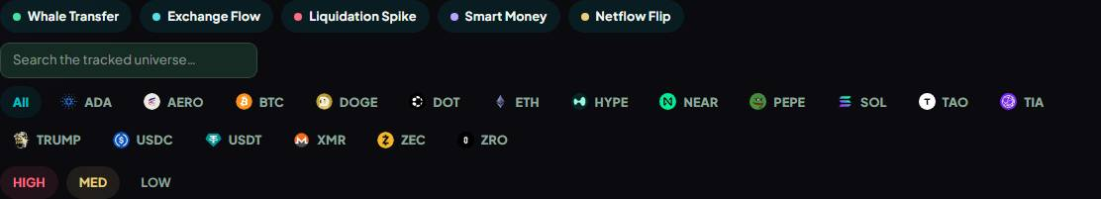  Pro filter chips include Netflow Flip; 11 netflow-flip events right now; no "Delayed" chip on Pro.
25 | Pro §19 Watchlist Pro — Section B pins: up to 15; the coin needs ≥ $10M 24h spot volume and a futures market (both from the cached netflow-lists); stablecoins, wrapped/staked tokens and the core coins can't be pinned; otherwise "Not enough liquidity to track reliably." | Built (rules/watchlistPins.ts, api/market/watchlist POST) with the exact messages: "Stablecoins and wrapped tokens can't be pinned.", "BTC is a core asset — it's always in Section A.", "Not enough liquidity to track reliably."; counter "n/15 assets tracked". Replaces the old fixed 10-coin list. | Pro /world/pro?tab=watchlist: pin USDC, BTC, ZZZQ → the three messages; pin PEPE → pinned, counter goes up; remove it again. Watchlist Pro test passes. |  | 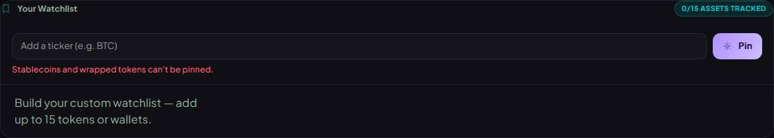  Pin USDC: "Stablecoins and wrapped tokens can't be pinned.".  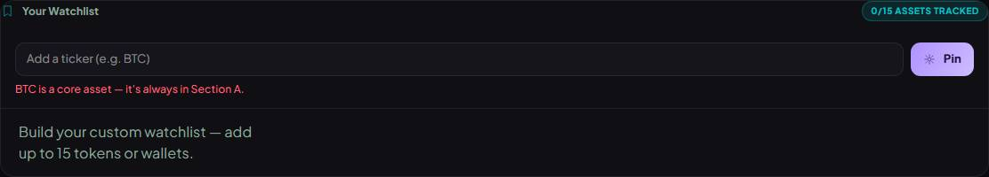  Pin BTC: "BTC is a core asset — it's always in Section A.".  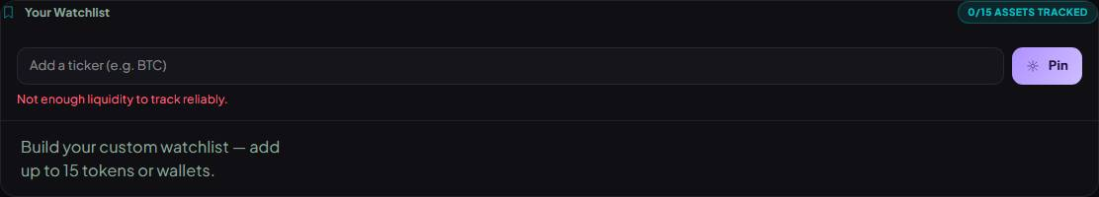  Pin ZZZQ: "Not enough liquidity to track reliably.".  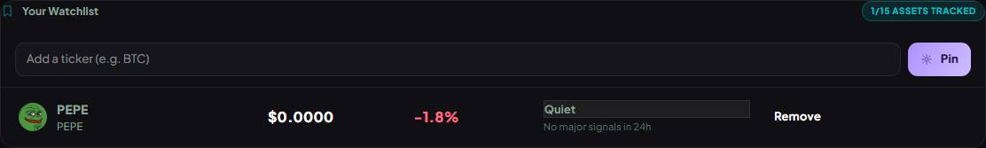  Pin PEPE: "1/15 ASSETS TRACKED".
26 | Pro §19 Watchlist Pro — Section C "Also Worth Watching": up to 5 coins, 3-day net accumulation, recomputed hourly from flow_hourly; candidates = coins with an event in 72h minus core, pins, stablecoins, wrapped, Dry Powder; qualifies only if net buying beats selling on ≥ 2 of 3 days, 3-day net > +$5M, last 24h undoes ≤ 25%, spot buyers net positive over 3 days, passes the pin liquidity check; ranked by days, then net ÷ volume; no padding ("Only N coins show sustained accumulation right now"); hover "Accumulating 3 of 3 days · net flow +$42M · spot buyers +$18M (3d)"; first 72h from flow_daily, labelled "building 3-day history". | Built exactly (rules/watchlistSectionC3d.ts, consistentCoins.ts): reads flow_hourly once its oldest hour is 72h old, otherwise flow_daily ("building 3-day history"). Fixed 22 Oct (hard rule, 5ea19b7): days from before v1.15 only had event counts and their $ was estimated from the counts — they are now left out, and the reason says how many real days there are ("Accumulating 2 of 2 days"). | Pro /world/pro?tab=watchlist → Also Worth Watching: labelled "3-day net accumulation"; hover ◆ shows the reason line; fewer than 5 → "Only N coins show sustained accumulation right now". | Until the Cloud Scheduler collector has run for 72h, history only builds while someone is on the site. | 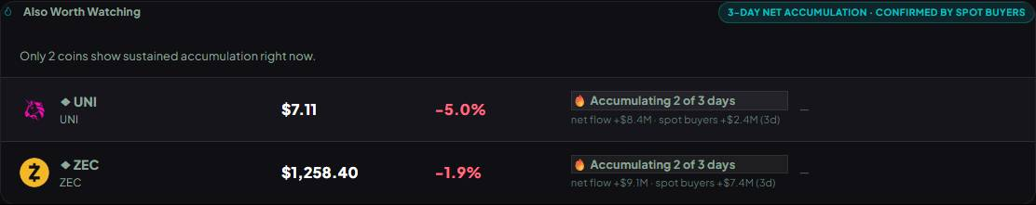  Also Worth Watching (mode: consistent): UNI — Accumulating 2 of 3 days · net flow +$8.4M · spot buyers +$2.4M (3d) | ZEC — Accumulating 2 of 3 days · net flow…
27 | Pro §19 Watchlist Pro — live prices: from Binance's free price stream (same as Following & Alerts); coins not on Binance keep the normal refresh (CoinGlass on STARTUP can't refresh every second). Backlog: saved lists, wallet rows, 30-day signal history, alert rules, ◆ early-signal tags. | Built: Watchlist rows subscribe to the Binance price stream; coins without a Binance pair keep the normal refresh. Backlog items not built. | Pro /world/pro?tab=watchlist: prices tick every second or two on BTC/ETH rows. |  | 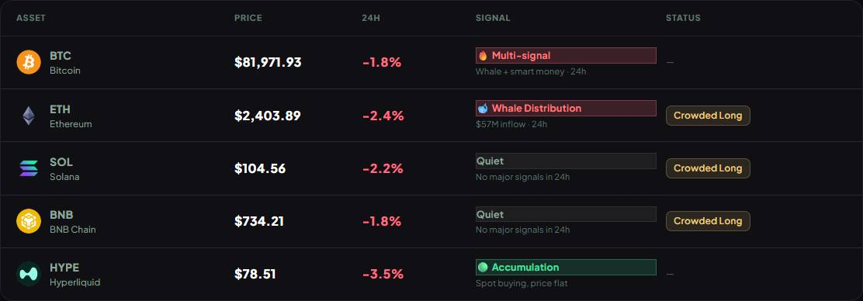  Live prices: Binance price stream connected: yes; a price on the table changed within 30 s: yes.
28 | Pro §17 Kuma AI Chat: build the knowledge refresh (v1.12) from v1.15. Pro §21 Subscriptions & Payments — before payments go live: deploy the v1.10/v1.14 database rules to production (only on kumami-dev); get CoinGlass's written approval for commercial use or move to Standard ($299/mo) — STARTUP is listed as personal use. Pro §3/§4: Smart Money Tracker and Coin/Token Tracker postponed. Pro §6, §8, §20: Security Scanner (GoPlus), AI Portfolio multi-wallet, Crypto Address Tracker extras — backlog. | Kuma knowledge: drafted from the spec in docs/kuma/kumami-knowledge-v1.16.md (with 10 test questions) — not loaded into Kuma yet, waiting for Rachelle's review. Payments prerequisites: not done — Andrew's actions (rules deploy to production, CoinGlass approval or upgrade). Postponed / backlog items: not built. | No screen to check: the knowledge draft is a document; the prerequisites are account/config actions (listed in the Roadmap section). | Owner Andrew: rules to production; CoinGlass written approval or Standard plan. Owner Rachelle: review the Kuma knowledge draft. | No screen — document or account action.
29 | Platform — background collector (new): Cloud Scheduler every 60 s calls a protected /api/v1 route with a shared-secret header; writes flow_events (one doc per event, unique key) and flow_hourly (bullish/bearish $ per coin per hour), both kept 7 days; about 5–10 CoinGlass calls a minute. Significance engine: the next big build, reusing the collector. | Collector built: POST /api/v1/cron/collect with the x-cron-secret header (401 without it, 503 when CRON_SECRET isn't set); writes flow_events (+ plusAt for the Plus delay, item 3) and flow_hourly, deletes past 7 days; the Console and Flow Radar pages also run it (at most once a minute) until the scheduler is on. Significance engine not built (no definition yet). | Tested on kumami-dev 22 Oct: a run stored 92 new events and 39 hourly rows; Plus served 18 stored events 15+ min old straight away. Production needs CRON_SECRET in App Hosting + the Cloud Scheduler job + a TTL policy on expireAt (docs/API.md). | Owner Andrew: CRON_SECRET, Cloud Scheduler job, TTL policy. | Collector run on kumami-dev, 22 Oct 2026: POST /api/v1/cron/collect with the secret header → {events: 93, created: 92, updated: 1, hourly: 39};…

Part 2 — Other website changes
- No stand-in values, anywhere (Andrew's hard rule, 22 Oct 2026). The product never shows a template or placeholder that could be read as real: the AI layer is off until Gemini billing and every AI spot says “AI read · coming soon”; Fear & Greed leaves missing signals out instead of counting a neutral 50; Flow Balance with no flow says so instead of 50/50; On-Chain Long/Short with no reading is “unavailable” instead of a verdict from a stand-in 50%; Also Worth Watching no longer estimates $ from event counts.
- Fear & Greed fix: Price Momentum and Volatility never had data (the page asked for “BTC” price history instead of “BTCUSDT”); they now read real daily closes.
- Flow Radar Plus delay rebuilt on stored event history (Plus §3): no warm-up, 24h history, works before the collector is scheduled.
- On-Chain: the ETF Flow panel only shows for BTC and ETH (SOL/BNB/HYPE showed Bitcoin ETF data unlabelled).
- Spot Pulse: hover card on every tile (Plus and Pro) with the UP / FLAT / DOWN directions; the divergence count matches the cards; an empty-state line when there are none.
- Shell: the Basic / Plus / Pro workspace toggle shows words only (no icons), also on mobile; the mobile 4-item bottom tab bar is removed — the top bar's menu button opens the sidebar and its Kuma button opens Kuma AI.
- Labels: “AI confidence” / “AI conf” / “AI-fused regime read” are now “Confidence” / “Conf” / “Rule-based regime read” — the confidence is rule maths, not AI.
- Reliability (21 Oct): shared CoinGlass budget of 70 calls/min with a log line when a call has to wait; dropped Watchlist rows are logged; Hyperliquid “k” symbols (kPEPE) show as the coin; Gemini quota cooldown; funding ×100 bug, ETF “Today $0” and “$0M” empty-window fixes.
- QA: 810 unit tests; Playwright suites for every v1.15 area (desktop + mobile) plus the access matrix; a new evidence suite (qa/features/v116-evidence.spec.ts) takes the screenshots on the evidence page. The sanity check now accepts large week-over-week ETF changes (a real +264% week).

Questions for Rachelle
- 1. Airdrop TGE / claim dates on the shared Calendar: Plus too, or Pro only (Pro only for now)?
- 2. Flow Radar Pro 7D verdict: is ×10 the right scaling (1H ×0.5 · 4H ×1 · 24H ×2.5 are yours)? And keep v1.14's $300M cascade / $500M wave amounts and the 3-event minimum?
- 3. Illiquid filter: OK with checking coins outside netflow-list's top ~100 against their Binance volume, or keep the strict rule (hide them)?
- 4. Significance engine: please define “significant” (baseline per coin? z-score vs N days? which events?), what the user sees and where.
- 5. Quiet markets: the Plus feed can be empty for hours (liquidation MED $50M, Dry Powder MED $100M) — keep the floors or lower them for Plus?
- 6. Open interest: is ±1% the right “flat” line for Trend Without Leverage / Decline Without Panic?
- 7. Spot Pulse market verdict: confirm bullish = REAL BUYING, ACCUMULATION, REVERSAL SETUP and bearish = DISTRIBUTION, QUIET DISTRIBUTION, COHERENT DECLINE, FORCED DECLINE (SPECULATIVE and BALANCED neither).
- 8. Exchange Flow (Dry Powder): which other Ethereum tokens, if any, should be tracked (inflow bearish / outflow bullish)?
- 9. Kuma AI knowledge refresh (Pro §17): please review the draft in docs/kuma/kumami-knowledge-v1.16.md before it is loaded.

Needs Andrew
- Gemini: enable billing on the key's Google project, then set AI_ENABLED=true — until then every AI spot says “coming soon”.
- Collector: set CRON_SECRET in App Hosting, create the Cloud Scheduler job (every 60 s) and a TTL policy on expireAt (docs/API.md).
- Before payments go live: deploy the database rules to production; CoinGlass commercial use — written approval for STARTUP or move to Standard ($299/mo).
- Website “What's new” page: decide where the customer-facing text (docs/release-notes/v1.16-whats-new-draft.md) goes.
- Not re-audited in this version: Basic §1–8, Plus §7–8, Pro §3–4, §6–17, §20–22, except where noted above.

v1.15 — 19 Oct 2026 (Rachelle's request version)
Rachelle's logic revisions and answers to Gap Report v1.2, written on v1.14 — her own Google Doc “Kumami Product Spec v1.15”. Every ask and what was built is in the v1.16 table above.
Numbering note (22 Oct 2026): the internal builds of 14–17 Oct were numbered v1.15–v1.19 in earlier copies of this document. They are renamed v1.14.1–v1.14.5 below so that v1.15 is Rachelle's request version and v1.16 is the build version that answers it. Mentions of v1.15–v1.19 inside those old entries refer to the old numbers.

v1.14.5 — 17 Oct 2026 (internal build)
Console regime scoring now follows Rachelle's Plus §1.1 exactly (Andrew: fix the gaps one by one, 17 Oct 2026).
- Console (Plus §1.1). Fear & Greed is weighted at the extremes (Extreme Fear +1.5, Extreme Greed −1.5); ETF flow only counts beyond ±$100M over 7 days; funding scores −1 above +0.1% and +1 below −0.05% (0 in between); OI up + price flat is now 0 and OI up + price down is −1; confidence is the share of active signals that agree (neutral signals no longer drag it down); HYPE's confidence is capped at 0.7.
- Bug fixed: funding scale. The OI-weighted funding feed is already a percentage (BTC 0.0066 = 0.0066%). The Console multiplied it by 100, so normal funding read as about 0.66% and scored overheated, pulling verdicts bearish. On-Chain Insights (§2.1) and Watchlist Plus still have this bug; it is the next fix.
- Corrections: §1.3 said the chips' prices come from one batched call; they come from one /api/futures/pairs-markets call per coin (the batched endpoint is locked on our plan).
- Not re-audited in this version: everything outside Console §1.1 and §1.3.

v1.14.4 — 15 Oct 2026 (internal build)
Invented legal text removed (to-do 5227a4b7, Andrew): legal content comes from Andrew's team only.
- Reverted: Legal & cookies (Basic §7). The v1.15/v1.17 Terms rewrite is gone. /terms and /world/terms show the team's original Terms again, read from Firestore app_config/terms_and_conditions (as on main). The invented Privacy Policy (/privacy, /world/privacy) is removed with every link to it — main never had one. Removed the made-up sign-up line (agree / 18+ / not financial advice), the Subscribe refund and “by paying you agree” lines, and the shell “not financial advice” paragraph. Section retitled “7. Terms & cookies”.
- Kept (Andrew, 15 Oct 2026): the cookie banner and Account deletion (Basic §8). The deletion panel no longer cites tax law, a privacy policy or refunds.
- Corrections to v1.15–v1.17 text: the 18+ age, refund rule, referral rules and other “Andrew decisions” recorded there were invented wording, not Andrew's decisions.
- Open for Andrew's team: Privacy Policy text, company details, refund and referral wording, disclaimer wording, age — proposed as to-dos. The rest of the 20-item reel checklist stays on the roadmap only.
- Not re-audited in this version: everything outside Basic §7–§8.

v1.14.3 — 14 Oct 2026 (internal build)
Terms of Service rewritten after Andrew's legal decisions (to-do 35775685). Audit: docs/legal/2026-10-14-compliance-audit.md.
- Changed: Legal, privacy & cookies (Basic §7). The Terms of Service at /terms and /world/terms are rewritten and now written in code, like the Privacy Policy (the Firestore text is no longer read). New: 18+ (was 17), not financial advice, AI answers can be wrong, Pro prices and auto-renewal, refunds (none once a paid period has started; cancel any time and keep Pro to the period end), sanctions, referral rules, acceptable use, copyright complaints, termination, liability cap, governing law.
- Subscribe (Pro §21). The payment note now says payments are non-refundable once a period has started, with a link to Terms → Refunds.
- Still open: company legal name, country and contact email are placeholders on both Terms and Privacy (one shared setting, src/components/legal/entity.ts); a lawyer review before main.
- Not re-audited in this version: every section except Basic §7 and the Subscribe note in Pro §21.

v1.14.2 — 14 Oct 2026 (internal build)
Self-serve account deletion (to-do 629973ef) — needed for GDPR/CCPA and the app stores. QA: docs/qa/2026-10-14-account-deletion.md. Plan: docs/plans/2026-10-14-account-deletion.md.
- Shipped: Account deletion (Basic §8) — new section. Profile → Profile → “Delete my account”: type DELETE and sign in again (password, or the Google popup), then the account is deleted straight away. Deletes the profile, course progress, Kuma chats, watchlists, wallet tracker, Pro tool settings, referral code and the sign-in. Payment, order, subscription and referral-ledger records are kept (uid only) for tax. A live card subscription is cancelled at once with no refund; crypto Pro time and any referral balance are lost (both warned). Staff accounts are refused until their role is removed. New endpoint DELETE /api/v1/me for the Flutter app.
- Also: payment webhooks, referral reversals and late Kuma replies no longer recreate a deleted user’s record. Privacy Policy now points to the self-serve option (deleted straight away from Profile; within 30 days by email). Legal §7 known gap on account deletion closed.
- Not re-audited in this version: every section except Basic §7 and §8.

v1.14.1 — 14 Oct 2026 (internal build)
Legal / compliance pass (to-do d5870b2d). QA: docs/qa/2026-10-14-legal-compliance.md. Audit: docs/legal/2026-10-14-compliance-audit.md.
- Shipped: Legal, privacy & cookies (Basic §7) — new section. Public Privacy Policy at /privacy (and /world/privacy); cookie banner on every page — Google Analytics no longer loads until the visitor clicks Accept; “By signing up you agree…” line (18+, not financial advice) on the sign-up form; “By paying you agree…” on the Subscribe page; Terms / Privacy / Cookie settings links on the landing page, footer and sidebar brand menu; a not-financial-advice footer at the bottom of every /world page.
- Open decisions: company legal name, country and privacy email are still placeholders in the Privacy Policy; age limit (18+), refund policy and referral rules need Andrew’s call; account deletion is a follow-up.
- Not re-audited in this version: every section except Basic §7 and the Subscribe page note in Pro §21.

v1.14 — 11 Oct 2026
Shipped the v1.13 planned items. QA: docs/qa/2026-10-11-payments-referrals.md.
- Shipped: Subscriptions & Payments (Pro §21) — planned flag removed. Subscribe page (Monthly $19.99 / Yearly $199.99, card or crypto), payment confirmation page, Profile → Subscription with Cancel / Resume / Update card, crypto “ends soon” banner. Pro is switched on only by verified payment notifications. Card flow awaits Stripe test keys for end-to-end QA.
- Shipped: Referral Program (Pro §22) — planned flag removed. Every account gets a unique 8-character code; $1 / $10 to both people once per new user; refunds reverse it; balance and history in Profile → Referrals.
- Shipped: Backend API platform (Pro §23) — planned flag removed. All payment, referral, Kuma chat and news-push logic now runs in /api/v1 on Firebase App Hosting, documented in docs/API.md and docs/DATABASE.md (new). Firebase Functions to be switched off by Andrew.
- Shipped: Kuma AI Chat move (Pro §17). Chat now checks who is sending; replies need a signed token.
- Security: users can no longer edit any billing or referral field on their own account, or see who owns a referral code (rules deployed to kumami-dev only). The old Profile “Unsubscribe”, which never stopped Stripe billing, is gone. Admin “Remove Pro” now also cancels a paying user’s Stripe subscription.
- Not re-audited in this version: sections other than Pro §17 and §21–23.

v1.13 — 11 Oct 2026
Planned — not live yet.
- Planned: Subscriptions & Payments (Pro §21). Monthly $19.99 / Yearly $199.99; card via Stripe (auto-renew, own Cancel/Resume) or crypto via NOWPayments (prepaid 30/365 days); Pro granted only by verified webhooks.
- Planned: Referral Program (Pro §22). Server-made unique 8-character codes; $1 / $10 to both sides once on the new user’s first payment; balance tracked, withdrawal later.
- Planned: Backend API platform (Pro §23). Firebase Functions retired; all endpoints under /api/v1 for web + Flutter; new docs/API.md and docs/DATABASE.md.
- Planned: Kuma AI Chat (Pro §17). Chat endpoints move to authenticated Next.js routes.
- Not re-audited in this version: all sections other than those named above.

v1.12 — 11 Oct 2026
- Planned: refresh Kuma AI’s company-knowledge PDF (n8n) from the current spec so its answers are smarter and up to date (Kuma AI Chat → Planned changes). Scheduled for later.

v1.11 — 11 Oct 2026
- Coin logos: every coin in the top ~300 by market cap now shows its real logo (Console, Watchlist Plus/Pro, On-Chain, Flow Radar) instead of a coloured letter. Logos are stored on our own site (public/coins/), refreshed with scripts/fetch-coin-logos.ts; the letter remains only for coins outside that list.

v1.10 — 10 Oct 2026
- Security (database rules), deployed to the dev database (kumami-dev) only: users can no longer give themselves Pro or admin rights, fake an active subscription, or read Pro content without an active Pro subscription (logged-out visitors included). Pro content and live-event Q&A are for active subscribers and admins; a time-limited Pro grant stops at its end date. Profile edits and Unsubscribe still work.
- Not yet on production: the deployed dev website and kumami.world use the production database, so the fix reaches them only when Andrew deploys the rules to production.

v1.9 — 10 Oct 2026
- Following & Alerts: followed airdrops/whitelists are listed by their name (before, a database code like “hBpbd… (airdrop)” showed). Removed airdrops are labelled as no longer listed.
- Daily Pro Digest: each section now really shows the newest 3 items, as its header promises (before, it took the first 3 in storage order, so new posts could be missing).
- QA: every admin-managed Plus/Pro content type is now tested end to end — the superadmin test account publishes “[TEST]” items, the Pro test account checks they show correctly, the free test account sees only the teaser. Test items stay on kumami-dev until the next run.

v1.8 — 10 Oct 2026
Admin Subscriptions tool and fixes from Andrew's review. QA: docs/qa/2026-10-10-subscriptions-and-fixes.md.
- Subscriptions admin page (superadmin only). Grant Pro for 1 / 3 / 12 months or no end date, or remove Pro; works on production; audited; expiry automatic. The Profile “Grant Pro / Remove Pro” testing buttons and their endpoint were removed.
- Flow Radar Plus always shows “Delayed 15m” (it showed “Live” while loading/failing — what Andrew saw on the deployed dev site); the Console tile is now “Flow Radar Plus” with a Delayed chip.
- Exchange Netflow 24H shows “Updates daily” instead of “$0 · Neutral”.
- Sign-up name is saved to the user profile and shown in the sidebar; users can edit their name in Profile; older accounts get their sign-up name copied over on next login.
- 7-day Flow Radar history backfilled (whale transfers + liquidation spikes, 4–9 Oct) — Watchlist Pro / Spot Pulse Pro extra coins now use the full 7-day rule. Wrapped tokens excluded.
- Fixed: liquidation-history cache ignored the exchange list (could serve Binance-only data for a cross-exchange request).
- Not re-audited in this version: sections not named above.

v1.7 — 10 Oct 2026
Shipped the v1.6 planned items (planned flags removed), plus Pro-access and Calendar changes. QA: docs/qa/2026-10-10-plus-pro-tool-split.md.
- Shipped: Plus/Pro tool split — planned flags removed. Flow Radar Plus (15-min delayed snapshot, 5 coins) / Flow Radar Pro (real-time, every coin); Watchlist Plus (5 fixed) / Watchlist Pro (anchors + your coins + 5 extra coins by 7-day Flow Radar consistency); Spot Pulse tile (Plus) / Spot Pulse Pro (10 tiles, real-time). Plus pages are Plus for every account. Pro → Tools lists the three Pro tools.
- Pro = subscribed only. Admin/superadmin roles no longer grant Pro (Andrew's test account was seeing Pro after unsubscribing because it is a superadmin). Enforced in pages, sidebar and server, incl. the Crypto Address Tracker API.
- Calendar: CoinGlass feeds OFF by default; two admin switches (macro events, token unlocks) on /admin/pro-calendar.
- Fixed during QA: Spot Pulse 7D showed only HYPE (CoinGlass rate limits on a cold cache — now 3 retries with back-off); stablecoins (USDC) were picked as extra coins; Watchlist Pro pins couldn't be removed on phones; Plus Flow Radar delay hid most events (now snapshot-based).
- Testing-only (remove before main): “Grant Pro” / “Remove Pro” buttons in Profile → Subscription simulate a completed / cancelled subscription (disabled in production).
- Known security holes (not fixed, need a rules deploy): users can edit their own isPremium/role, create active subscriptions, and read pro_* content without subscribing — see docs/security/2026-10-10-firestore-rules-pro-leaks.md.
- Not re-audited in this version: sections outside Flow Radar, Watchlist, Spot Pulse, Calendar and the Pro intro.

v1.6 — 10 Oct 2026
Planned — not live yet.
- Planned: Plus/Pro tool split — Flow Radar Plus / Flow Radar Pro, Watchlist Plus / Watchlist Pro, Spot Pulse tile (Plus) / Spot Pulse Pro (full tool). Plus is cut down and Flow Radar Plus is delayed 15 min; Pro is complete and real-time. See the “Planned changes (v1.6)” sub-sections in Plus §2, §3, §6 and Pro §5, §18, §19.

v1.5 — 10 Oct 2026
Andrew's decision: a less crowded sidebar — each workspace shows only its own tier.
- Sidebar (Plus intro, Pro intro). Basic shows only Basic items, Plus only Plus tools, Pro only Pro tabs (Home stays in all three). Previously Plus also listed every Basic item, and Pro listed Pro + Plus + Basic.
- Workspace follows the page. Opening a page switches the Basic / Plus / Pro toggle to its tier; switching the toggle goes to that workspace's home page. Fixes Calendar, Flow Radar, Fear & Greed and Settings showing the Basic workspace (they weren't registered as Plus pages).
- Watchlist Pro (Pro §19). Pro sections (your pins, Also Worth Watching) now follow the account, like Flow Radar Pro, so Pro users keep them when they open Watchlist from the Plus workspace.
- Not in Rachelle's spec (her doc only asks for a regrouped, collapsible sidebar) — product decision by Andrew, 10 Oct 2026.

v1.4 — 10 Oct 2026
First release under the new development workflow (docs/DEVELOPMENT_WORKFLOW.md): two bugs found by the first Playwright QA pass, fixed.
- Calendar (Plus §5). Repeated macro releases (same name, country and time) are now shown once — they previously produced duplicate entries.
- Spot Pulse alert cards (Plus §2.9, Pro §5). Amounts are shown at the right scale ($B / $M / $K) — small moves previously read “Spot buying $0M in 4H”.
- Not re-audited in this version: everything outside the two items above.

v1.3 — 9 Oct 2026
Brings the document in line with the dev branch after the 21 Sep data-integrity build and the 9 Oct Calendar / Spot Pulse build, and corrects several v1.2 statements that were already out of date.
- Calendar (Plus §5, Pro §14) — one Calendar for Plus and Pro. Pro's separate admin-only Calendar tab is retired; /world/calendar now merges the market-data feed (macro prints + token unlocks) with events the team adds at /admin/pro-calendar. Drafts stay hidden; publish/edit/delete show on the next load. Month grid with a “Next up” card replaces the old list view.
- Calendar data fixes. Macro feed now covers 30 days back → 60 days ahead (it previously returned only the past 30 days, so nothing upcoming showed and the high-impact popups could never fire). Unlocks are dated on the actual next unlock (were stamped “now”) and sized by that unlock as % of circulating supply.
- Console (Plus §1). Preview row is now Spot Pulse · Flow Radar · Calendar (next 7 days) · Watchlist. The Intelligence preview and the separate “Radar Watchlist” auto-pick engine were retired. New “Needs your attention today” popup.
- Intelligence (Plus §7) — removed from navigation; /world/intel redirects to Console. The engine still feeds Fear & Greed's News Tone.
- Spot Pulse (Pro §5) — now live in Pro, showing the same panel as Plus On-Chain Insights (faster 15s refresh for Pro). /world/spot-pulse redirects to On-Chain Insights.
- Pro navigation (Pro intro, §3, §4, §12). Smart Money Tracker, Coin/Token Tracker and the Pro Fear & Greed slot were removed (empty placeholders, absent from Rachelle's latest mockup). Pro now has 14 sidebar tabs; Security Scanner is the only placeholder left.
- Watchlist (Plus §6). Fixed 5-asset roster (BTC/ETH/SOL/BNB/HYPE) for everyone; the table now has separate Signal (whale / smart money / Spot Pulse) and Status (risk tags + regime) columns. Whale tags no longer wrongly Pro-gated.
- Fear & Greed (Plus §4). Inverted colours fixed (Extreme Greed was red); history chart gets colour bands + axis labels; the composite shows as unavailable when all five inputs fail instead of a fake neutral 50.
- All Plus panels — no stale data. The shared cache no longer serves old numbers when CoinGlass fails; panels show “No data” instead of $0 / 50 / neutral placeholders.
- Corrections to v1.2 text: Plus Flow Radar events arrive on a 30-minute delay (v1.2 said real-time / ~15 min); AI Portfolio's 24h change is a real weighted figure (v1.2 called it fabricated); Watchlist roster is 5 assets, not 10.
- Not re-audited in this version: Kumami Basic, On-Chain Insights panel thresholds (§2.1–2.8) and the Console regime formulas (§1.1–1.3) were not re-checked against code — treat them as v1.2 content.

v1.2 — 20 Sep 2026
- Added Pro §18 Flow Radar (Pro), §19 Watchlist (Pro) and §20 Crypto Address Tracker, built against Rachelle's Kumami Website (6) spec, with what shipped vs. what is deferred.

v1.1 — 15 Sep 2026
- Every feature rewritten into the standard What it is / Where it is / How the user uses it / How we build it format, with live screenshots and admin-panel walkthroughs for all admin-authored content.
- Product changes in that build: Spot Pulse moved onto the Console preview; Watchlist roster aligned to the 5-asset universe; AI Portfolio wallet import added.

v1.0 — 13 Sep 2026
- First full Basic / Plus / Pro specification: every product's data source, API and calculation, written in the same What it is / Data in / How it's calculated style as Rachelle's Kumami Plus sheet.

Roadmap / To be developed
Everything asked for but not live yet, and what each needs. Updated with every build version.
Item | Where | Status | Next step / owner
Switch the AI layer on | Plus §1, §3, §4 · Pro §23 | Built, off (no billing) | Andrew: Gemini billing, then AI_ENABLED=true
Schedule the background collector | Pro §23 | Done 27 Oct 2026 | — (Cloud Scheduler every 60 s on kumami-dev; TTL on)
Database rules to production | Pro §21 | On kumami-dev only | Andrew: deploy before payments go live
CoinGlass commercial use | Pro §21 | Open | Andrew: written approval for STARTUP, or Standard ($299/mo)
Significance engine | Pro §18 | To be developed — defined in v1.17 | Build after 30 days of collector data (~26 Nov 2026)
Kuma AI knowledge refresh | Pro §17 | Draft ready — not sent yet | Andrew: send docs/kuma/kumami-knowledge-v1.16.md to Rachelle; then load it
Dry Powder for other Ethereum tokens | Plus §3 | Closed — USDT / USDC only (v1.17) | —
Calendar: day/week/list toggle, Today / This Week / Next 30D filter, “Add to my events” | Plus §5 | Backlog | —
Watchlist 7-day sparkline | Plus §6 | Backlog | —
Watchlist Pro: saved lists, wallet rows, 30-day signal history, alert rules, ◆ early-signal tags | Pro §19 | Backlog | —
Flow Radar Pro: “+ Custom” asset picker (up to 10), event counts on chips | Pro §18 | Backlog | —
Volume and sentiment alerts | Pro §2 | Volume alerts built (v1.18); sentiment needs the AI | Sentiment alerts after the AI layer is on
Smart Money Tracker, then Coin / Token Tracker | Pro §3, §4 | Cancelled (v1.17) | —
Security Scanner (GoPlus) | Pro §6 | Backlog | —
AI Portfolio: multiple wallets | Pro §8 | Backlog | —
Crypto Address Tracker: PnL, win rate, multi-chain, behaviour flags, AI read | Pro §20 | Backlog | —
Large Limit Order, liquidation heatmap, Near Liquidation Zone | Pro §18 · Plus §2 · Plus §6 | Blocked on the CoinGlass plan | Needs Standard plan or another source
Website “What's new” page | — | Text drafted | Andrew: choose where it goes

Kumami Basic
Kumami Basic is the free, always-on tier — the entire onboarding, learning, news, and community surface of the platform. There is no logged-out preview: the whole shell sits behind a Firebase auth gate (WorldProtected), and once inside, every Basic feature is fully open to any authenticated user regardless of premium status. The one exception is News, where individual PRO-flagged articles are visually gated as an upsell into Pro — that is an upsell mechanic layered onto Basic, not a restriction of Basic content itself.

1. Home
The brand story page — not a personalized dashboard.

What it is
The original Kumami marketing/landing page (“About Kumami”), reused verbatim inside the World shell. It is a static composition, not a per-user dashboard: Hero → Ecosystem anchor → Moving tagline → Trending News / Numbers / Blog Updates / FAQ (over a background image) → Partners → Contact → Footer.

Where it is
Tier: visible in all three workspace modes (Basic/Plus/Pro) — not gated to Basic only.
Nav path: Sidebar → Home. It is the only item that sits outside every collapsible group, directly under the brand logo/workspace switcher — always the first thing in the sidebar regardless of mode.
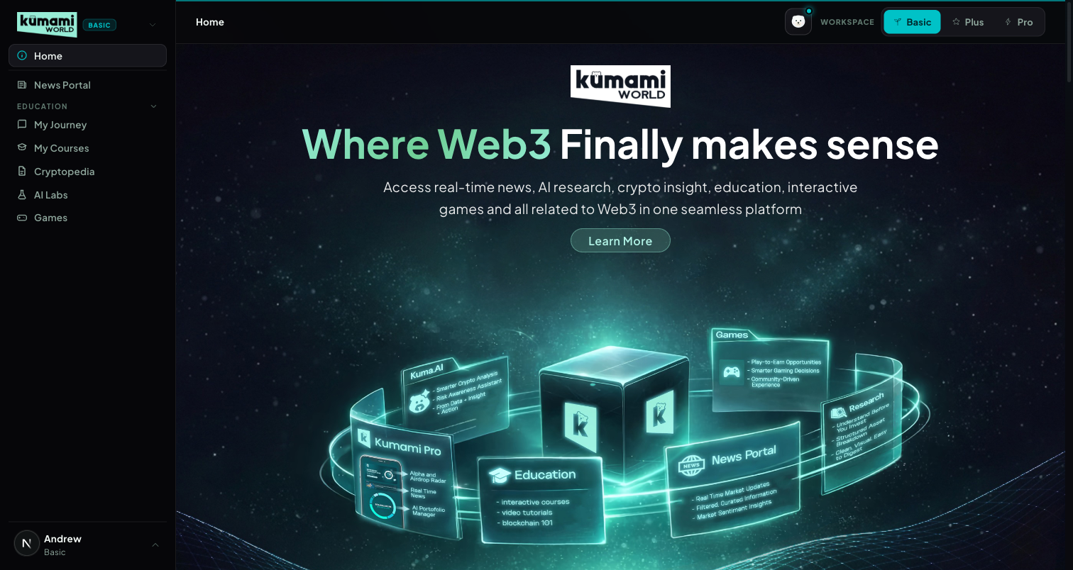
Figure: Home in Basic mode — sidebar shows Home as a standalone top item; page shows Hero → Ecosystem → Trending News → Numbers → Our Journey → FAQ → Partners → Contact → Footer.

How the user uses it
Land here after logging in, or click “Home” anytime to return. It's a scroll-and-read page: click “Learn More” in the hero to jump to the Ecosystem anchor; use the Trending News carousel's ‹ › arrows to browse recent headlines and click “Read More” to open the full article; click any Partner logo to open that partner's external site in a new tab; click “See more” under Our Journey to open the full Blogs grid; click a FAQ question to expand its answer; click “Join Our Community” to open the community CTA.

How we build it

Via API
None for the page shell itself — it's a stack of legacy marketing components with no page-level fetch.

Via Admin Dashboard (manual)
Its live sub-sections are each authored separately:
- Trending News strip — reads Firestore news (same collection/admin flow as News Portal, below).
- Our Journey blog highlight — reads Firestore blogs, authored at Content → Blog → Publish Blog (/admin/blog): Title, Read Time, Thumbnail/Detail images, Summary, Content Section 1/2 → Publish Blog or Save as Draft. Edit via Content → Blog → Edit Blog; drafts at Content → Blog → Blog Drafts.
- Partners strip — reads Firestore homepage_partners, authored at Management → Partners → Homepage Partners (/admin/homepage-partners) — a curated subset of the full directory (Management → Partners → All Partners).
Computed, not manually entered: the Total Users / Partners counters run a live Firestore .count() aggregation over the users and all_partners collections at request time — always the real current count, never hand-typed.
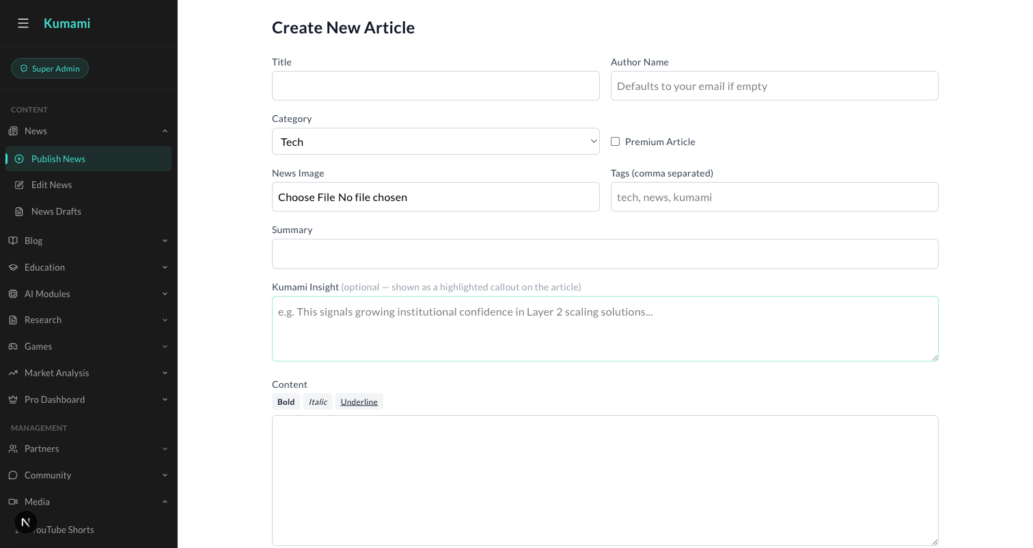
Figure: Content → News → Publish News — the admin form behind the Trending News strip and the News Portal below.
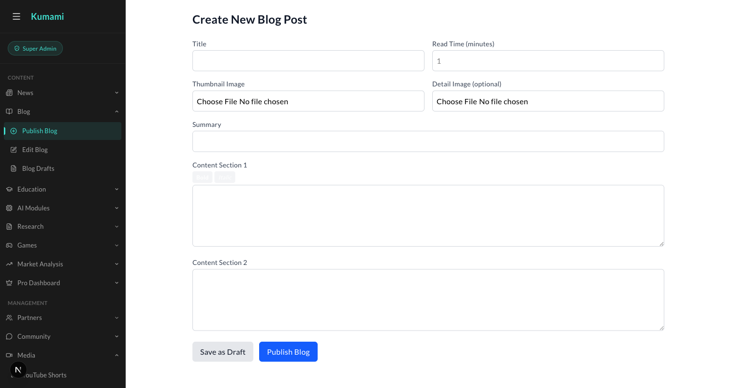
Figure: Content → Blog → Publish Blog — the admin form behind Home's Our Journey highlight.

2. News Portal
The daily crypto/Web3 news feed — hero, latest, and a river of stories.

What it is
The main news feed: a live ticker, a hero story, a ‘Latest’ aside, an upsell banner into Plus/Pro, and a river of further articles.

Where it is
Tier: Basic.
Nav path: Sidebar → News Portal (standalone item, directly below Home — not inside a group).
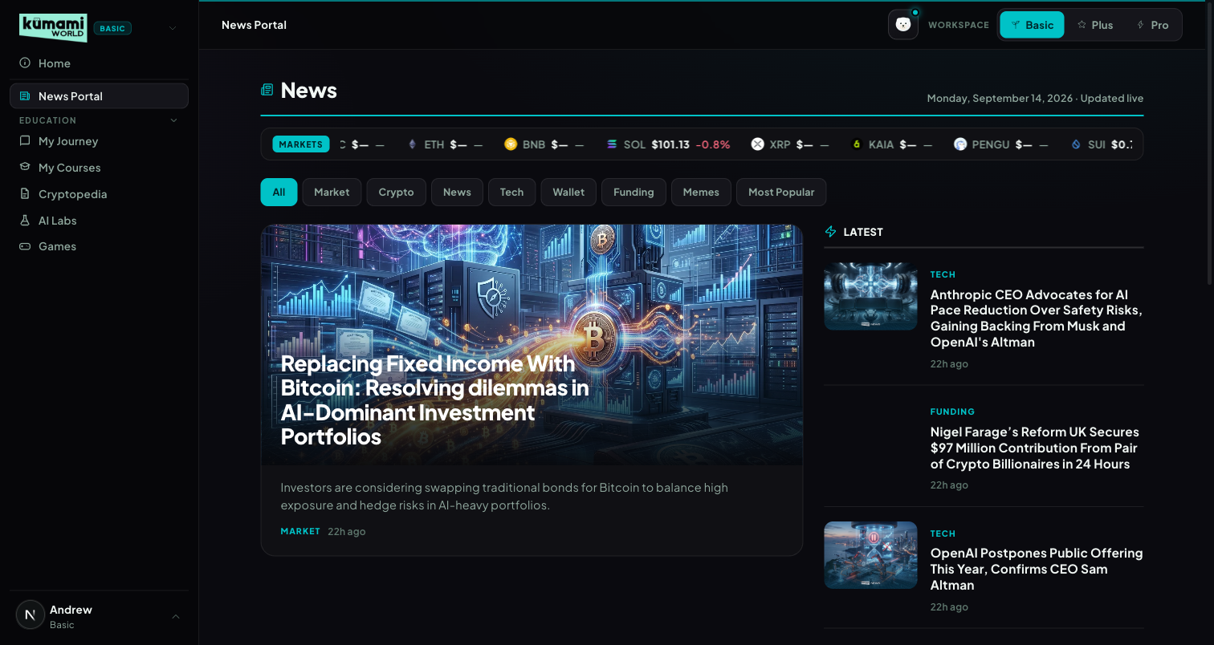
Figure: News Portal in Basic mode — live ticker, category pills, hero story, Latest aside.

How the user uses it
Read the live price ticker at the top; click a category pill (All / Market / Crypto / News / Tech / Wallet / Funding / Memes / Most Popular — pills are generated from whatever categories actually exist in Firestore, not hardcoded) to filter the river; click the hero image or headline, or any Latest/river card, to open the full article at /world/news/[id]; scroll past the “MORE NEWS” river grid and click “View all news” for the full paginated list. Articles flagged Pro in Firestore show a dimmed lock veil — clicking it routes to /world/pro instead of opening the article.

How we build it

Via Admin Dashboard (manual)
Firestore news, authored at Content → News → Publish News (/admin/news): Title, Author Name (defaults to your email if left empty), Category (dropdown), tick “Premium Article” to Pro-gate it, upload a News Image, comma-separated Tags, Summary, optional “Kumami Insight” callout box, then the main Content body → Publish. Edit existing articles via Content → News → Edit News (/admin/edit-news); unpublished work sits in Content → News → News Drafts (/admin/news-drafts).

Via API
Only the live ticker — 10 coins (BTC, ETH, BNB, SOL, XRP, KAIA, PENGU, SUI, DOGE, POL) pushed over a WebSocket (wss://tickerworker.kumamiworldapp.workers.dev/), a Cloudflare Worker proxying Binance's real-time @ticker stream — push-based, not a polling REST call, auto-reconnects 1s after any drop.
Figure: Content → News → Publish News — the exact form used to author every News Portal article.

3. Education — My Journey & My Courses
Two tabs, one underlying engine: a first-timer intro that becomes a personal dashboard once you start.

What it is
Basic's learning system: 5 fixed levels totaling 65 lessons (~19 hours), each tracked per-user at chapter and section granularity. ‘My Journey’ is a smart tab — first-time visitors see an intro/level-picker; anyone with any progress sees the Dashboard experience instead, automatically, with no separate setting to toggle.
# | Tag | Title | Badge | Duration | Chapters
1 | Beginner | Start Here | First Steps | 2h 10m | 7
2 | Elementary | Understand What You Just Bought | Under the Hood | 3h 40m | 12
3 | Intermediate | Learn to Trade | Sharp Eye | 5h 05m | 17
4 | Advanced | Think Like an Investor | Market Mind | 3h 55m | 12
5 | Expert | Go Deeper | Web3 Native | 4h 20m | 12

Where it is
Tier: Basic.
Nav path: Sidebar → Education (collapsible group) → My Journey, or Sidebar → Education → My Courses.
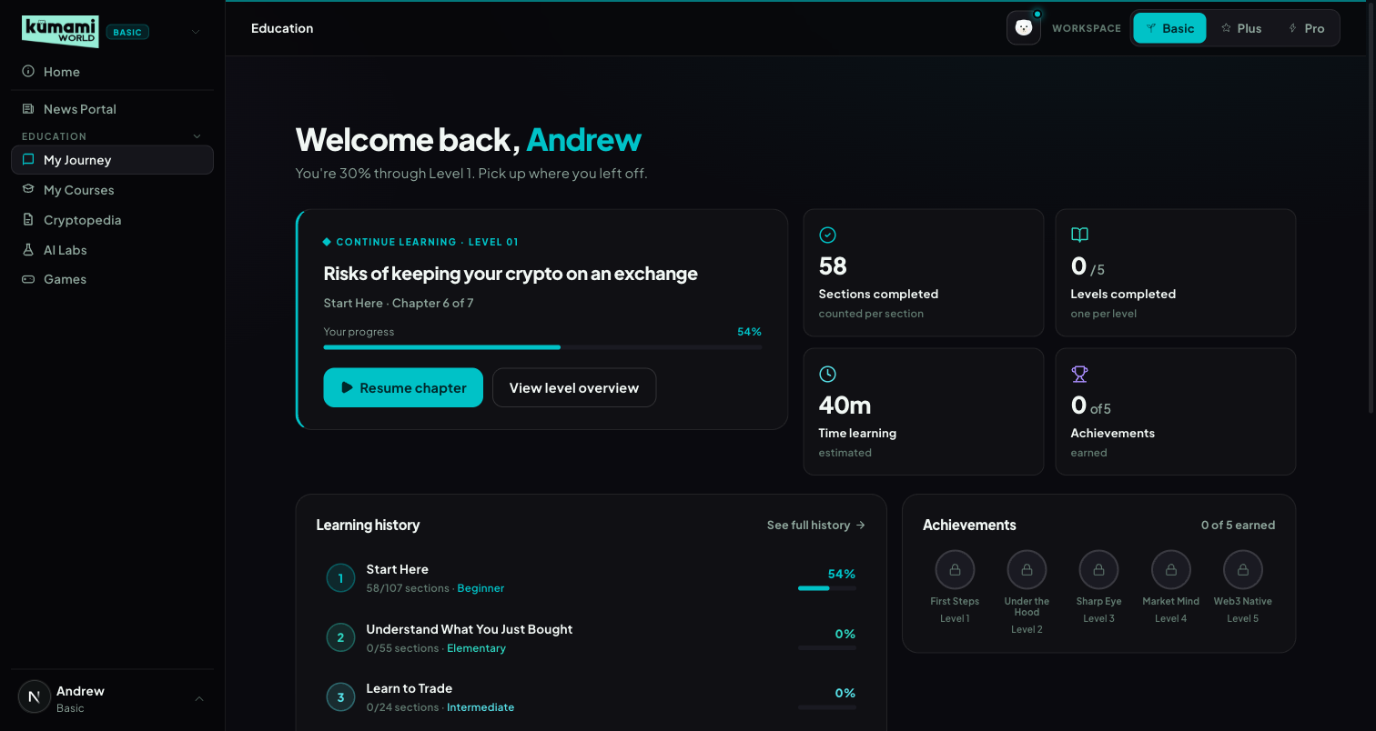
Figure: My Journey, returning-user Dashboard state — welcome banner, Continue Learning card, stats, learning history, achievements.
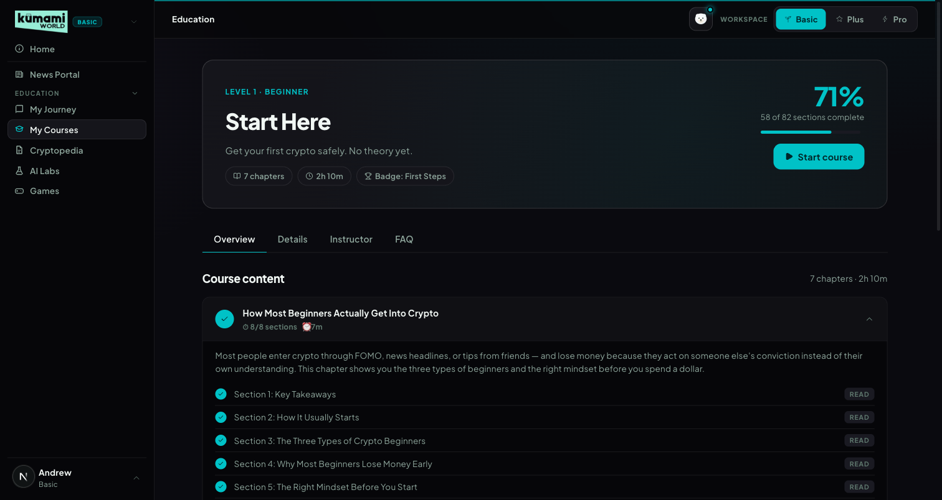
Figure: My Courses, Level 1 detail — progress bar, Overview/Details/Instructor/FAQ tabs, chapter accordion with per-section Read checklist.

How the user uses it
First-time state (My Journey): click a level card, or the “Start Level 1” CTA, to begin. Returning state (My Journey): the same tab now shows a Dashboard — click “Resume chapter” on the Continue Learning card to jump straight back into the exact chapter/section left off, or “View level overview” to see the full level. My Courses: pick a level (via the level cards or the ?level=1-5 URL), work through the Overview tab's chapter accordion, click “Read” on each section to mark it complete, and switch to Details / Instructor / FAQ for the level blurb, instructor bio, and the FAQ (which states plainly that all 5 levels are completely free).

How we build it

Via Admin Dashboard (manual)
Chapter content lives in Firestore education_articles, authored at Content → Education → Publish Education (/admin/education): choose Level (dropdown, Level 1-5) and Chapter position (0-based index — sets ordering within that level; the article title becomes the chapter name), Author, Read time, tick “Featured lesson” or “Coming soon” (placeholder, no content yet) as needed, Blurb (1-2 sentence card summary), Description (SEO meta), Thumbnail, then build the body in Content Sections using either the Classic or TipTap editor — a Live Preview panel mirrors the breadcrumb and content live as you type. Edit via Content → Education → Edit Education; drafts sit at Content → Education → Education Drafts.

Via API
None — progress is per-user Firestore state, not an external fetch. Stored at users/{uid}/education_progress/{levelNum} (falls back to localStorage when logged out). Progress % is section-based, not chapter-based: pct = round(completedSections / totalSections × 100), summed per level and overall on the Dashboard.
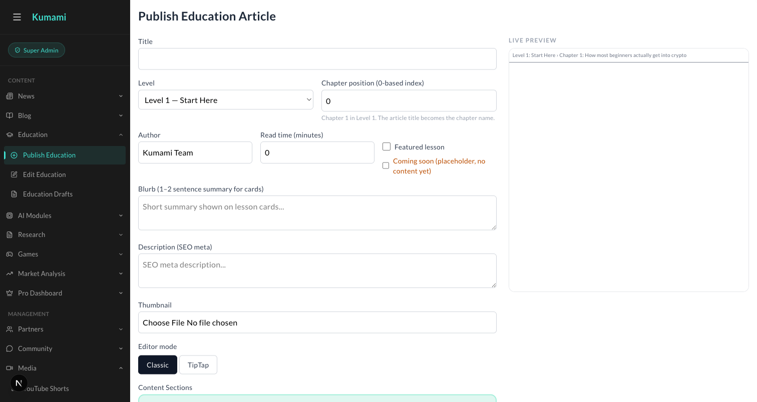
Figure: Content → Education → Publish Education — Level dropdown, Chapter position, Content Sections editor with Live Preview.

4. Cryptopedia — Tokenpedia & Glossary
An onchain asset directory and a plain-language glossary, unified under one capsule selector.

What it is
A reference-desk tab with an underline-style capsule toggle between two views: Tokenpedia (?view=tokenpedia, default) and Glossary (?view=glossary).

Where it is
Tier: Basic.
Nav path: Sidebar → Education (group) → Cryptopedia — its own item alongside My Journey/My Courses inside the same group.
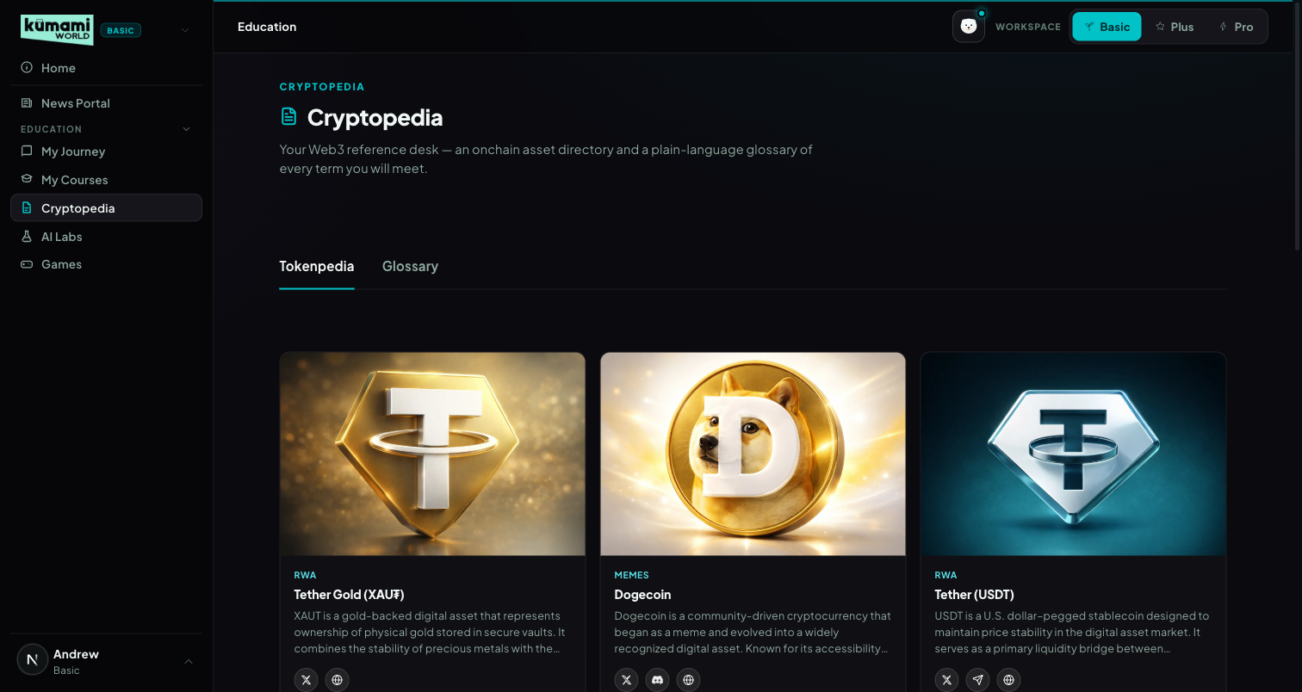
Figure: Cryptopedia → Tokenpedia view — card grid of on-chain assets/projects with social links.
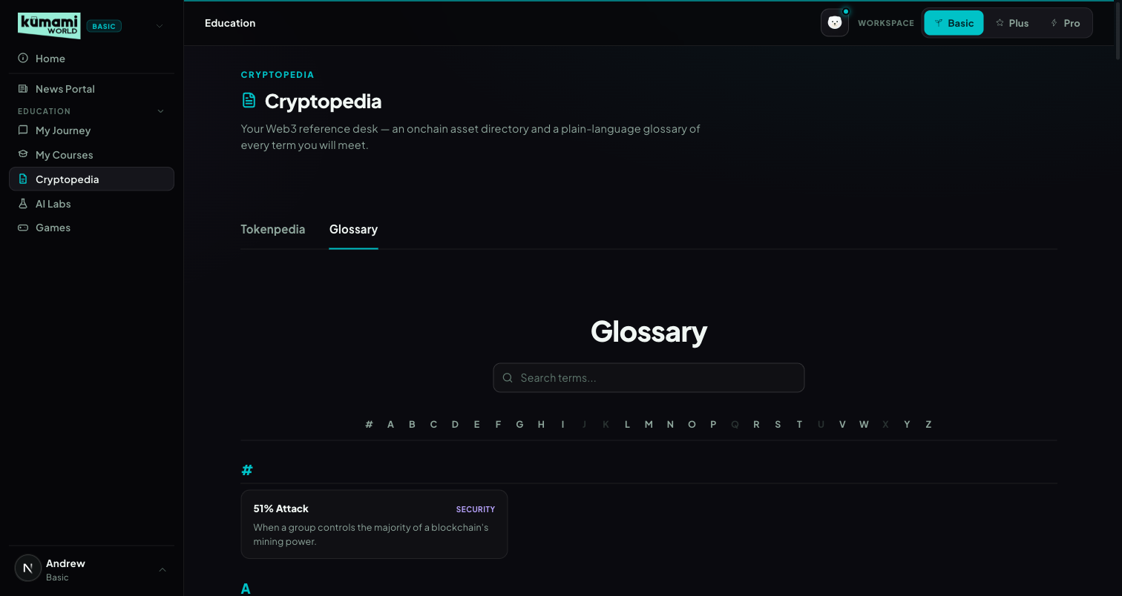
Figure: Cryptopedia → Glossary view — searchable, A–Z indexed term list.

How the user uses it
Land on Tokenpedia by default — click any project card to open its detail page (/world/research/[id]) with its description and X/Discord/Telegram/Website links. Click the “Glossary” capsule to switch views; type in the search box (matches term/definition/category) or click a letter in the A–Z index to jump; click any term to open its detail page (/world/glossary/[id]).

How we build it

Tokenpedia — Via Admin Dashboard (manual)
Firestore research_articles, authored at Content → Research → Publish Research (/admin/research): Title, Author, Category (dropdown, e.g. “Web 3 Platform”), Research Image (Main), Short Description, one or more Content Sections, optional Detail Image 2 → Publish. Edit via Content → Research → Edit Research; drafts at Content → Research → Research Drafts.

Glossary — Via Code only
No admin panel today: a fully static file, src/data/glossaryData.ts — 147 hardcoded {id, term, category, definition} entries, no Firestore involved. Adding or editing a term currently requires a developer to change that file and deploy — there is no admin UI for it. Flagged here as a gap if the team wants to manage terms without a developer.
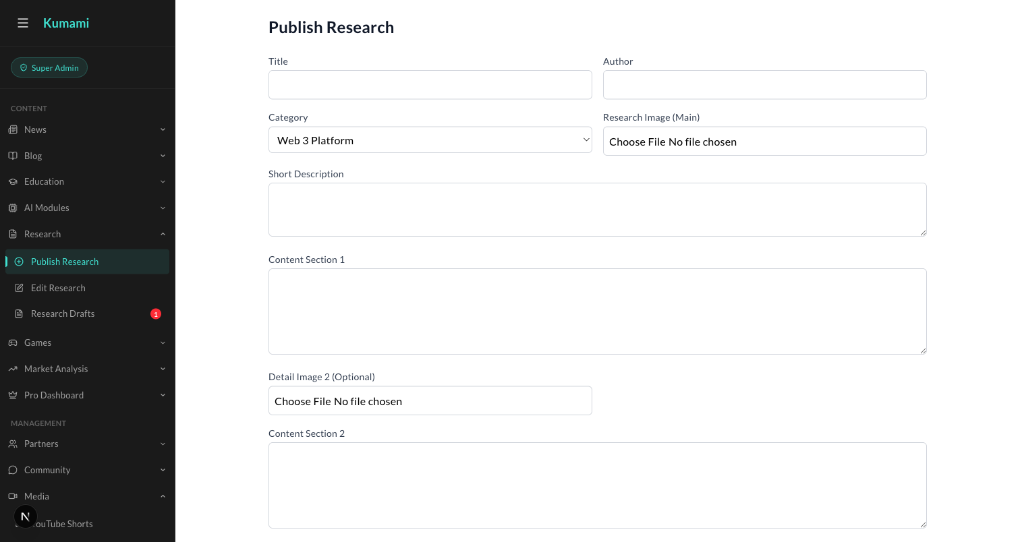
Figure: Content → Research → Publish Research — the admin form behind every Tokenpedia card.

5. AI Labs
A marketing placeholder for an upcoming AI + Web3 hub — no live tools yet.

What it is
An informational page previewing 3 planned features. 100% static — a hardcoded featureCards array, no Firestore, no API.

Where it is
Tier: Basic.
Nav path: Sidebar → AI Labs (standalone item, below the Education group).
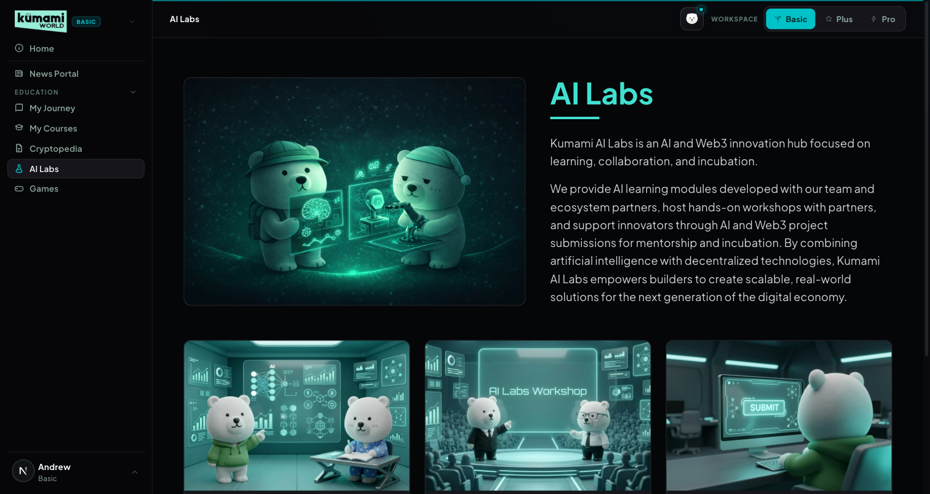
Figure: AI Labs — hero + intro copy, 3 “Coming Soon” feature cards (Module, Workshop, Submission).

How the user uses it
Read-only today — scroll through the hero and the 3 feature cards. Each card's button is disabled and reads “Coming Soon”; there is no interactive action to take yet.

How we build it

Via Code only
A hardcoded featureCards array inside the page component. No Firestore, no API, no admin panel — any copy or card change requires a developer to edit the code and deploy.

6. Games
An interactive-learning games catalog with a featured carousel and category rails.

What it is
A games portal: a featured carousel plus category-filtered rails (Most Popular, Free to Play, Coming Soon).

Where it is
Tier: Basic.
Nav path: Sidebar → Games (standalone item, bottom of the Basic sidebar).
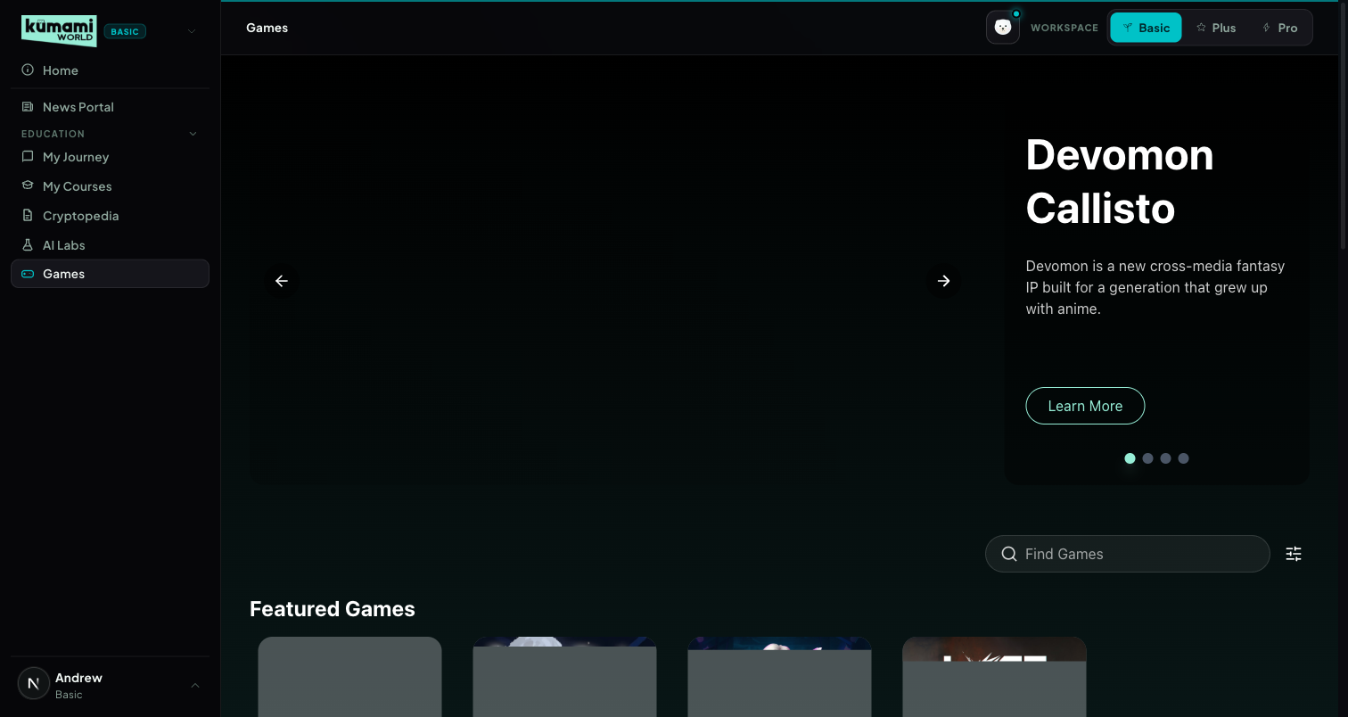
Figure: Games — featured carousel, search + platform filter, category rails below.

How the user uses it
Browse the auto-advancing featured carousel (every 8s) or use the ‹ › arrows / pagination dots to control it manually; type in “Find Games” to search by title/tagline/genre/platform, or open the filter icon to tick a Platform (PC / Website / Mobile App); scroll the All Games, Most Popular, Free to Play, and Coming Soon rails below; click any game card to open its detail page (/world/games/details?name=<title>); click “View More” on the All Games rail to see the full catalog.

How we build it

Via Admin Dashboard (manual)
Firestore games, authored at Content → Games → Publish Games (/admin/games): Game Title, Tagline, Genres (checkboxes), Networks (checkboxes), Platform Types (checkboxes), Categories (Featured / Free to Play / Most Popular / Coming Soon — checkboxes), Released On date, plus multiple image variants (portrait/catalog/landscape/detail/carousel) → Publish. Edit via Content → Games → Edit Games; drafts at Content → Games → Game Drafts.

Via API
None.
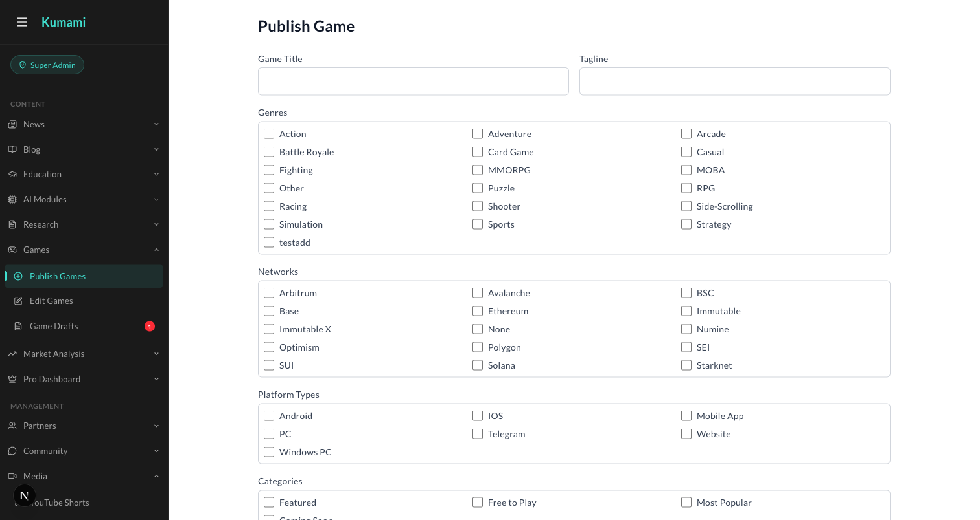
Figure: Content → Games → Publish Games — the admin form behind every Games catalog entry.

7. Terms & cookies
The Terms page and the cookie banner every visitor sees.

What it is
The team's Terms & Conditions (supplied by Andrew's team, shown as written) and a cookie-consent banner that controls Google Analytics. There is no Privacy Policy page yet.

Where it is
Tier: everyone, signed in or not.
- Terms: /terms (public, with the site footer) and /world/terms (inside the shell).
- Cookie banner: bottom of the screen on any page until the visitor answers. Reopened from “Cookie settings”.
- Links: landing page (Terms · Cookie settings under the copyright), site footer (Company → Terms, Cookie settings), sidebar brand menu (Company → Terms of Service), and a small links-only footer at the bottom of every /world page (Terms · Cookie settings).

How the user uses it
- First visit: the banner explains that sign-in cookies are needed and asks about analytics cookies. “Accept analytics” starts Google Analytics; “Reject analytics” keeps it off and deletes the _ga cookies. The choice is saved in the browser.
- Terms: open the link to read the team's Terms & Conditions.

How we build it

Via API
None. src/components/TermsContent.tsx reads Firestore app_config/terms_and_conditions (title + markdown content) in the browser; the banner is src/components/legal/CookieConsent.tsx with src/lib/consent.ts.

Via Admin Dashboard (manual)
The Terms text lives in app_config/terms_and_conditions (admin-writable). Only Andrew's team supplies its wording.

Known gaps
- No Privacy Policy page: the text has to come from Andrew's team (to-do proposed).
- No company details, refund wording, referral rules wording or disclaimer wording on the site; all to be supplied by Andrew's team (to-dos proposed).
- The rest of the 20-item legal checklist (data export, breach plan, licences, DMCA, sanctions) is on the roadmap only — docs/legal/2026-10-14-compliance-audit.md.

8. Account deletion
Lets any signed-in user permanently delete their Kumami account themselves, as GDPR/CCPA and the Apple and Google app stores require.

What it is
A “Delete my account” panel at the bottom of Profile. After a confirmation step it deletes the account and the user’s personal data at once, keeps the payment records the law requires, and signs the user out.

Where it is
Tier: every signed-in user (Basic, Plus, Pro).
- /world/profile → Profile tab → “Delete my account” (red panel under Account Information).
- After deleting, the user lands on the landing page with “Your Kumami account has been deleted.”

How the user uses it
- Click “Delete my account”. The panel lists what is deleted and says payment and invoice records (without name or email) are kept.
- Warnings appear when they apply: “Your card subscription is cancelled now and your Pro access ends.”, “Your remaining Pro time is lost.”, and a lost referral balance.
- Type DELETE (exactly) and enter the password. Google accounts confirm with the Google sign-in popup instead. The “Permanently delete my account” button stays disabled until both are done. Cancel closes the panel.
- A wrong password or a closed popup shows an error and deletes nothing.
- Staff accounts (any role other than user) see “This is a staff account. Ask a superadmin to remove your admin role first…” and no button.

How we build it

Via API
DELETE /api/v1/me (website and Flutter app). It needs a Firebase ID token from a sign-in in the last 5 minutes (auth_time); otherwise 401 reauth_required. Staff get 403 staff_account. Order: cancel a live Stripe subscription (immediately, no refund) → revoke sessions → delete Firestore data → delete the Auth user. If Stripe can’t be cancelled nothing is deleted, so the user can retry.
- Deleted: users/{uid} with all subcollections (education_progress, pro/state, watchlist, chatrooms + messages), user_prefs/{uid}, watchlists/{uid}, the user’s alerts and referralCodes, and the Firebase Auth user.
- Kept (uid only, no name or email): payments, checkout_orders, subscriptions, webhook_events, referral_rewards, referral_ledger, admin_audit.
- Webhooks and the Kuma callback never recreate a deleted user’s doc: a payment that arrives later is still recorded, but no user fields are written.

Via Admin Dashboard (manual)
None. Admin pages are unchanged.

Known gaps
- No self-serve data export yet (email request).
- No grace period or undo: deletion is immediate.
- No confirmation email is sent after deletion.
- Pro Events Q&A questions are anonymous and stay (they have no user id).
- The Stripe customer record stays in Stripe (needed for invoices); only the subscription is cancelled.

Kumami Plus
Kumami Plus is the “Advanced” tier — a fixed 5-asset universe (BTC, ETH, SOL, BNB, HYPE) across 7 tools in the sidebar: Console, On-Chain Insights, Flow Radar Plus, Fear & Greed, Calendar, Watchlist Plus and Settings. Every panel runs through the same 4-stage pipeline: (1) live data fetched from the CoinGlass v4 API, (2) cached briefly and shared across panels, (3) fed into a rule engine that converts raw numbers into a verdict + color using fixed thresholds, and (4) rendered. The interpretation layer — not the data — is the product. The cache never serves stale data: if an upstream call fails, that panel shows “No data” rather than old numbers or a $0 / 50 / neutral placeholder. Flow Radar Plus (its own tab and the Console feed) shows the feed as it was 15 minutes ago — for every account, Pro included (FREE_TIER_DELAY_MINUTES, served from saved snapshots); other panels are not delayed. Pro removes the delay and widens the asset universe (see the Kumami Pro section). Spot Pulse has no tab of its own — it lives inside On-Chain Insights (§2.9) and on the Console; Intelligence was removed from the navigation on 21 Sep 2026 (§7).
Plus vs Pro versions (since v1.7): Flow Radar, Watchlist and Spot Pulse each exist in a cut-down Plus version (Plus pages, every account) and a complete, real-time Pro version (Pro → Tools: Flow Radar Pro, Watchlist Pro, Spot Pulse Pro, subscribers only). Plus pages always behave as Plus — Pro accounts and admins see exactly what Plus users see there.
Navigation (since 10 Oct 2026): each workspace's sidebar shows only its own tier — Basic shows Basic, Plus shows Plus, Pro shows Pro (Home stays at the top in all three). The workspace follows the page: opening any page switches the Basic / Plus / Pro toggle to that page's tier, and switching the toggle jumps to that workspace's home page (Basic → My Journey, Plus → Console, Pro → AI Portfolio). Shared pages (Home, About, Blogs, Profile) keep the current workspace.

1. Console
The 10-second daily briefing — aggregates every other Plus tool onto one screen.

What it is
The first screen Plus users land on. Fuses market sentiment, four macro tiles, five per-asset regime chips, and live previews of Spot Pulse, Flow Radar, a mini month Calendar and the Watchlist — all in one scroll, zero extra clicks. A “Needs your attention today” popup flags high-impact events landing in the next 24 hours.

Where it is
Tier: Plus.
Nav path: Sidebar → Plus (group) → Console. Console is also the landing page you reach first when you switch to the Plus workspace.
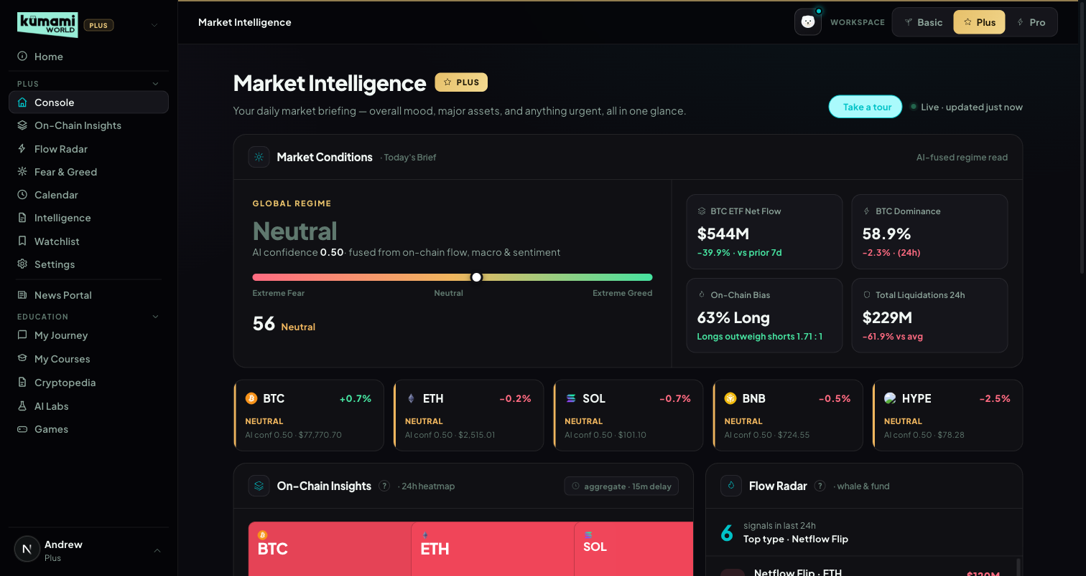
Figure: Console — Market Conditions regime, 4 macro tiles, 5 asset regime chips, and preview panels below.

How the user uses it
Scroll top to bottom for the full briefing: read the Global Regime word and confidence score, glance at the 4 macro tiles (BTC ETF Net Flow, BTC Dominance, On-Chain Bias, Total Liquidations 24H), check each of the 5 asset regime chips (BTC/ETH/SOL/BNB/HYPE), then use the preview panels below (Spot Pulse, Flow Radar, Calendar, Watchlist) as jump-off points — each has an “Open X →” link into its full tab. If the attention popup appears, read it and click Dismiss (it won't show those events again in this browser).

How we build it

Via API

1.1 Market Conditions — Global Regime & Fear/Greed
Data in: Kumami's own Fear & Greed index (0–100, Plus §4 — v1.18: the same cached payload as the Fear & Greed page, so the Console shows the same number, label and colour), 7-day BTC/ETH ETF flow direction, OI-weighted funding rate, OI-vs-price trend.
API: Fear & Greed: the Plus §4 composite (lib/market/fearGreedIndex) · /api/etf/bitcoin/flow-history · /api/etf/ethereum/flow-history · /api/futures/funding-rate/oi-weight-history · /api/futures/open-interest/aggregated-history · /api/futures/pairs-markets
How it's calculated: 4 inputs, scored as in the table (Fear & Greed can score ±1.5 at the extremes, the others −1/0/+1), summed, then NORMALIZED by dividing by the count of non-zero (“active”) signals, so the verdict stays meaningful when some signals are neutral. Long/Short bias is intentionally NOT part of this composite — it still drives the standalone On-Chain Bias macro tile below, just not this score. Follows Rachelle's Plus §1.1 exactly since v1.19 (17 Oct 2026).
Signal | Scoring
Fear & Greed | 0–24 → +1.5 · 25–45 → +1 · 46–55 → 0 · 56–74 → −1 · 75–100 → −1.5 (contrarian, weighted at the extremes)
ETF Flow (7D) | 7-day cumulative > +$100M → +1 · within ±$100M → 0 · < −$100M → −1 (BTC and ETH chips; 0 for coins without an ETF)
Funding Rate | > +0.10% → −1 (overheated long) · −0.05%…+0.10% → 0 · < −0.05% → +1 (crowded short, contrarian bullish). The feed is already in percent.
OI vs Price | OI up + price up → +1 · OI up + price down → −1 (overleveraged) · everything else → 0 (OI up + flat, short covering, unwind)
Normalized score = (sum of the 4 scores) / (count of non-zero scores). Verdict bands on the NORMALIZED score:
Normalized score | Verdict | Color
≥ +0.60 | Strongly Bullish | green
+0.25 to +0.60 | Cautiously Bullish | grey-green
−0.25 to +0.25 | Neutral | grey
−0.60 to −0.25 | Cautiously Bearish | grey-red
< −0.60 | Strongly Bearish | red
Confidence = share of the ACTIVE (non-zero) signals that agree with the winning direction (an extreme Fear & Greed counts as one signal).
One confidence rule (v1.18, Rachelle v1.17 Plus §1) for the Global Regime and every coin chip, replacing the HYPE-only cap: 0 active signals → “Neutral · Low Signal”; 1–2 active signals → “Leaning Bullish / Bearish” at most (“Neutral · Low Signal” under 0.60) — two agreeing signals read as 100% on thin evidence, so never the full verdict; 3–4 active signals → ≥ 0.75 full verdict · 0.60–0.75 “Leaning …” · < 0.60 “Neutral · Low Signal”. Opposing signals that cancel out read “Neutral”. Code: rules/regime.confidenceVerdict (unit-tested).
Sentiment extremes are contrarian; fusing 4 independent signals reduces false-confidence single-indicator whipsaws.
AI read (v1.16, Rachelle v1.15 Plus §1). Off until Gemini billing is switched on (AI_ENABLED=true). Until then the spot under the Global Regime says “AI read · coming soon” — no template sentence is shown in its place (Andrew's hard rule, 22 Oct 2026: never show a stand-in that reads like real analysis). When on, the AI layer (Pro §23) writes two short sentences from the verdict, confidence, Fear & Greed, 7-day ETF flow, % long and 24h liquidations (cached 20 min per rounded set of inputs); it restates the verdict, never changes it, and hover says so. If a call fails it says “AI read unavailable right now”. The confidence line reads “Confidence … from Fear & Greed, ETF flows, funding and open interest” and the panel header “Rule-based regime read” — they used to say “AI confidence” / “AI-fused”, but this is rule maths.

1.2 Macro Tiles (4 tiles)
Tile | API | Calculation | Refresh
BTC ETF Net Flow | /api/etf/bitcoin/flow-history | Sum of last 7 daily flows vs. the prior 7-day window; “$X · +Y% vs prior 7d” | daily, after US close
BTC Dominance | CoinGecko /api/v3/global (free, no key) | BTC's share of total crypto market cap + 24h market-cap-wide change. Rising = risk-off; falling = risk-on/alt-season. | 15 min
On-Chain Bias | /api/futures/global-long-short-account-ratio/history (BTC-USDT, 1h) | % long + ratio, both derived from the same API response row | 15 min
Total Liquidations 24H | /api/futures/liquidation/coin-list + /api/futures/liquidation/aggregated-history | 24h liquidations across all coins vs. trailing hourly average; “$X · ±Y% vs 7D avg” | 15 min

1.3 Regime Chips — BTC / ETH / SOL / BNB / HYPE
One card per asset — price, 24h change, the same fused regime engine as 1.1 scoped to that asset, its own confidence score, and (v1.18) the same label rule as the Global Regime: chips show “Leaning Bullish / Bearish” and “Neutral · Low Signal”, not just Bullish / Neutral / Bearish. Fetched via /api/futures/pairs-markets (one call per coin; the batched endpoint is locked on our plan) plus the same funding/OI/L-S endpoints, scoped per asset. Each asset runs the engine independently. The HYPE 0.70 cap was removed in v1.18 (replaced by the signal-count rule). Refreshes every 5 minutes.

1.4 Preview Panels
Preview | Logic | Footer
Spot Pulse preview | The same 5 Spot Pulse tiles as On-Chain Insights §2.9 (asset, verdict, price move) | “Open Spot Pulse →” (On-Chain Insights)
Flow Radar preview | Latest events from the shared Flow Radar feed (15-min delay for non-Pro), coloured by lean | “Open Flow Radar →”
Calendar preview | Mini month calendar of Calendar Plus (§5, v1.18): today highlighted, one coloured dot per event kind on each day (same colours as the Calendar), month arrows, and the next 3 upcoming events below | “Open Calendar →”
Watchlist preview | The same fixed 5-asset roster as the Watchlist tab (§6), most notable signal first, “Quiet” assets last | “Open Watchlist →”
Retired on 21 Sep 2026: the Intelligence preview (replaced by the Calendar preview) and the separate “Radar Watchlist” auto-pick engine, which could show different assets than the real Watchlist. Console and the Watchlist tab now read the same data, so they can never disagree.

1.5 “Needs your attention today” popup
Fires when Console loads if a team-added Calendar Plus event is HIGH impact, starts within the next 24 hours, and hasn't been dismissed in this browser (v1.16: team-added HIGH events only — the Calendar is manual-first, Rachelle v1.15 Plus §5; feed events never trigger it). Lists up to 5 such events with a countdown (“In 3h”). Dismiss hides those events for good (localStorage). Same rule as the Calendar's own D-1 popup (§5). Not built: the mockup's airdrop “you are eligible” line — there is no per-user eligibility data, so it would be fabricated.

1.6 Console badge
Built in v1.16 (Rachelle v1.15 Plus §1.5, from Calendar §7.4). A team-added HIGH Calendar event that starts within the next 6 hours shows as an amber badge at the top of the Console: “{event title} in 4h — expect volatility” (under an hour: “in 35m”), with “+N more” when several qualify. Clicking it opens the Calendar. All-day events and events that already started are left out; the countdown updates every minute. Code: consoleBadgeEvents / badgeCountdown in src/lib/market/rules/calendarEvents.ts, component src/components/world/panels/ConsoleEventBadge.tsx.

2. On-Chain Insights
Market-structure deep dive per asset — 8 independent panels plus the Spot Pulse verdict grid.

What it is
Selectable asset (BTC/ETH/SOL/BNB/HYPE) and range (24H/7D/30D) driving 8 independent panels, each a chart + verdict tag + one-line headline, plus the embedded Spot Pulse panel (§2.9). Every panel is wrapped in its own try/catch — a failing endpoint degrades just that one panel to “No Data” rather than failing the page.

Where it is
Tier: Plus.
Nav path: Sidebar → Plus (group) → On-Chain Insights.
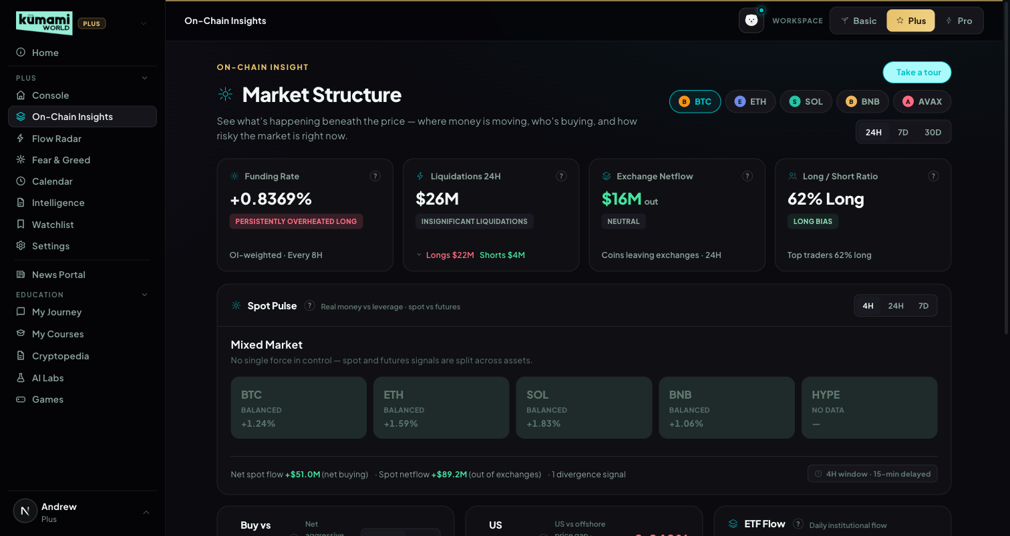
Figure: On-Chain Insights — asset/range selector, Funding Rate / Liquidations / Exchange Netflow / Long-Short tiles, and the embedded Spot Pulse panel.

How the user uses it
Pick an asset tab (BTC/ETH/SOL/BNB/HYPE — HYPE replaced AVAX in v1.16; HYPE has no exchange-balance data, so its Netflow panel shows “No data”) and a range (24H/7D/30D) at the top — every panel below re-fetches for that selection. Read each panel's colored verdict tag and one-line headline first; expand into the mini trend chart for detail. The banner reads “Data delayed 15 min · Upgrade to Pro for real-time.”

How we build it

Via API

2.1 Funding Rate
What it is: the recurring fee leveraged perpetual traders pay to hold a position — a direct read of crowd positioning.
API: /api/futures/funding-rate/oi-weight-history (OI-weighted, aggregated across exchanges). Cache: 300s.
How it's calculated: bands on the 3-cycle average funding rate (Rachelle v1.15 Plus §2.1 — continuous bands, no holes; “Mild Short Bias” removed in v1.16); a “Persistently” modifier applies if the current band is extreme AND the last 3 cycles were all extreme in the same direction; a “· Rising Fast” tag fires if the 24h delta > +0.05%, or “· Unwinding” if an extreme reading is moving back toward zero. Scale: the feed is already in percent (BTC 0.0066 = 0.0066%). Until v1.16 this page multiplied it by 100, so normal funding read as Overheated Long — fixed.
3-cycle avg funding rate | Verdict | Color
> +0.15% | Overheated Long | red
+0.05% to +0.15% | Crowded Long | amber
−0.05% to +0.05% | Neutral | grey
−0.10% to −0.05% | Crowded Short | amber
< −0.10% | Extreme Short | green
What the user sees: Funding {rate}% — {verdict} headline, “OI-weighted · Every 8H” cadence label, mini trend chart. Persistently one-sided funding is a classic squeeze setup — traders paying to stay positioned signals crowding, not conviction.

2.2 Exchange Netflow
v1.16 (Rachelle v1.15 Plus §2.2): the panel opens on 7D. On the page's 24H range it reads the 7-day exchange-balance change and says “· 7D (updates daily)” — CoinGlass exchange balances update once a day, so a 24-hour window usually compares a value with itself. A zero change still shows “Updates daily”.
What it is: whether coins are leaving exchange wallets (accumulation/bullish) or arriving (distribution/bearish).
API: /api/exchange/balance/list + /api/exchange/balance/chart. Cache: 600s.
How it's calculated: netUsd = −(balance change) × price (positive = net outflow = accumulation).
Net flow | Verdict | Color
≥ +$1B | Strong Accumulation | green
+$200M to <+$1B | Accumulation | green
>+$50M to <+$200M | Mild Accumulation | grey-green
−$50M to +$50M | Neutral | grey
<−$50M to >−$200M | Mild Distribution | grey-red
−$1B to ≤−$200M | Distribution | red
≤ −$1B | Heavy Distribution | red
Divergence tags (when flow is accelerating, |netUsd| > $50M, and price is moving): price up + net inflow → “Distribution into Strength” (red) · price down + net outflow → “Accumulation on Dip” (green) · price up + net outflow → “Conviction Rally” (green) · price down + net inflow → “Panic Selling” (red).
What the user sees: “{$X}M net {in/out}” colored bull/bear, verdict tag, “Coins leaving/arriving exchanges · {range}”, chart of total exchange balance (falling = bullish). Combines the flow direction with price context so a move can be read as conviction vs. panic, not just “up” or “down”.

2.3 Long/Short Ratio
What it is: how crowded the perpetual long/short trade is, plus whether top traders are positioned differently from the crowd.
API: /api/futures/global-long-short-account-ratio/history + /api/futures/top-long-short-account-ratio/history (Binance). Cache: 300s each.
Global % long | Verdict | Color
> 75% | Extremely Crowded Long | red
65–75% | Crowded Long | amber
55–65% | Long Bias | grey-green
45–55% | Balanced | grey
35–45% | Short Bias | grey-red
25–35% | Crowded Short | amber
< 25% | Extremely Crowded Short | green
Smart-money divergence: gap = top-trader %long − global %long. gap < −15 → “Smart Money Fading the Crowd” (amber); gap > +15 → “Smart Money Leading Long” (green); |gap| ≤ 15 → no tag.
What the user sees: “Long {X}% / Short {100−X}% — {verdict}”, a global vs. top-trader % line overlay, and the divergence tag when present. A crowded trade is fragile; when “smart money” diverges from the crowd, that's historically a more reliable signal than the crowd's own position.

2.4 Buy vs Sell Pressure (CVD)
What it is: whether a price move is backed by real aggressive buying/selling (Cumulative Volume Delta) or is hollow/liquidity-driven.
API: /api/futures/aggregated-cvd/history + /api/spot/aggregated-cvd/history. Cache: 300s each.
Price | CVD | Verdict | Color
Up | Up | Buyer-Led Rally | green
Up | Flat | Liquidity-Driven Rally | amber
Up | Down | Distribution Rally | red
Down | Down | Seller-Led Decline | red
Down | Flat | Forced Liquidation Decline | amber
Down | Up | Accumulation Decline | green
Flat | any | Neutral CVD Signal | grey
Spot-vs-futures divergence tag: futures up + spot flat/down → “Speculative Move — Spot Not Confirming” (amber); spot up + futures flat → “Organic Move — Spot Leading” (green).
What the user sees: dual chart of CVD vs. price with a shaded divergence region; a Futures/Spot toggle switches the charted CVD series. This is the single clearest “is this rally real” read on the platform.

2.5 US Demand Premium (Coinbase Premium)
What it is: the price gap between Coinbase (US demand) and the global average BTC price. Always computed on BTC regardless of the selected asset tab.
API: /api/coinbase-premium-index. Cache: 300s.
Premium | Verdict | Color
> +0.3% | Strong US Premium | green
+0.1% to +0.3% | Mild US Premium | grey-green
−0.1% to +0.1% | Neutral | grey
−0.3% to −0.1% | Offshore Leading | amber
< −0.3% | US Discount | red
Cross-signal overrides (using the shared exchange-flow direction from §2.2): Strong US Premium + exchange outflow → “Institutional Accumulation Signal” (green); US Discount + exchange inflow → “Retail Distribution Signal” (red). 7-day trend tags: sustained positive streak → “Sustained Institutional Demand”; flips positive → “US Demand Returning”; flips negative → “US Demand Fading.”
What the user sees: a premium % stat colored bull/bear, a verdict chip, a zero-lined trend chart, and Avg/Trend stats. One of the earliest tells for a genuinely new market regime.

2.6 ETF Flow
What it is: daily net creation/redemption flow through US spot BTC/ETH ETFs.
API: /api/etf/bitcoin/flow-history (BTC) or /api/etf/ethereum/flow-history (ETH). Cache: 900s.
Shown for BTC and ETH only (v1.16). They are the only coins with ETF data. Until 22 Oct 2026 SOL, BNB and HYPE silently showed the Bitcoin ETF numbers under a plain “ETF Flow” title; they now have no ETF panel, and the middle row shows two panels (Buy vs Sell Pressure and US Demand Premium). The API returns a neutral “No spot ETF data” panel for them without fetching ETF flows.
Daily flow | Verdict | Color
≥ +$500M | Heavy Institutional Buying | green
+$100M to <$500M | Solid ETF Inflow | green
+$10M to <$100M | Mild Inflow | grey-green
−$10M to <+$10M | Neutral Flow | grey
−$100M to >−$10M | Mild Outflow | grey-red
−$500M to >−$100M | ETF Redemptions | red
≤ −$500M | Heavy Institutional Exit | red
A separate 7-day cumulative verdict is shown as the headline stat (Sustained Institutional Accumulation > +$1B down to Sustained Institutional Distribution ≤ −$1B). Cross-signal tags (can stack): daily ≥$500M + rising Coinbase premium → “Dual Institutional Signal”; daily ≤−$500M + exchange inflow → “Institutional Exit Confirmed”; daily inflow + 7D price decline → “Accumulating Into Weakness”; daily outflow + 7D price gain → “Selling Into Strength”.
What the user sees: headline = 7D net flow figure, verdict chip uses the daily verdict, a diverging green/red bar chart with a dashed price overlay. Slow-moving but hard to fake.

2.7 Open Interest Trend
What it is: total leveraged futures positions read against price direction.
“Flat” scales with the range (v1.18, Rachelle v1.17 Plus §2.7): OI and price count as flat when they move less than ±1% over 24H, ±2.5% over 7D or ±5% over 30D (rules/oi.oiFlatBand; a 1% move over a month is noise). The panel's help text says so. Checked 30 Oct 2026: BTC 24H “Leverage Building”, 7D and 30D “Stable OI”.
API: /api/futures/open-interest/aggregated-history + /api/futures/price/history (Binance). Cache: 300s / 120s.
OI direction | Price direction | Verdict | Color
Up | Up | Trend Strengthening | green
Up | Flat | Leverage Building | amber
Up | Down | Overleveraged Market | red
Down | Up | Short Covering Rally | amber
Down | Flat | Deleveraging | grey
Down | Down | Capitulation / Unwind | grey
Flat | Up | Trend Without Leverage (v1.16) | grey-green
Flat | Down | Decline Without Panic (v1.16) | grey
Flat | Flat | Stable OI | grey
What the user sees: total OI + % change over range headline, a dual OI-vs-price chart with a shaded divergence region. Rising OI with rising price is a healthy trend; rising OI with falling price precedes a long-squeeze cascade.

2.8 Stablecoin Supply
What it is: combined circulating market cap of major stablecoins — a read of “dry powder” on the sidelines. Not asset-scoped.
API: /api/index/stableCoin-marketCap-history. Cache: 1800s (the slowest-refreshing panel — treated as a macro indicator, not a trade trigger).
30D change | Verdict | Color
≥ +5% | Dry Powder Building | green
+1% to <+5% | Mild Capital Inflow | grey-green
−1% to +1% | Neutral | grey
−5% to −1% | Capital Deploying | grey
≤ −5% | Stablecoin Drain | amber
What the user sees: total stablecoin cap + “30D {change}%” headline, a simple area chart, no price overlay. “Capital Deploying” is deliberately colored neutral grey since it can be bullish or bearish either way — the code makes no assumption.

2.9 Spot Pulse (embedded panel)
As built (v1.16, Rachelle v1.15 Plus §2.9): the shared engine for this tile, the Console preview and Spot Pulse Pro (Pro §5). Plus = the 5 core assets (60 s cache), with an “Unlock Spot Pulse Pro →” link.
API (same exchange lists for every coin): /api/spot/aggregated-cvd/history?exchange_list=Binance,OKX,Coinbase,Bybit,Bitget · /api/futures/aggregated-cvd/history?exchange_list=Binance,OKX,Bybit,Bitget,Hyperliquid · /api/futures/price/history — 1H bars, limit 2016 (84 days). Per bar flow = taker buy − taker sell (cum_vol_delta is not differenced); timestamps normalised (seconds or ms). HYPE price comes from Binance HYPEUSDT (CoinGlass has no Hyperliquid price pair). Footer: 24h spot volume from /api/spot/netflow-list.
Flow direction: UP / DOWN only beyond 0.5× the coin's normal swing (z-score ±0.5), where normal swing = standard deviation of past windows of the same length (4H → last 42 · 24H → last 30 · 7D → last 11). Fewer than 8 past windows → “NOT ENOUGH HISTORY”: the tile reads BALANCED and is left out of the market verdict. Price bands: 4H ±0.75% · 24H ±1.5% · 7D ±4%.
Price · Spot · Futures (first match wins) | Verdict
UP · UP · flat or down | REAL BUYING (spot-led)
UP · UP · UP, spot share r > 0.4 (r = |spot Δ| ÷ |futures Δ|) | REAL BUYING
UP · UP · UP, r ≤ 0.4 | SPECULATIVE
UP · FLAT · UP | SPECULATIVE
UP · DOWN · any | DISTRIBUTION
FLAT · UP · any | ACCUMULATION
FLAT · DOWN · any | QUIET DISTRIBUTION (new in v1.16)
DOWN · UP · any | REVERSAL SETUP
DOWN · DOWN · any | COHERENT DECLINE
DOWN · FLAT · DOWN | FORCED DECLINE
Everything else (all 27 combinations covered) | BALANCED
Market verdict — shares of the tiles with data, so the same rules work for 5 and 10 tiles; fewer than 4 tiles with data → “Not enough data”. First match wins: ≥ 60% bullish and ≤ 20% bearish → Broad Buying · ≥ 40% DISTRIBUTION + QUIET DISTRIBUTION → Distribution Wave · ≥ 40% COHERENT + FORCED DECLINE → Broad Selloff · ≥ 40% ACCUMULATION with no distribution → Selective Accumulation · ≥ 40% SPECULATIVE → Speculation Dominant · otherwise Mixed Market.
Divergence alert cards (top 3 by score, BTC/ETH ×1.3): DISTRIBUTION +5 · QUIET DISTRIBUTION +4 · SPECULATIVE with spot/fut ratio < 0.2 +4 · ACCUMULATION +4 · REVERSAL SETUP +3 · REAL BUYING with spot flow > $50M +2 · row-2 coins ×1.2 (Pro).
Hover card and card count (v1.16). Hovering or focusing a tile (Plus and Pro) shows price, spot flow and futures flow for the window, each marked UP / FLAT / DOWN, plus the price band and the swing rule — it replaced a slow browser tooltip without directions. The footer's “N divergence signals” counts the cards shown (top 3); with no cards the panel says “No divergence signals in this window right now.”
What the user sees: colored tiles (asset, price, verdict, 24h spot volume), the market banner, up to 3 alert cards, “Updated n min ago” (a stale chip after 5 min) and the footer total 24h spot volume. Code: src/lib/market/rules/spotPulse.ts, live/spotPulse.ts, route /api/market/spot-pulse.

3. Flow Radar Plus
Live event feed — what just happened in the market. The shared engine for Flow Radar Plus and Pro (Pro §18 lists only the differences).
As built (v1.16, Rachelle v1.15 Plus §3): the 5 core assets, HIGH + MED events, 15 minutes behind for every account. The delay is served from the stored event history (rebuilt 22 Oct 2026 on Andrew's idea): every event is stored once in flow_events with plusAt — the time Plus may see it (the earlier of the event's own time and when it was first seen; an event that only later grows into MED/HIGH gets the time it did). Plus and the Console preview show stored events at least 15 min old from the last 24h, so the feed keeps its history, needs no warm-up after a deploy and is never empty after a quiet spell. Events are stored by the background collector (Pro §23) and, until Cloud Scheduler is set up, by the Console and Flow Radar pages themselves (at most one run a minute across servers). Liquidation and Dry Powder events are hourly and keep updating (peak / latest net), so a row's amount can have grown within the last 15 min; the event itself is 15+ min old. Replaced the per-minute flow_snapshots copies, which only existed while someone was on the site.

What it is
A filterable feed of large whale, stablecoin, liquidation and smart-money events, a verdict band for the selected window, and coloured “confirming” outlines when another tool agrees.

Where it is
Tier: Plus (every account). Nav path: Sidebar → Plus (group) → Flow Radar Plus. The Console shows the latest events (Plus §1.4), coloured by lean.
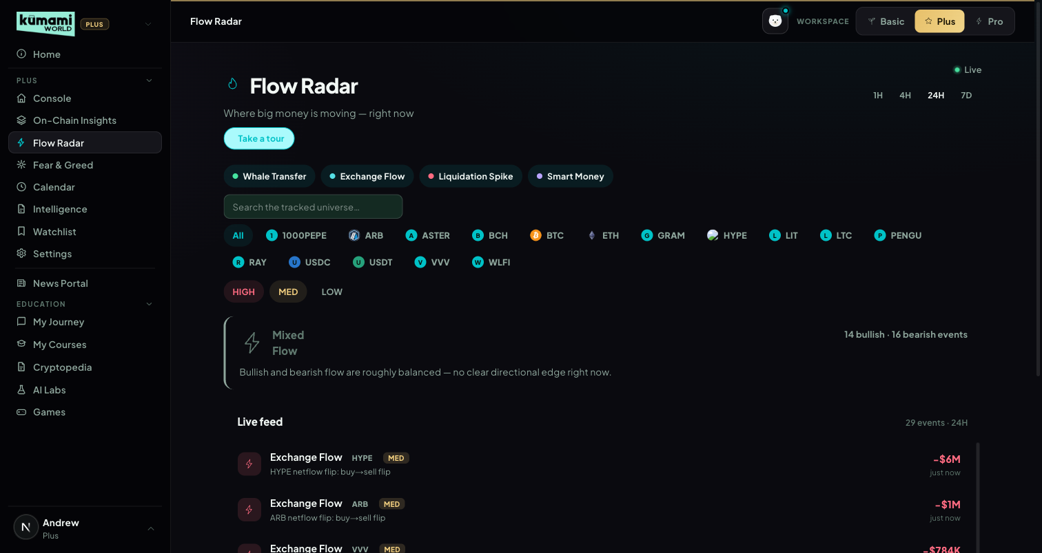
Figure (captured before 21 Oct 2026 — shows the old direction labels; to be re-captured).

How the user uses it
Pick 1H / 4H / 24H, filter by event type, coin and severity, read the verdict band (the AI read under it says “coming soon” until the AI layer is on) and scroll the feed. Dry Powder events are market-wide, so they show under every coin filter. Quiet market (v1.18, Rachelle v1.17 Plus §3): with no HIGH/MED events in the window the feed says “No major flows in the last hour / 4 hours / 24 hours — market is quiet” (the Console preview says the same for 24 hours); when events exist but the user's filters hide them it says “No events match these filters right now.” The floors stay (liquidation MED $50M/h, Dry Powder MED $100M), to be reviewed after 2 weeks of collector data.

How we build it

Via API
Event | Source | HIGH / MED / LOW (Pro) | Direction
Whale Transfer | /api/chain/v2/whale-transfer (key = tx hash) | ≥ $100M / $10–100M / — | Deposit to an exchange = Inflow (bearish) · withdrawal = Outflow (bullish) · exchange↔exchange and wallet↔wallet not counted
Dry Powder (stablecoins) | /api/exchange/chain/tx/list for USDT and USDC (transfer_type 1 = into an exchange, 2 = out), net per exchange and token over the last 60 min, one event per exchange + token + hour | ≥ $500M / $100–500M / $25–100M | Net onto exchanges = Dry Powder In (bullish) · off = Dry Powder Out (bearish) · market-wide: shown under every coin filter and counted in the band, never in a coin's Watchlist accumulation · Ethereum only
Liquidation Spike | /api/futures/liquidation/coin-list?exchange=X for Binance, OKX, Bybit, Bitget, Hyperliquid, summed per coin, one event per coin + hour (peak) | ≥ $200M/h / $50–200M/h / $10–50M/h | > 70% longs = Long Flush (bearish) · < 30% = Short Squeeze (bullish) · else Two-sided Flush (neutral)
Smart Money | /api/hyperliquid/whale-alert (~50 latest positions ≥ $1M; position_action 1 = open, 2 = close) | HIGH ≥ $100M, ≥ $25M BTC/ETH, ≥ $10M others · MED ≥ $5M BTC/ETH, ≥ $2M others · LOW ≥ $1M | Long Opened (bullish) · Short Opened (bearish) · Position Closed (neutral)
Buckets — bullish: Outflow, Dry Powder In, Short Squeeze, Long Opened · bearish: Inflow, Dry Powder Out, Long Flush, Short Opened · neutral (shown, not counted): Two-sided Flush, Position Closed.
Exchange Flow / Dry Powder: USDT and USDC only (Rachelle v1.17 answer 8) — no other Ethereum tokens are tracked.
Verdict band for the selected window, first match wins. Dollar thresholds scale with the window: 1H ×0.5 · 4H ×1 · 24H ×2.5 (· 7D ×10, Pro).
Condition (4H values) | Verdict | Color
Liquidations > $300M | Long Liquidation Cascade (mostly longs) / Short Squeeze Cascade | amber
Bearish > $500M, ≥ 3 bearish events and bearish ≥ 1.5× bullish | Distribution Wave | red
Bullish > $500M, ≥ 3 bullish events and bullish ≥ 1.5× bearish | Broad Accumulation | green
≥ 3 bullish and ≥ 3 bearish events | Mixed Flow | grey
Otherwise | Quiet Flow | grey
AI read under the band (v1.16). Off until Gemini billing: the spot under the band says “AI read · coming soon”, and no template sentence is shown in its place (Andrew, 22 Oct 2026). When on, the server asks the AI layer (Pro §23) to rewrite the band from the verdict, its stat line and the 3 biggest events, per window (Plus 1H/4H/24H, Pro + 7D), cached 30 min per tier, window, verdict and biggest event; empty windows get nothing. The page shows it only while no coin / type / severity filter is on and its own band has the same verdict; otherwise nothing.
Cross-signal outlines (Plus and Pro, same rules, first match wins): (1) whale Outflow + Spot Pulse REAL BUYING or ACCUMULATION → green “Spot Pulse confirming”; (2) Long Flush + Bearish regime → red “Regime confirming”, Short Squeeze + Bullish regime → green; (3) Long Opened + 2 or more bullish whale events on that coin in 24h → green “Watchlist confirming”, Short Opened + 2 or more bearish → red; fallback: Outflow + Fear or Extreme Fear → green “Regime shift confirming”.
Code: src/lib/market/live/flow.ts (fetching), rules/flowRadar.ts (events), rules/flowDirections.ts (buckets), rules/flowVerdict.ts (band), rules/flowCrossSignal.ts, route /api/market/flow-radar. The feed is cached 60 s and shared by every viewer.

Known gaps
- Whale transfers have no BNB Chain or Hyperliquid coverage, so BNB and HYPE rarely show them; Dry Powder sees Ethereum only.
- On quiet days the Plus feed can be sparse: at 01:30 WIB on 21 Oct 2026 the biggest 1h liquidation was ~$0.5M and the biggest exchange stablecoin net ~$12M, both below the floors ($10M / $25M even for Pro LOW).

4. Fear & Greed Index
A composite of five sourced, dated factors — not a bare number.

What it is
A full standalone tab (vs. just the index bar on Console) — a 5-metric weighted composite scored 0–100, with historical context.

Where it is
Tier: Plus.
Nav path: Sidebar → Plus (group) → Fear & Greed.
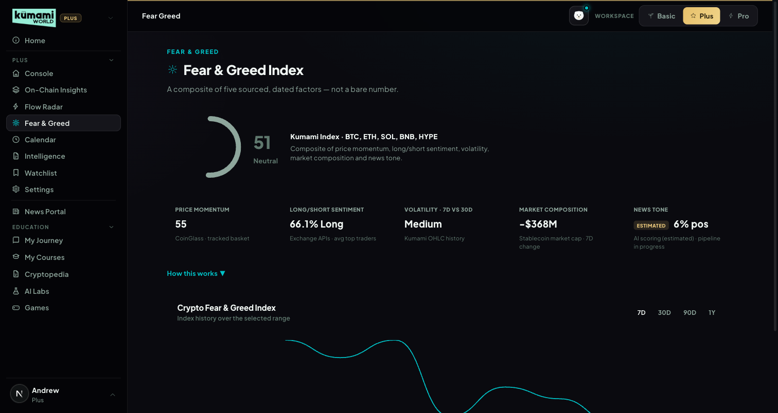
Figure: Fear & Greed Index — circular gauge, 5 sub-metric tiles, historical trend chart.

How the user uses it
Read the circular gauge (score + label) and the 5 sub-metric tiles below it; click “How this works” to expand the methodology explainer; switch the historical chart's range (7D/30D/90D/1Y) to see the trend.

How we build it

Via API
composite = Price Momentum×0.30 + Long/Short Sentiment×0.20 + Volatility×0.15 + Market Composition×0.20 + News Tone×0.15. Bands: 0–24 Extreme Fear · 25–45 Fear · 46–55 Neutral · 56–74 Greed · 75–100 Extreme Greed. Missing signals are left out (v1.16): a sub-metric without real data — and News Tone while the AI is off — is not counted and the other weights re-normalise; nothing is filled in with a neutral 50.
Sub-metric | Data source | Measures | Scoring
Price Momentum | Daily price history, weighted basket (BTC 50%/ETH 25%/SOL 10%/BNB 10%/HYPE 5%) | (price − 30D avg)/30D avg | >+20%→95 · >+10%→80 · −10..+10%→55 · ≥−20%→25 · else→5
Long/Short Sentiment | Long/short account ratio, same basket | % long, contrarian | >75%→95 · >65%→80 · >55%→62 · 45–55%→47 · 35–45%→32 · 25–35%→17 · <25%→5
Volatility (7D vs 30D) | OHLC history | 7D realized vol ÷ 30D realized vol | >1.5→7(High) · >1.2→22(High) · >0.9→50(Med) · >0.7→70(Low) · else→90(Low)
Market Composition | Stablecoin market-cap index | 7D stablecoin supply change, inverted | >+$5B→7 · >+$2B→25 · ±$2B→50 · ≥−$5B→75 · else→92
News Tone | Live Intelligence headlines, keyword heuristic (marked “Estimated” — no LLM classifier wired yet) | % recent headlines bullish | >75%→92 · >60%→75 · 40–60%→50 · 25–40%→27 · else→8
News Tone (v1.16, Rachelle v1.15 Plus §4). AI-scored: the Intelligence engine's headlines (it keeps running in the background) are labelled bullish / bearish / neutral by the AI layer (Pro §23), cached 30 min per headline set. While the AI is off (until Gemini billing) the tile says “Coming soon” and News Tone is not counted; the keyword estimate was removed (Andrew's hard rule, 22 Oct 2026). Also fixed 22 Oct: Price Momentum and Volatility asked CoinGlass for “BTC” instead of the pair “BTCUSDT”, so they never had data (they were quietly filled with neutral values); they now read real daily closes.
Own history (v1.18, Rachelle v1.17 Plus §4). The cron collector saves Kumami's score once a UTC day (fear_greed_daily/{YYYY-MM-DD}: score, label, colour; an unavailable index is never saved). Until 30 days are saved the history chart keeps the market-wide index series and is titled “Market index” (no provider name), with “n/30 saved”; from 30 saved days it shows Kumami's own daily score, titled “Kumami Fear & Greed history”. First day saved on kumami-dev 29 Oct 2026; production starts when this build is live.
One index, one set of labels and colours (v1.18, Rachelle v1.17 Plus §4): Kumami's 5-factor index is the only Fear & Greed number in the product — Console tile, Console regime, this page and the Daily Digest. One classification (rules/fearGreedComposite.classifyComposite): 0–24 Extreme Fear (red) · 25–45 Fear (light red) · 46–55 Neutral (grey) · 56–74 Greed (light green) · 75–100 Extreme Greed (green). The Console's older cut-offs (Greed from 60, Neutral 40–59) and its reversed colours were removed. The history chart's colour bands use the same edges (Extreme Greed from 75). Each sub-metric tile shows “unavailable” when its input fails; News Tone stays out until the AI is on.

5. Calendar (Calendar Plus)
A colour-coded month calendar of the dates that matter, picked by the Kumami team. Calendar Pro (Pro §14) is the same calendar with the Pro-only events added.
As built (v1.18, Andrew 29 Oct 2026 + Rachelle v1.17 Plus §5): manual-first — events the team adds at /admin/pro-calendar. The automatic CoinGlass feeds (“Macro events”, “Token unlocks”) are still OFF by default (checked 29 Oct 2026: off on kumami-dev, never switched on in production); when switched on, macro events show here and token unlocks only in Calendar Pro. No category, asset or impact filters (removed in v1.18). Airdrop TGE / claim days never show here (Rachelle v1.17 answer 1) — only in Calendar Pro.

What it is
A Google-Calendar-style month grid: every event is a colour-coded chip with a text label — Kumami team events turquoise, Macro blue (and, in Calendar Pro, Token unlock amber, Airdrop purple) — so colour is never the only cue. A “Next up” card shows the nearest event; a day panel lists the selected day's events in full.

Where it is
Tier: every signed-in account (Plus and Pro users see the same Calendar Plus). Pro users also have Calendar Pro (Pro §14).
Nav path: Sidebar → Plus (group) → Calendar (/world/calendar). The Console shows a mini version (§1.4).
Figure (30 Oct 2026, kumami-dev): Calendar Plus — legend, colour-coded month grid, day panel; no filters.

How the user uses it
Read the “Next up” card for the nearest event. Move between months with ‹ › or jump back with Today. Each day shows up to 3 colour-coded events — team events first, then by impact (HIGH events start with “!”), with “+N more”. Click a day to see its events in full on the right: time, title, impact, kind, description (with the team's bold / italic / underline), affected assets and official link. A HIGH team event in the next 24 hours opens a reminder popup once per browser.

How we build it

Via API
GET /api/market/calendar = Calendar Plus for every signed-in account; ?view=pro = Calendar Pro (Pro accounts only, 403 pro_required otherwise). Sources: published pro_calendar events, published pro_airdrops with a TGE / claim date (Calendar Pro only), and — only when switched on — macro events from /api/calendar/economic-data (30 days back → 60 days ahead) and token unlocks from /api/coin/unlock-list (Calendar Pro only), both cached 1800 s. The route itself is not cached so admin changes appear straight away. Filtering is server-side (rules/calendarEvents.calendarEventsForView): Calendar Plus drops airdrops, token unlocks and events marked “Pro only”.
Event type | HIGH | MED | LOW
Macro (economic-data) | importance_level ≥ 3 | importance_level = 2 | importance_level ≤ 1
Token unlock (market cap > $50M only) | next unlock ≥ 5% of circulating supply | 1–5% | < 1%
Kumami team event | Impact chosen by the admin
Macro events count as market-wide (tagged BTC). Identical repeated releases from the feed are de-duplicated. Unlocks are dated on next_unlock_date. Popup rule (D-1 popup here, the Console attention popup and the Console badge): team-added HIGH events only (v1.16, Rachelle v1.15 Plus §5 — manual-first; feed events never trigger them). Code: src/lib/market/rules/calendarEvents.ts (pure, unit-tested) and src/lib/market/live/calendarPage.ts.

Via Admin Dashboard (manual)
Firestore pro_calendar (collection name is historical), authored at /admin/pro-calendar: Title, Date, Time in UTC (blank = all day), Impact (High/Medium/Low), Who sees this event (v1.18: “Plus and Pro” — default — or “Pro only”; stored as audience { plus, pro }; events saved before v1.18 have none and show in both), Affected assets, and Description in the rich-text editor (bold / italic / underline show while typing). No Category field any more (v1.18): new events show as “Kumami” team events; an older event keeps its stored category on edit, and an older “Token sale / TGE” event keeps its Venue, Raise / FDV and Link fields and checks.
Importance (guide for the team, v1.16) | Examples
HIGH | CPI, PCE, NFP, FOMC decision or press conference, BoJ decision; unlocks ≥ 5% of circulating or ≥ $100M; Binance or Coinbase spot listings; tier-1 token sales
MED | PPI, GDP, Retail Sales, ISM, JOLTS, FOMC Minutes, Fed Chair; ECB/BoE/PBoC decisions; unlocks ≥ 2% or ≥ $25M; OKX/Bybit/Upbit spot listings
LOW | Everything else
Airdrop claim dates: an Airdrops & Whitelist entry (/admin/pro-airdrops, Pro §7) with a TGE / claim date shows as a MED “{name} — Airdrop TGE / claim” event in Calendar Pro only (Andrew, 29 Oct 2026), never in Calendar Plus.

Known gaps
- Token unlocks only ever show today's unlocks: on the current CoinGlass plan /api/coin/unlock-list returns rows whose next unlock is today (all 100 rows dated today on 9 Oct 2026). Future unlocks need a different endpoint or plan.
- No day / week / list-view toggle — month grid only (Rachelle §7.2 asks for day/week/month + list).
- The Today / This Week / Next 30D timeframe filter from the spec is not on the grid.
- No “Add to my events” button on the popup, and the D-1 popup fires when this page is opened, not app-wide on next login (the Console popup covers the landing screen).
- New token sales can't be created any more (no Category to choose); only older token-sale events keep those fields. Decide whether to add optional Venue / Raise / Link fields for every event.

6. Watchlist Plus
Per-asset live price, a flow Signal and a risk Status — personalization is the Pro upsell.
As built (v1.7): the 5 fixed coins (BTC/ETH/SOL/BNB/HYPE) with Signal and Status — no adding, no pinned coins, no extra coins, for every account. The “Open Watchlist Pro” button leads to the Pro version (Pro §19).

What it is
A live table of the fixed Plus roster, each row showing price, 24h change, a Signal (the most notable flow story for that coin) and a Status (up to two risk/positioning tags plus a regime label).
Asset roster: the same fixed 5-asset universe as the rest of Plus — BTC, ETH, SOL, BNB, HYPE — for every viewer (changed from an older 10-symbol list on 15 Sep 2026). The Console Watchlist preview reads exactly this data.

Where it is
Tier: Plus.
Nav path: Sidebar → Plus (group) → Watchlist Plus.
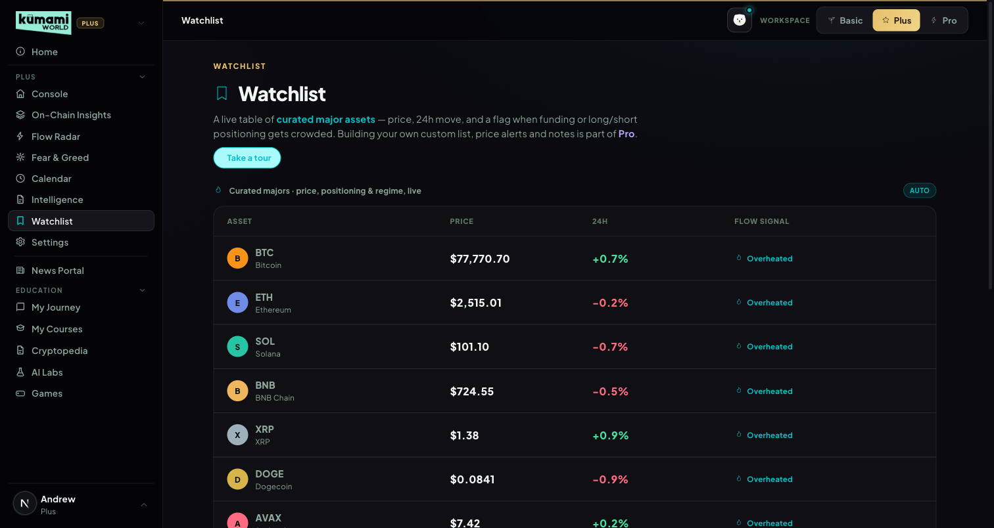
Figure (captured before the 21 Sep rebuild — shows a single “Flow signal” column; the live table now has separate Signal and Status columns).

How the user uses it
Read the table (Asset / Price / 24H / Signal / Status). Signal answers “is money moving into this?”; Status answers “is it risky right now?”. Plus viewers see the 5 assets read-only; “Your Watchlist” (pin your own tokens) and alerts are shown as Pro upsells (“Customize with Pro”, “Open Following & Alerts”).

How we build it

Via API
Per asset: Price + 24h: /api/futures/pairs-markets. Funding rate: /api/futures/funding-rate/oi-weight-history (already in percent — v1.16 fixed the same ×100 scale bug as On-Chain, which had made normal funding fire “Overheated”). Long/short ratio (perp assets only): /api/futures/global-long-short-account-ratio/history. Open interest: /api/futures/open-interest/aggregated-history (1h, the same cached feed as the Console chips) — the regime tag now uses the real 24h OI direction, so “Coiling” (OI up, price flat) can fire; before v1.16 OI was estimated from price and Coiling never fired. 4 CoinGlass calls per asset, all cached; the whole payload is cached 300s per user.
Up to 2 action tags per asset (most severe wins):
Signal | Tag (color) | Threshold
Funding rate | Overheated (red) | > +0.10%
Funding rate | Short Heavy (amber) | < −0.05% (v1.16; was < 0%)
Long/short ratio | Crowded Long (amber) | > 70% long
Long/short ratio | Crowded Short (amber) | < 30% long
Tie-break: red > amber; within the same color, funding-rate tags outrank long/short tags. A separate, uncapped regime tag (Trending Up / Trending Down / Ranging / Coiling) reads the real 24h OI direction (v1.16), so “Coiling” (OI up, price flat) can fire. The Signal column uses the corrected Flow Radar directions (Plus §3).
Signal column (src/lib/market/rules/watchlistSignal.ts), first match wins: (1) whale flow and smart money aligned in the same direction → “Multi-signal”; (2) Whale Accumulation / Distribution (2+ whale transfers in 24h, with the real $ total as the detail line); (3) a notable Spot Pulse verdict for that coin; (4) “Quiet”. Whale tags are available to Plus (they were wrongly Pro-gated before 21 Sep).
Known gap: liquidation-proximity tags (“Near Liq Zone” / “Watch Level”) exist in the rule engine but can't fire live — that data is tier-locked on the current CoinGlass plan.
Pro tier note: Pro rebuilds this single table into 3 sections — a real user-editable pinned watchlist, this same curated table, and a new whale-flow-scored “Also Worth Watching” list. See Pro §19.

7. Intelligence (removed from navigation)
Retired as a Plus tab on 21 Sep 2026 — it is not in Rachelle's latest Plus navigation (Calendar took its slot).

What happens now
/world/intel redirects to the Console, so old links and bookmarks still land somewhere useful. The Console's Intelligence preview was replaced by the Calendar preview (§1.4).

What still uses it
The Intelligence engine (src/lib/market/live/intel.ts: news articles + macro calendar + unlocks scored into A/B/C briefs by impact × timing) still runs behind the scenes: its headlines feed the News Tone sub-metric of Fear & Greed (§4). The detailed A/B/C rules are kept in v1.2 of this document.

8. Settings
Standard account management.

What it is
Profile, plan, notification preferences, language — a placeholder page today. Explicitly scoped as “not detailed in this brief — treat as placeholder pending separate spec,” so the current bare page is intentional, not a gap.

Where it is
Tier: Plus.
Nav path: Sidebar → Plus (group) → Settings.
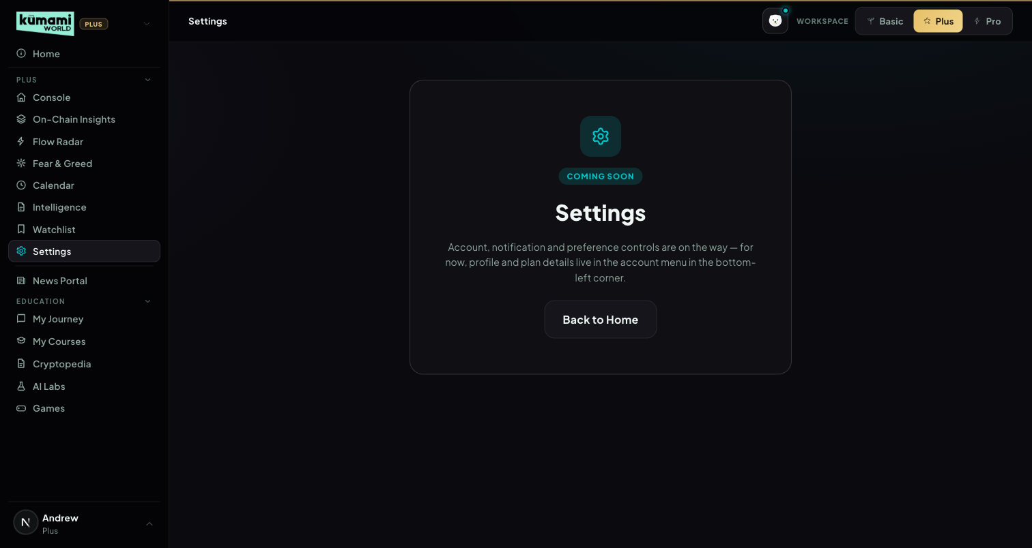
Figure: Settings — Coming Soon placeholder; profile/plan details currently live in the account menu instead.

How the user uses it
Nothing to configure yet — the page reads “Account, notification and preference controls are on the way; for now, profile and plan details live in the account menu in the bottom-left corner.” Click “Back to Home” to leave.

How we build it

Via Code only
A static placeholder component — no Firestore, no API, no admin panel.

Kumami Pro
Kumami Pro sits at /world/pro. Its sidebar has 16 tabs: Daily Digest and Following & Alerts at the top; News & Signals (Real-Time News, Alpha Room, Kumami Research, Market Analysis); Tools (Flow Radar Pro, Watchlist Pro, Spot Pulse Pro, Security Scanner, Market Cap Comparison, Airdrops & Whitelist); AI Tools (AI Portfolio, Crypto Address Tracker, Kuma AI Chat); and Events & Announcements at the bottom. The Pro sidebar lists only these Pro tabs (each workspace shows only its own tier — see the Kumami Plus intro). Pro users reach the Plus tools, including the shared Calendar, by switching to the Plus workspace; the Pro-only depth on Flow Radar (§18) and Watchlist (§19) follows the account, so it is there in the Plus workspace too. Security Scanner is the only remaining “Coming Soon” placeholder. Smart Money Tracker, Coin/Token Tracker and the Pro Fear & Greed slot were removed on 21 Sep 2026 (§3, §4, §12), and Pro's Calendar tab was merged into the shared Calendar on 9 Oct 2026 (§14). Non-premium users never reach any of this — they see a locked teaser instead.
Access (since v1.7): Pro = subscribed (users.isPremium) — nothing else. Admin and superadmin roles no longer unlock Pro; they only control the admin dashboard. This is enforced in the Pro tab gate, the sidebar lock, the server's Pro data (Flow Radar Pro, Watchlist Pro, Spot Pulse Pro, pinning) and the Crypto Address Tracker API. Non-subscribers opening any Pro tab get the Pro teaser and no Pro data is requested. Verified by the access-matrix QA (docs/qa/2026-10-10-plus-pro-tool-split.md).
Granting Pro (since v1.8): superadmins grant or remove Pro on the admin page Administration → Subscriptions (/admin/subscriptions), choosing 1 month, 3 months, 12 months or no end date. It works in every environment (comps, partners, staff, support fixes). A grant writes users/{uid} (isPremium, proUntil, proGrantedBy/At), a subscriptions record (planId pro-manual) and an admin_audit entry. Pro switches off automatically after the end date: every Pro check (server resolveTier, client AuthContext) treats a past proUntil as not Pro. Regular admins cannot grant Pro. This replaced the temporary Profile “Grant Pro / Remove Pro” testing buttons, which were removed.

1. Daily Digest
Rolls up every other Pro tool onto one scannable feed.

What it is
Aggregates the latest Kumami Research (pro_research), Real-Time News (pro_news), Airdrops (pro_airdrops), upcoming team-added Calendar events (pro_calendar, filtered to today-forward, top 3 — the full Calendar with the market feed lives at Plus §5), and the latest Alpha Room messages (top 3, system/image messages filtered out). Each section shows its 3 newest published items (sorted by publish time, newest first). Pure aggregation/sort/slice — no calculation logic. Each section links out to its full tab. v1.16 (Rachelle v1.15 Pro §1) adds three market lines: Smart Money — the 3 largest Hyperliquid position OPENS in the last 24h (asset, long/short, size; closed positions are skipped), Also Worth Watching — today's Watchlist Pro Section C coins with their first reason, and Fear & Greed — today's composite read (label, score / 100). Each shows an honest empty line (“No large position opens in the last 24h.”) when there is nothing.
v1.16: the old “once the market-data integration is live” disclaimer is gone — the market data is live and the three lines above use it.

Where it is
Tier: Pro only. Non-premium users never reach any of this — they see a locked teaser instead.
Nav path: Sidebar → Pro (workspace) → Pro → Daily Digest. Daily Digest is also the landing tab you reach first when you switch to the Pro workspace.
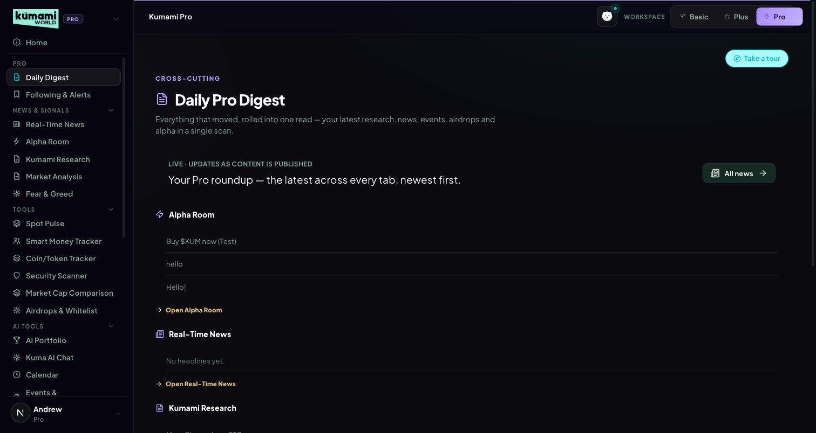
Figure: Daily Pro Digest — rolled-up feed of Alpha Room, Real-Time News, Kumami Research, Airdrops, and Calendar, each linking to its own tab.

How the user uses it
Scroll the single feed for a rollup of everything new; click any section's link (“Open Alpha Room”, “Open Real-Time News”, etc.) to jump into that tab directly.

How we build it

Via Admin Dashboard (manual)
Every source it aggregates is itself admin-authored — see Kumami Research (§13), Real-Time News (§10), Airdrops & Whitelist (§7), Calendar (§14), and Alpha Room (§11) below for each one's own admin panel. Daily Digest has no admin panel of its own; it purely reads and re-sorts those five collections.

Via API
The three market lines read the same endpoints as the Pro tools: /api/market/flow-radar?view=pro (smart_money events, which now carry action = open/close and side = long/short from Hyperliquid position_action / position_size), /api/market/watchlist?view=pro (sectionC) and /api/market/fear-greed (composite). Pick logic: topSmartMoneyOpens in src/lib/market/rules/digestLines.ts.

2. Following & Alerts
A follow list + CoinMarketCap-style price alerts, checked by Kumami every minute (v1.18).

What it is
Alerts on any coin with a Binance USDT pair: price rises above / drops below $X, up / down X% in 24h, 24h volume up X% (vs the volume when the alert armed). Frequency Once (pauses after it fires) or Every time (fires again after the condition has cleared). An alert only fires on a crossing — if the condition is already true when it's created, it waits (“Waiting to re-arm”). The follow list (wallets, alpha items, airdrops) is unchanged.
Alerts saved before v1.18 were carried over: “price changes by X%” keeps working as “moves X% either way”; news-sentiment alerts have no data source and were not carried (the page says so).

Where it is
Tier: Pro only. Non-premium users never reach any of this — they see a locked teaser instead.
Nav path: Sidebar → Pro (workspace) → Pro → Following & Alerts. Also linked from the Watchlist tab in Plus (“Open Following & Alerts”).
Figure (30 Oct 2026, kumami-dev): Following & Alerts — builder, a Once alert that fired (Triggered, Re-arm), an Every-time alert watching, Recent alerts.

How the user uses it
Create an alert: Coin · Alert when · Target price or Percent · Frequency → Create alert. Each alert shows its status — Watching, Waiting to re-arm, Triggered (with when it last fired and how often), Paused — and the live price; Pause / Resume, Re-arm (after a Once alert fired) and Delete. “Turn on browser notifications” asks the browser once. When an alert fires, a toast shows on whatever Kumami page is open (and a browser notification if allowed), and it is listed under “Recent alerts”.
Airdrops and whitelists you Follow (on their detail page) are listed under “Following” by name — e.g. “Lumen Network Airdrop · Airdrop”. If the team later removes or unpublishes one, the row says “An airdrop that is no longer listed” and you can unfollow it there.

How we build it

Via API
Server-side (v1.18): /api/v1/me/alerts (GET / PUT, Pro only — 403 pro_required otherwise; max 50 alerts, invalid ones dropped) stores the list in price_alerts/{uid} (server-only, no client rule). The cron collector (every 60 s) runs lib/pro/alertRunner: every user with an active alert who is still Pro, one Binance 24h MINI ticker call for all coins (data-api.binance.vision, cached 50 s), rules in lib/pro/priceAlerts.evaluateAlert (unit-tested). A trigger writes a notifications doc { userId, kind: 'price_alert', title, message, read } that the user's browser reads live (existing rule: users read their own). The page shows live prices from the shared Binance WebSocket feed.

Via Admin Dashboard
None — alerts and follows are set by each user. No email, Telegram or push-provider delivery yet (in-app + browser notification only).

3. Smart Money Tracker (cancelled)
Cancelled — will not be built (Rachelle v1.17). Removed from the Pro navigation on 21 Sep 2026 and, in v1.18, from the Pro sales page (it was still listed as “Coming Soon”) and the Pro member note. Old ?tab=smartmoney links fall back to the Daily Digest. The Hyperliquid whale data stays in use for Flow Radar and the Daily Digest.

4. Coin / Token Tracker (cancelled)
Cancelled — will not be built (Rachelle v1.17), same as §3. Old links fall back to the Daily Digest.

5. Spot Pulse Pro
Spot-vs-futures activity per coin — the same engine as Plus §2.9, with 10 tiles.
As built (v1.16, Rachelle v1.15 Pro §5): real-time (15 s cache). Row 1 = the 5 core assets. Row 2 = Watchlist Pro's “Also Worth Watching” coins (Pro §19); empty slots are filled with the most-traded coins by 24h spot volume (excluding core assets, stablecoins and wrapped tokens), labelled “Top volume”. Same share-based market verdict as Plus — the separate 10-tile thresholds are gone.

Where it is
Tier: Pro only (Plus users see the 5-tile panel inside On-Chain Insights). Nav path: Sidebar → Pro (workspace) → Tools → Spot Pulse Pro.
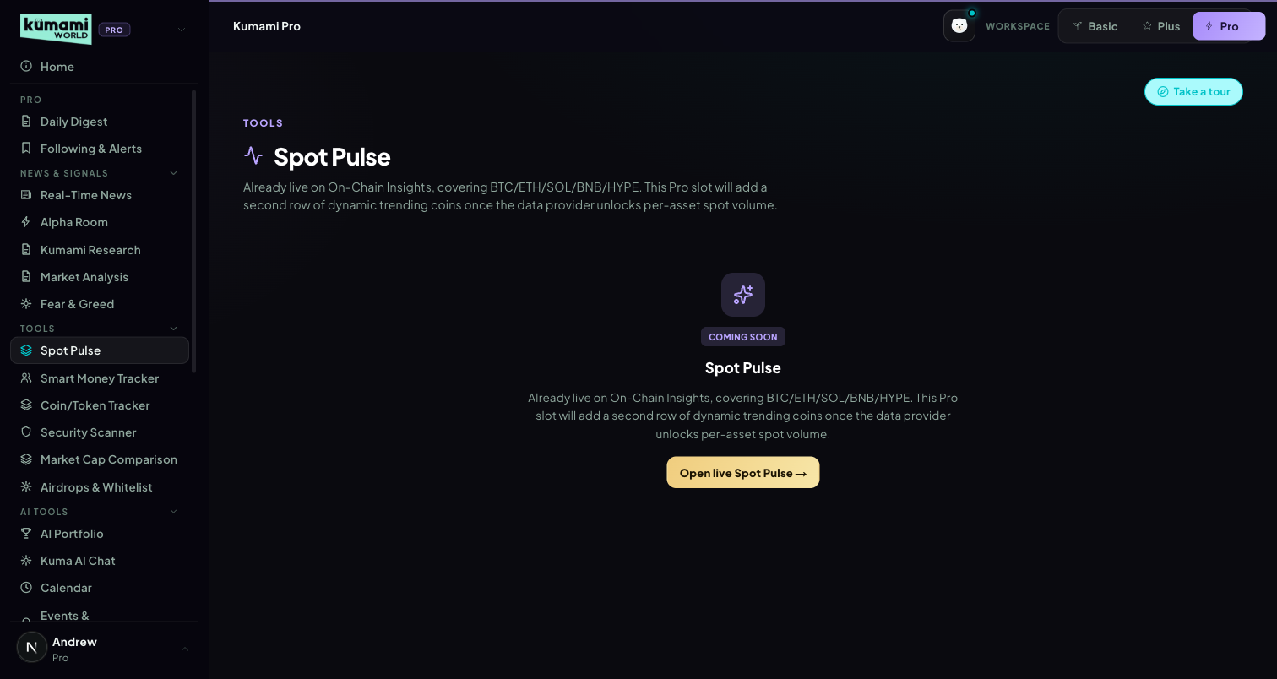
Figure (captured before 9 Oct 2026 — shows the old Coming Soon card; to be re-captured).

How the user uses it
Pick 4H / 24H / 7D, read the market-wide banner, then each tile's verdict and the alert cards for the biggest divergences. Row-2 tiles say whether they're an “Also Worth Watching” coin or “Top volume”.

How we build it

Via API
Same pipeline as Plus §2.9, served by /api/market/spot-pulse?view=pro. Row-2 fillers: topVolumeCoins() from /api/spot/netflow-list.

6. Security Scanner
Contract- and wallet-level risk scoring before you interact.

What it is
Status: PLACEHOLDER — renders the generic “Coming Soon” card. Copy references honeypots, mint authority, and LP locks; no data source wired.

Where it is
Tier: Pro only. Non-premium users never reach any of this — they see a locked teaser instead.
Nav path: Sidebar → Pro (workspace) → Tools → Security Scanner.
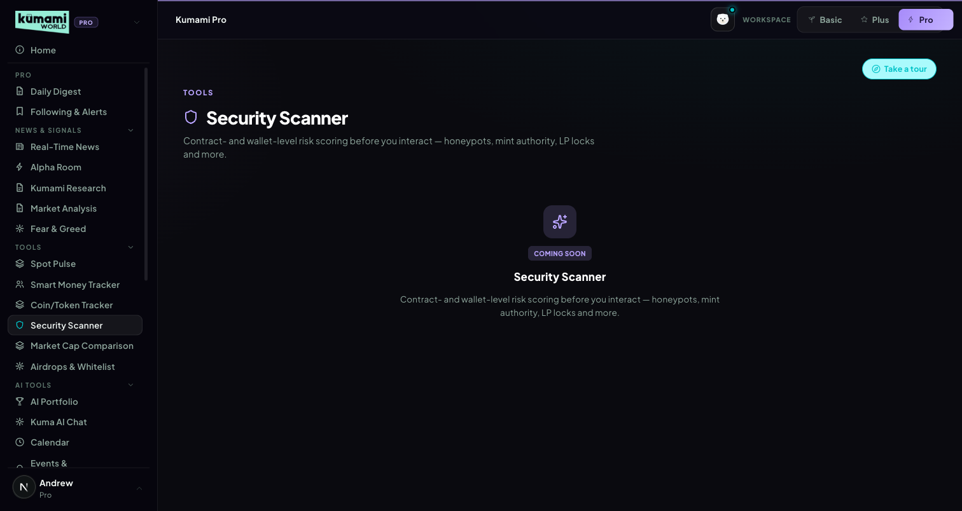
Figure: Security Scanner — generic Coming Soon placeholder card.

How the user uses it
Nothing to interact with yet.

How we build it

Not built yet
No Firestore, no API, no admin panel.

7. Airdrops & Whitelist
Admin-curated airdrop and whitelist opportunities with an eligibility checklist.

What it is
Status: LIVE (Firestore, real-time). Reads pro_airdrops (status == 'published'). Two sub-tabs (Airdrops / Whitelists), card grid → detail view with an eligibility checklist, deadline, estimated value, and a Follow toggle. No scoring — purely admin-entered content, sorted by createdAt desc client-side.

Where it is
Tier: Pro only. Non-premium users never reach any of this — they see a locked teaser instead.
Nav path: Sidebar → Pro (workspace) → Tools → Airdrops & Whitelist.
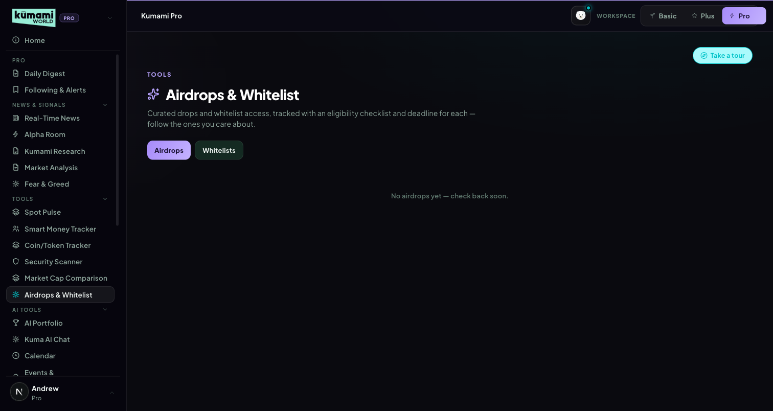
Figure: Airdrops & Whitelist — Airdrops/Whitelists sub-tabs over a card grid.

How the user uses it
Switch between the Airdrops and Whitelists sub-tabs; click any card to open its detail view — deadline, estimated value, and an eligibility checklist; click Follow to track one.

How we build it

Via Admin Dashboard (manual)
Firestore pro_airdrops, authored at Content → Pro Dashboard → Airdrops & Whitelist (/admin/pro-airdrops): Name, Category (airdrop dropdown), Description, Deadline (free text, e.g. “2d 4h” or “Not live”), Estimated value, Eligibility (checklist type), Accent color, and an “+ Add checklist item” builder → Publish or Save Draft.
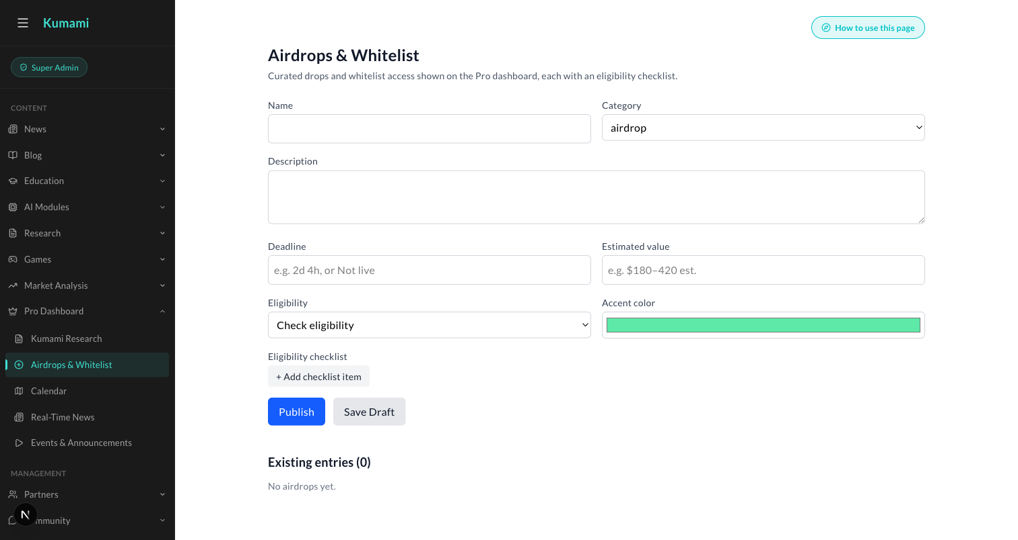
Figure: Content → Pro Dashboard → Airdrops & Whitelist — the admin form behind every Airdrops/Whitelist card.

8. AI Portfolio
Live holdings and pricing, plus an externally-scored risk scan.

What it is
Status: LIVE. Holdings read from users/{uid}.cryptoPortfolio (Firestore), priced live via /api/coingecko/markets (with 429 retry/backoff, plus a follow-up fetch for coins missing from the top-100 list). Add/Edit/Delete write straight back to Firestore. “Import Wallet” pulls live holdings from a pasted wallet address (same Alchemy wallet-scanning pipeline as the address tools) and merges them into the portfolio.
24h change: a real weighted figure — each holding's value 24h ago is derived from its own 24h price change and summed, so the hero card shows the portfolio's true move (up or down). The earlier hard-coded +2.3% was removed.

Where it is
Tier: Pro only. Non-premium users never reach any of this — they see a locked teaser instead.
Nav path: Sidebar → Pro (workspace) → AI Tools → AI Portfolio.
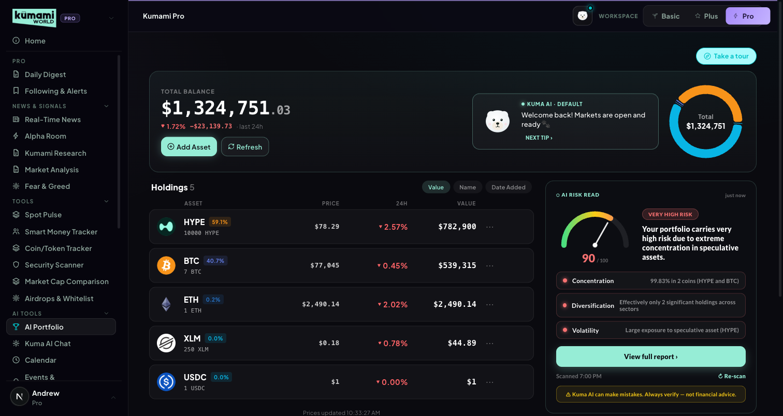
Figure: AI Portfolio — total balance, holdings table, AI risk-read panel.

How the user uses it
Click “Add Asset” to log a coin, amount, and price paid, or “Import Wallet” to paste an address and pull its holdings; click Refresh to re-pull live prices; click a holding's “…” menu to edit or delete it. Click “Scan my portfolio” (or “Re-scan”) to get a risk read — the result caches until your holdings change.

How we build it

Via API
Pricing: /api/coingecko/markets (429 retry/backoff). Risk scan: POST /api/portfolio-scan forwards {userId, totalValue, holdings[]} to an external n8n webhook (N8N_PORTFOLIO_SCAN_WEBHOOK_URL) and only validates/clamps the response shape (overall.score clamped 0–100, level clamped low/medium/high, dimensions limited to concentration/diversification/volatility/liquidity, actions capped at 4). The actual scoring logic — thresholds, weighting — lives outside this repo, in the n8n workflow; this codebase has no visibility into it. Results cache with a portfolio-hash staleness check (“Portfolio changed since this scan”).

Via Admin Dashboard
None — holdings are entirely user-entered, written straight to the user's own Firestore document.

9. Market Cap Comparison
“What if Coin A had Coin B's market cap?” — with real formulas.

What it is
Status: LIVE. Two searchable coin-selector dropdowns, a swap button, a stats comparison table (price/market cap/circulating supply/24h/rank/ATH/FDV), and an auto-generated insight sentence.

Where it is
Tier: Pro only. Non-premium users never reach any of this — they see a locked teaser instead.
Nav path: Sidebar → Pro (workspace) → Tools → Market Cap Comparison.
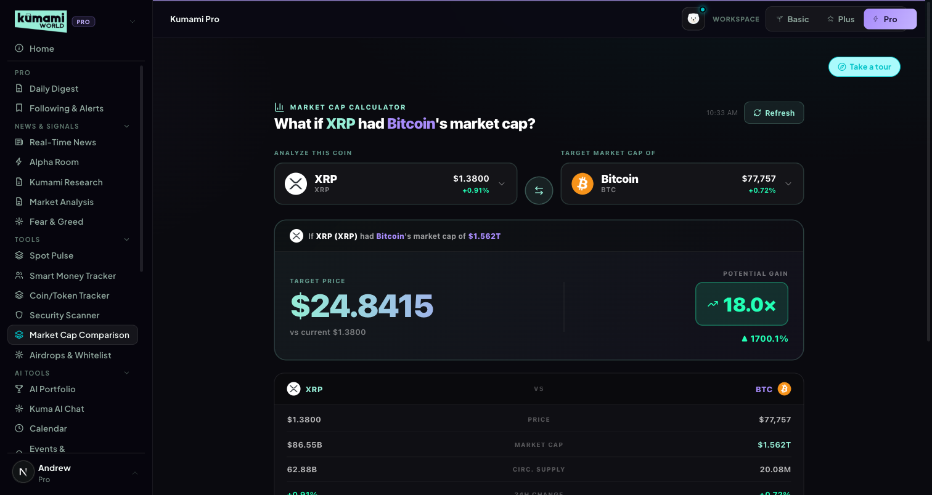
Figure: Market Cap Comparison — Coin A vs. Coin B selectors, swap button, stats table.

How the user uses it
Pick Coin A and Coin B from the two searchable dropdowns (defaults to XRP vs. BTC); click the swap button to flip them; read the comparison table and the auto-generated insight sentence below it.

How we build it

Via API
/api/coingecko/markets (top 100 coins, 429 retry/backoff).
How it's calculated: targetPrice = coinB.market_cap / coinA.circulating_supply · multiplier = targetPrice / coinA.current_price · pctChange = (targetPrice − current)/current × 100.

10. Real-Time News
Admin-curated, sentiment-tagged breaking news.

What it is
Status: LIVE (Firestore, real-time). Reads pro_news (status == 'published'). Each row: exact + relative time, headline with a sentiment dot (bull=green/bear=red/neutral=grey), one-line summary, tags, sentiment badge, source badge. Sorted newest-first.

Where it is
Tier: Pro only. Non-premium users never reach any of this — they see a locked teaser instead.
Nav path: Sidebar → Pro (workspace) → News & Signals → Real-Time News.
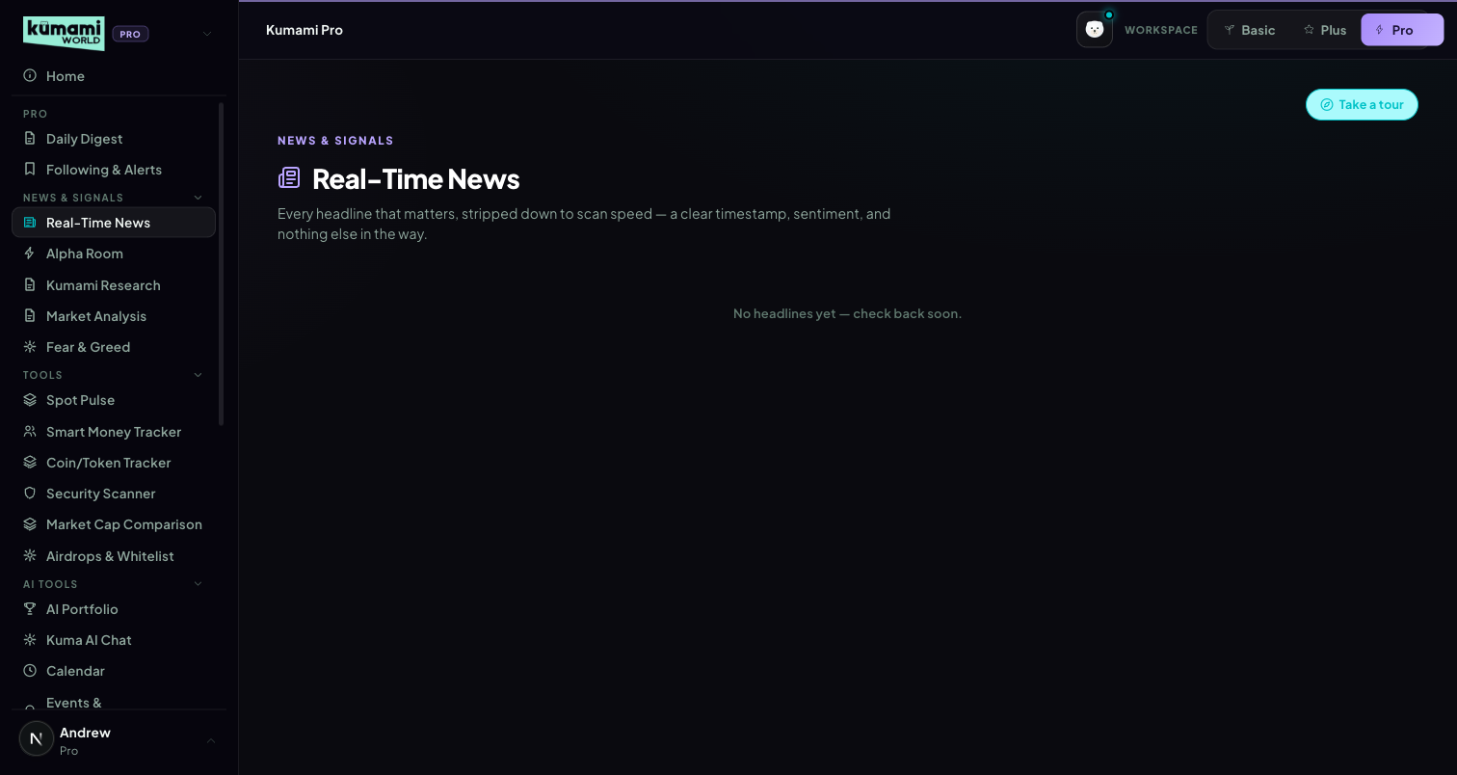
Figure: Real-Time News — sentiment-tagged headline list, newest first.

How the user uses it
Scroll the list; each row's sentiment dot (green/red/grey) gives an at-a-glance read before you even read the headline.

How we build it

Via Admin Dashboard (manual)
Firestore pro_news, authored at Content → Pro Dashboard → Real-Time News (/admin/pro-news): Headline, Sentiment (Bullish/Bearish/Neutral dropdown), Source (optional), one-line summary (optional), comma-separated Tags (optional) → Publish or Save Draft.
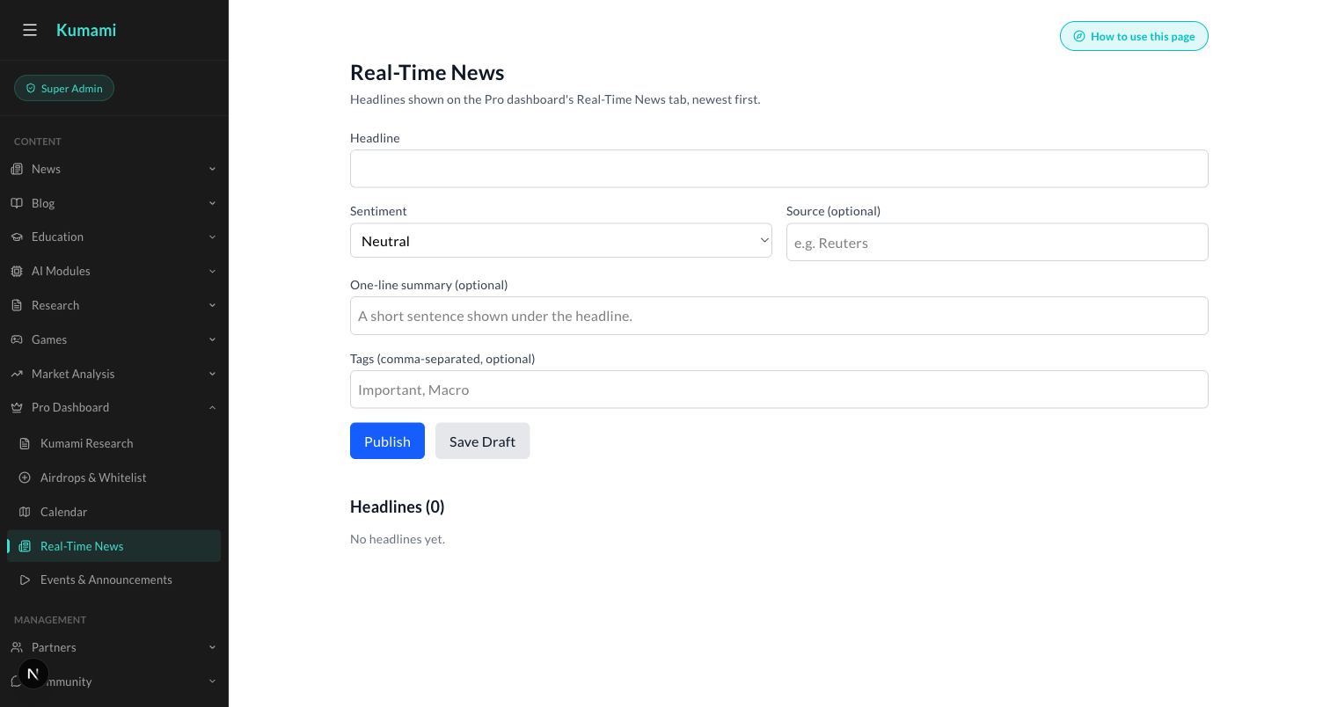
Figure: Content → Pro Dashboard → Real-Time News — the admin form behind every headline.

11. Alpha Room
A chat-style feed of curated alpha calls.

What it is
Status: LIVE (Firestore, real-time, read-only in this component). Reads the alphaRoom collection as a chat-style feed — system messages (centered pill) and user/image messages (chat bubble, avatar, timestamp).

Where it is
Tier: Pro only. Non-premium users never reach any of this — they see a locked teaser instead.
Nav path: Sidebar → Pro (workspace) → News & Signals → Alpha Room.
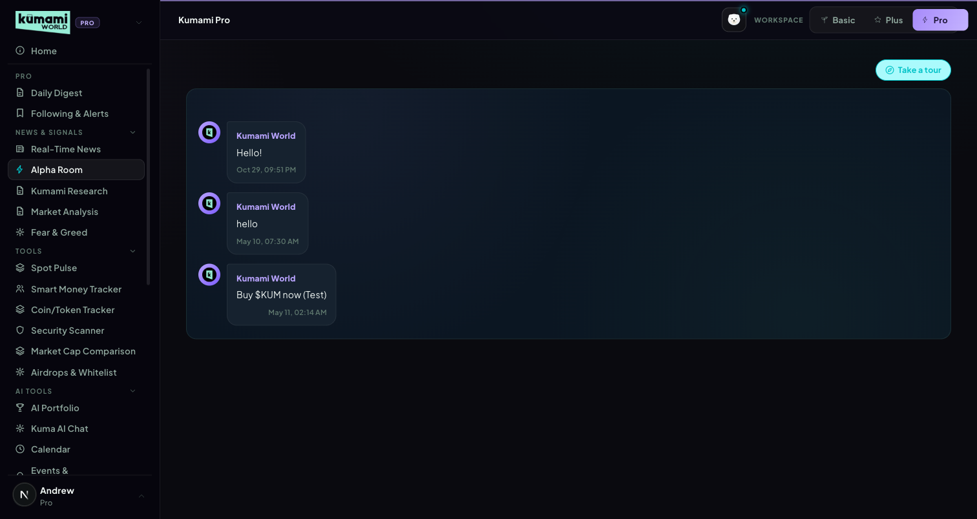
Figure: Alpha Room — chat-style feed of curated alpha calls, read-only for Pro users.

How the user uses it
Read-only feed — scroll to see the latest posted calls. There is no way to post or reply from this tab.

How we build it

Via Admin Dashboard (manual)
Firestore alphaRoom collection, authored at Management → Community → Alpha Room (/admin/alpha-room) — a chat-style composer where an admin types a message (or pastes/uploads an image) and sends it directly into the live feed as “Kumami World”. This resolves what the raw spec data left ambiguous (“presumably authored elsewhere”) — the admin panel is confirmed to be the actual write path, not a guess.
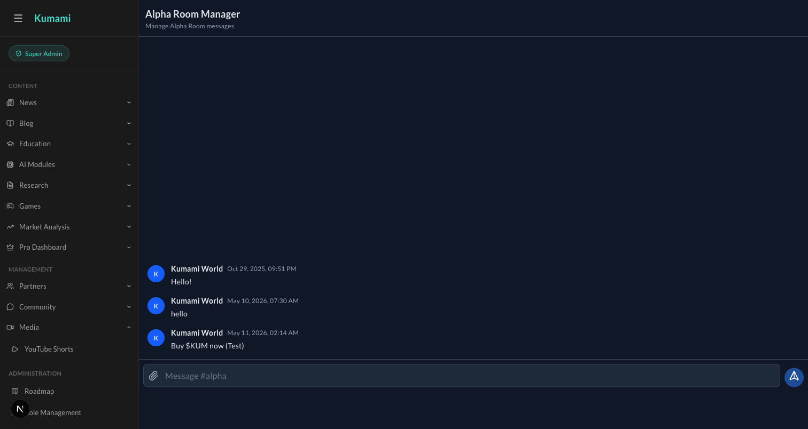
Figure: Management → Community → Alpha Room — the admin chat composer that writes directly into the live Alpha Room feed.

12. Fear & Greed (removed from Pro)
The Pro-only placeholder slot was removed on 21 Sep 2026. Pro users use the fully built Fear & Greed tab in the Plus workspace (Plus §4).

13. Kumami Research
Admin-authored research notes with a position call.

What it is
Status: LIVE (Firestore, real-time). Reads pro_research (status == 'published'). Each card: author name/role, relative timestamp, a position badge (long/short/neutral + asset), body text, and an optional “What this means for you” premium callout. No scoring — purely authored content.

Where it is
Tier: Pro only. Non-premium users never reach any of this — they see a locked teaser instead.
Nav path: Sidebar → Pro (workspace) → News & Signals → Kumami Research.
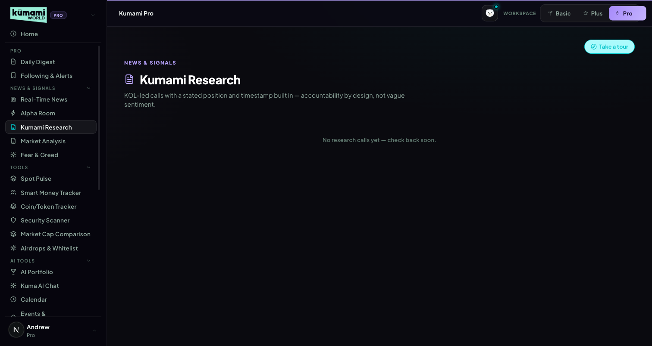
Figure: Kumami Research — author cards with a position badge and body text.

How the user uses it
Scroll the card feed; each card states its author, a long/short/neutral position badge on a specific asset, the reasoning, and (when present) a “What this means for you” callout.

How we build it

Via Admin Dashboard (manual)
Firestore pro_research, authored at Content → Pro Dashboard → Kumami Research (/admin/pro-research): Analyst name, Role/title, Position (long/short/neutral dropdown), Asset/ticker, “The call” body text, and an optional “What this means for you” field → Publish or Save Draft.
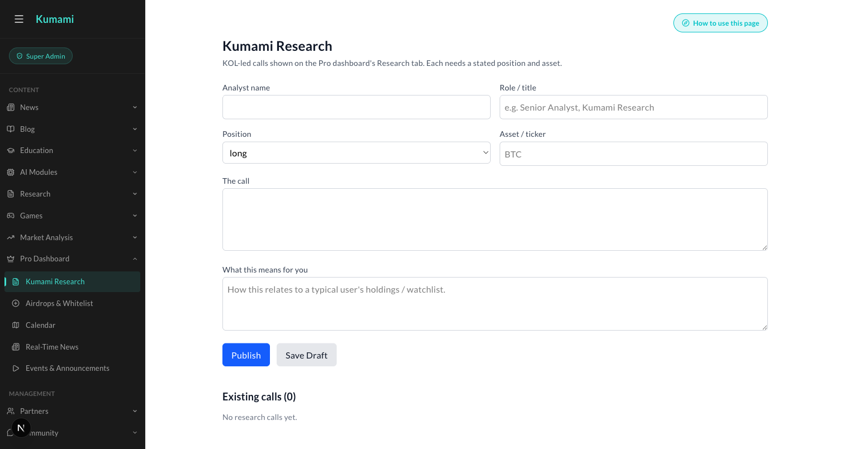
Figure: Content → Pro Dashboard → Kumami Research — the admin form behind every research card.

14. Calendar Pro
The same month calendar as Calendar Plus (Plus §5), with the Pro-only events added (Andrew, 29 Oct 2026).

What it is
Calendar Plus + team events the admin marked “Pro only” (marked PRO), airdrop TGE / claim days (purple “Airdrop”) and — when the feed is switched on — token unlocks (amber). Same UI, colours, day panel and reminder popup.

Where it is
Tier: Pro. Nav path: Sidebar → Pro → Tools → Calendar Pro (/world/pro?tab=calendar). The Daily Digest's Calendar section reads Calendar Pro and links here.

How we build it

Via API
GET /api/market/calendar?view=pro (Pro accounts only; 403 pro_required for others) — the same payload as Calendar Plus without the Plus filter (rules/calendarEvents.calendarEventsForView).
Figure (30 Oct 2026, kumami-dev): Calendar Pro — a “Pro only” team event (PRO tag), an airdrop claim day (purple), legend with Token unlock / Airdrop.

Via Admin Dashboard (manual)
Content → Pro Dashboard → Calendar (/admin/pro-calendar): “Who sees this event” → “Pro only” puts an event only here; “Plus and Pro” puts it in both. Airdrop claim days come from Airdrops & Whitelist (Pro §7).
Figure (30 Oct 2026): Admin → Calendar — no Category; “Who sees this event”: Plus and Pro / Pro only; rich-text description.

15. Events & Announcements
Live-streamed events with real-time audience Q&A.

What it is
Status: LIVE (Firestore, real-time, including a genuinely live sub-feature). Reads pro_events (pubStatus == 'published'), admin-authored, split into upcoming/past. Live events get a red “Live now” badge + embedded YouTube iframe.
How Q&A works: questions write to pro_events/{id}/questions, sorted by votes desc, with one-vote-per-user upvoting, a profanity/link/length moderation filter, and a client-side rate limiter before writes. Past events show a “Watch replay” toggle for the same embed. One of the more fully-built live features on the Pro surface — real-time, moderated, rate-limited audience interaction, not just static content.

Where it is
Tier: Pro only. Non-premium users never reach any of this — they see a locked teaser instead.
Nav path: Sidebar → Pro (workspace) → Events & Announcements. (Ungrouped — sits below the AI Tools group in the sidebar.)
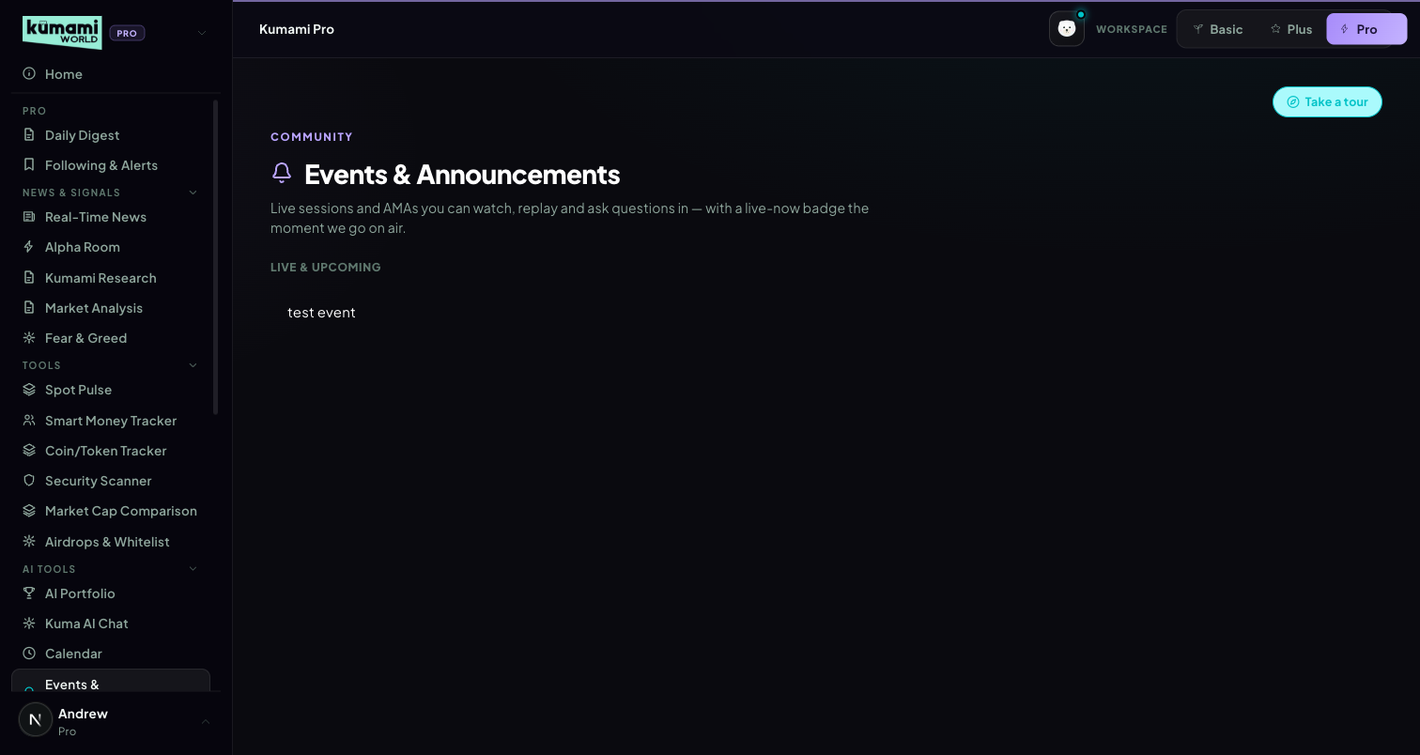
Figure: Events & Announcements — Live & Upcoming list; live events show a Live-now badge and embedded video with Q&A.

How the user uses it
Click a live event to watch the embedded stream and submit/upvote questions in the Q&A panel; click a past event to watch the replay via the same embed.

How we build it

Via Admin Dashboard (manual)
Firestore pro_events, authored at Content → Pro Dashboard → Events & Announcements (/admin/pro-events): Title, Date/time label, Host, Status (upcoming/live/past dropdown), YouTube video (id or URL), and a “Live now” checkbox (shows the Live badge + enables audience Q&A) → Publish or Save Draft.
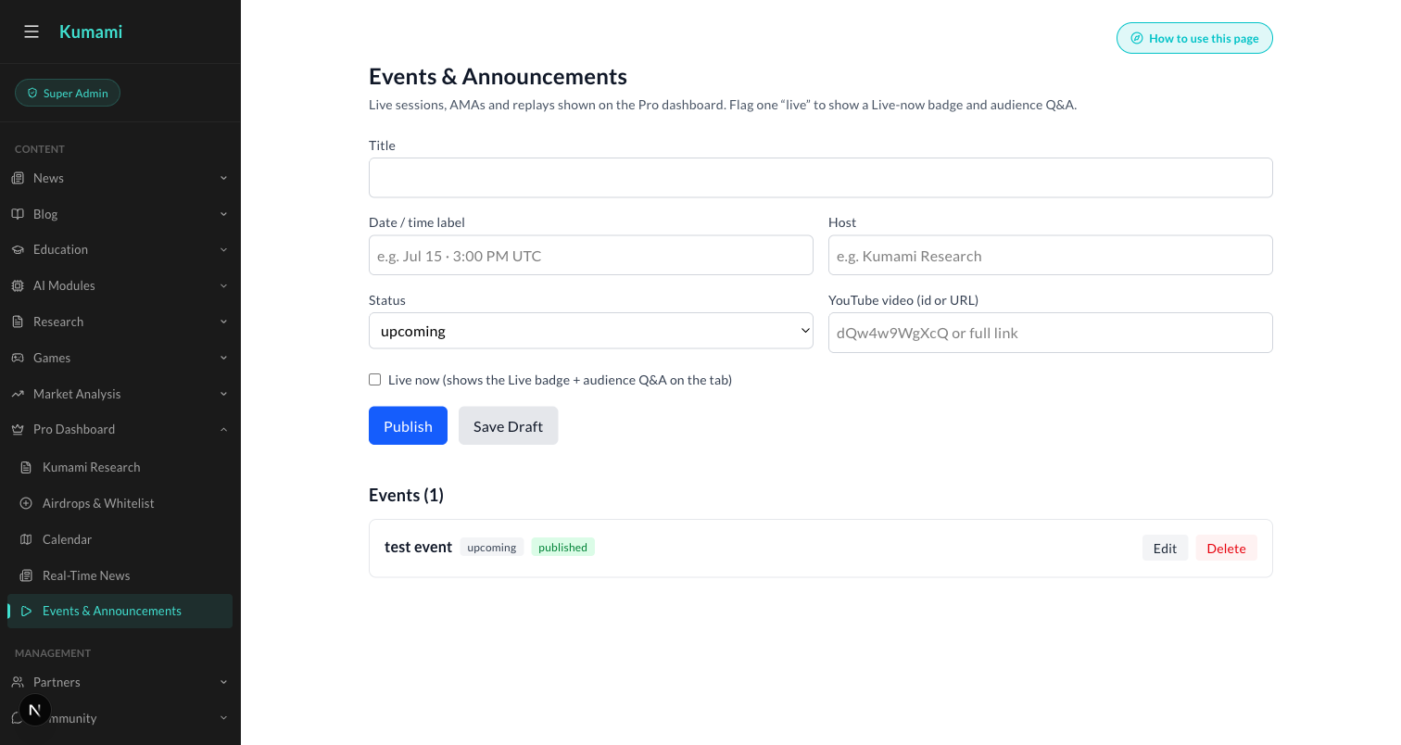
Figure: Content → Pro Dashboard → Events & Announcements — the admin form behind every event, including the Live-now toggle.

16. Market Analysis
A curated carousel of admin-authored market takes.

What it is
Status: LIVE (Firestore, real-time). Reads marketAnalysis (top 5 by createdAt desc), a hero/carousel layout with prev/next navigation, asset badge, delta badge, tag pill (Bullish/Bearish/Rotation/On-chain), author chip. Optional fields degrade gracefully if absent. No computed analysis — purely authored content with presentational formatting.

Where it is
Tier: Pro only. Non-premium users never reach any of this — they see a locked teaser instead.
Nav path: Sidebar → Pro (workspace) → News & Signals → Market Analysis.
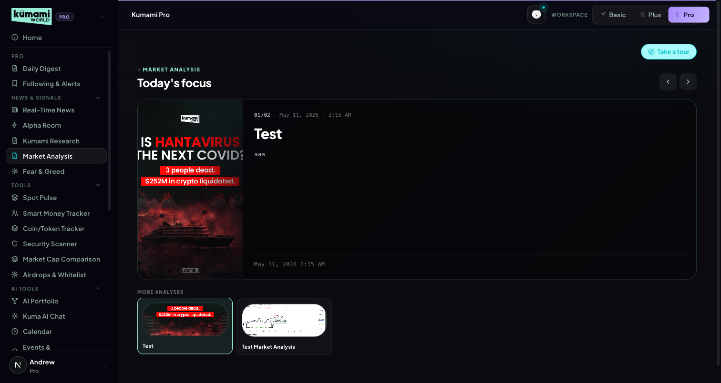
Figure: Market Analysis — hero carousel of the latest analysis, with More Analyses thumbnails below.

How the user uses it
Use the ‹ › arrows to move through the latest analyses, newest first; click a thumbnail under “More Analyses” to jump straight to it.

How we build it

Via Admin Dashboard (manual)
Firestore marketAnalysis, authored at Content → Market Analysis → Publish Market Analysis (/admin/market-analysis): Title, Content, and an Image upload → Publish Market Analysis.
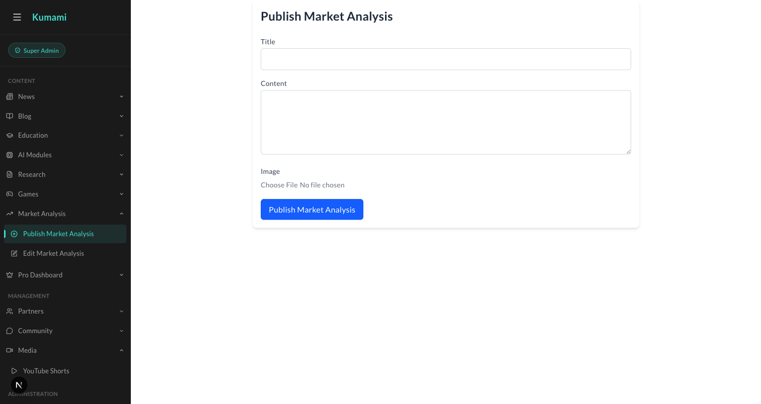
Figure: Content → Market Analysis → Publish Market Analysis — the admin form behind every carousel card.

17. Kuma AI Chat
Two products in one tab: general AI chat, and a live on-chain whale-wallet tracker.

What it is
Status: LIVE — the most substantively “real” integration in the whole Pro surface.
General chat: per-user rooms at users/{uid}/chatrooms/{roomId}/messages (Firestore real-time). Sending a message posts to an external chat API (the project's existing n8n backend). Prompt-snippet suggestions, custom markdown rendering, typing indicator, infinite-scroll pagination, room create/delete.
Crypto Address Tracker (default bot room): lets users watch up to 20 EVM wallets (ETH/Base/Arbitrum) with per-wallet USD alert thresholds and mute durations (1h/4h/24h). Wallet stats (balances, NFT counts, tx counts, top holdings) are fetched live via the Alchemy SDK server-side (Firebase ID token verified) — genuinely live on-chain data, not mocked. Alerts render direction (in/out), amount, chain, counterparty, USD value, and explorer links (Etherscan/Basescan/Arbiscan). This tab touches a real external chain-data provider (Alchemy) rather than Firestore-only content — the closest thing on the Pro surface to genuine on-chain intelligence today.

Where it is
Tier: Pro only. Non-premium users never reach any of this — they see a locked teaser instead.
Nav path: Sidebar → Pro (workspace) → AI Tools → Kuma AI Chat.
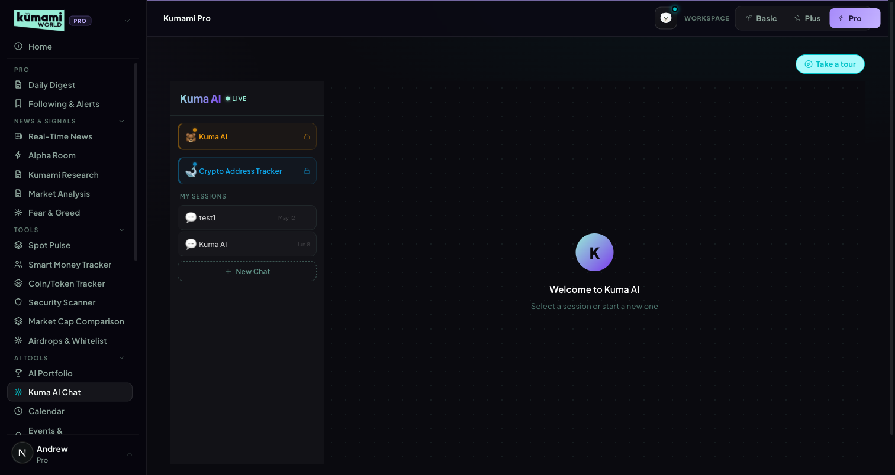
Figure: Kuma AI Chat — room list (Kuma AI, Crypto Address Tracker, My Sessions) with the main chat panel.

How the user uses it
Click “New Chat” to start a general conversation, or open the default “Crypto Address Tracker” room to add up to 20 wallet addresses with a USD alert threshold and mute duration each; past sessions are listed under “My Sessions” for quick resume.

How we build it

Via API
General chat messages go through POST /api/v1/kuma/chat (since v1.14; the user comes from the sign-in token — the old Firebase Function trusted a user id in the request) to the n8n “Kuma AI Agent” workflow, which posts the reply to /api/v1/kuma/callback with a signed token valid for that one user and chat room for 15 minutes. Same Firestore paths as before. Wallet stats and live on-chain activity for the Address Tracker are fetched server-side via the Alchemy SDK (Firebase ID token verified) — real on-chain data, not mocked.

Via Admin Dashboard
None — rooms, messages, and tracked wallets are entirely user-configured.

Planned changes (v1.12)
PLANNED — from Andrew, 11 Oct 2026 · added in v1.12 · not live yet.
Refresh the company knowledge Kuma AI answers from, so it is smarter and current. Kuma AI answers questions about Kumami from a knowledge PDF loaded into its n8n workflow (stored as searchable chunks in Supabase). That PDF predates most of what Kumami is today.
- Rewrite the knowledge PDF from the current product spec: Basic / Plus / Pro tiers, every Plus and Pro tool, the Calendar, Kumami Research, Airdrops & Whitelist, Events, Subscriptions and how to get Pro.
- Re-load it into the n8n workflow (replace the old chunks, not add duplicates) and check answers against a short list of real user questions.
- Timing: later — after the current Plus/Pro work. Tracked in the roadmap.

18. Flow Radar Pro
Same events, buckets, verdict band and cross-signal rules as Plus §3 — this section lists only the differences.
As built (v1.16): its own Pro page (Pro → Tools → Flow Radar Pro, /world/pro?tab=flowradar), subscribers only.

What it is
- Real-time (Plus is 15 min behind), every coin, HIGH / MED / LOW severity, multi-coin filter, 1H / 4H / 24H / 7D windows, plus the Netflow Flip event type.
- 7D window: the verdict band's dollar thresholds scale ×10 for 7 days (Rachelle defines 1H ×0.5 · 4H ×1 · 24H ×2.5 only; ×10 chosen by Andrew on 21 Oct 2026 — question for Rachelle in the Release notes).
- Illiquid filter: events on coins with under $1M of 24h spot volume are hidden. Volume = taker buy + sell from /api/spot/netflow-list. That list only has the top ~100 coins, so a coin missing from it falls back to the 24h volume of its Binance USDT pair (one exchange, so it can only under-count); missing from both → hidden. Core assets, stablecoins and market-wide Dry Powder events are never hidden; if the list can't be read, nothing is hidden. Andrew, 21 Oct 2026: the spec's strict “missing from the list → hide” rule would have hidden every coin outside the top ~100.
- Flow Balance panel: fixed 24h bull / bear USD split from the corrected buckets — Strong Accumulation (net > $500M) · Accumulation (> $100M) · Balanced (≥ −$100M) · Distribution (≥ −$500M) · Heavy Distribution. With no bullish or bearish flow in 24h it says “No bullish or bearish flow in the last 24h.” instead of a 50/50 bar (v1.16).
- Netflow Flip: unchanged (a coin's exchange netflow flipping sign).

Where it is
Tier: Pro only — Sidebar → Pro → Tools → Flow Radar Pro (/world/pro?tab=flowradar).

How the user uses it
Same as Plus §3, plus: pick several coins, add LOW severity, use 7D, read the Flow Balance panel above the feed, and hover an outlined row to see which cross-signal fired.

How we build it

Via API
Same route as Plus (/api/market/flow-radar?view=pro). Code: rules/flowLiquidity.ts (illiquid filter), live/binance.ts (Binance volume, cached 15 min), rules/flowBalance.ts, rules/flowVerdict.ts (WINDOW_SCALE).

Known gaps
- Significance engine (⭐) — defined by Rachelle v1.17 (Pro §18): an event is significant when it is ≥ 3× the 30-day median size for that coin and event type (Whale Transfer, Liquidation Spike, Smart Money; not Dry Powder), with ≥ 10 such events in 30 days; ⭐ on the Flow Radar Pro row with hover text “3.4× this coin's usual {event type}”. To be developed: build once the collector has 30 days of data (it has run every minute since 27 Oct 2026 → about 26 Nov 2026).
- Large Limit Order: blocked on the current CoinGlass plan.
- Backlog: “+ Custom” asset picker (up to 10) and event counts on the filter chips.

19. Watchlist Pro
Pro-tier rebuild of Plus §6's single table into 3 sections.
As built (v1.16, Rachelle v1.15 Pro §19): its own Pro page (Pro → Tools → Watchlist Pro, /world/pro?tab=watchlist), subscribers only. A = the 5 core assets (same table as Plus §6). B = your own pins, up to 15, liquid coins only. C = “Also Worth Watching”: up to 5 coins with 3 days of real net buying, confirmed by spot buyers, never padded. Live Binance prices on every row.

What it is
- Section B — pins. Any coin can be pinned if it has at least $10M of 24h spot volume and a futures market (both from the cached /api/spot/netflow-list and /api/futures/netflow-list). Stablecoins, wrapped / staked tokens and the 5 core assets can't be pinned. Messages: “Stablecoins and wrapped tokens can't be pinned.”, “BTC is a core asset — it's always in Section A.”, otherwise “Not enough liquidity to track reliably.” The check runs on the server (POST /api/market/watchlist), not only in the browser.
- Section C — Also Worth Watching. Candidates: coins with a Flow Radar event in the last 72h, excluding the core assets, your pins, stablecoins, wrapped tokens and market-wide Dry Powder events. A coin qualifies only if ALL hold: net buying beats selling on at least 2 of the last 3 days; 3-day net buying > +$5M; the last 24h doesn't undo more than 25% of that net; spot buyers are net positive over 3 days (net_flow_usd_3d > 0); it passes the Section B liquidity check. Ranked by days of accumulation, then net buying ÷ 24h spot volume. Fewer than 5 qualify → fewer are shown, with “Only N coins show sustained accumulation right now”.
- Hover reason: “Accumulating 3 of 3 days” and “net flow +$42M · spot buyers +$18M (3d)” (small amounts read $K, never “$0M”).
- Live prices: every row (A, B and C) uses Binance's free price stream, the same one Following & Alerts uses. Coins not on Binance keep the normal refresh.

Where it is
Tier: Pro only — Sidebar → Pro → Tools → Watchlist Pro (/world/pro?tab=watchlist). The Pro sections follow the account, whichever workspace is selected.
Figure (captured before 21 Oct 2026 — shows the 7-day “Also Worth Watching” label; to be re-captured).

How the user uses it
Type a ticker and press Pin (the header shows “{pinned}/15 assets tracked”); remove a pin with its Remove button (× on phones). Read “Also Worth Watching” for coins with sustained buying that aren't on your list yet — hover the ◆ marker for the reasons.

How we build it

Via API
Pins: checkPin() in src/lib/market/rules/watchlistPins.ts, called by POST /api/market/watchlist (userWatchlist.addSymbol takes the check as a parameter). Section C: computeSectionC3d() in src/lib/market/rules/watchlistSectionC3d.ts via pickSectionC() in src/lib/market/consistentCoins.ts — the same pick is Spot Pulse Pro's row 2 (Pro §5).
Data source for the 3 days: once the background collector (Pro §23) has written 72h of flow_hourly, the three days are rolling 24h blocks ending now, recomputed on every request (cached with the page). Until then: the last 3 days of flow_daily (UTC days), labelled “building 3-day history”. Days recorded before v1.15 have only event counts; they are left out — no $ estimated from counts (v1.16, Andrew's hard rule) — and the reason line says how many real days there are (“Accumulating 2 of 2 days”).

Known gaps
- Backlog (Rachelle v1.15): saved lists, wallet rows, 30-day signal history, alert rules on pins, ◆ early-signal tags.
- “Near Liquidation Zone” stays blocked on the current CoinGlass plan.

20. Crypto Address Tracker (standalone)
Paste any wallet, get a readable profile — a new standalone Pro page, not to be confused with the similarly-named bot room in Kuma AI Chat.

What it is
A one-shot wallet lookup tool: paste any EVM address, get portfolio value, holdings, a behavioral tag, and recent activity. Distinct from the existing “Crypto Address Tracker” bot room inside Kuma AI Chat (Pro §17) — that one is a saved, alert-driven wallet-watching room for up to 20 addresses; this is an unsaved, single-address read. Same underlying Alchemy data source and no new paid vendor, but a separate API route that doesn't touch Kuma AI Chat's existing contract.
Built: portfolioValueUsd + holdings (top-10 ERC20 tokens plus native ETH, priced via CoinGecko, sorted by value with % of portfolio); a single “Whale” tag when portfolio value ≥ $10M (the only behavioral tag shipped — see gaps below); transaction count and first-seen date; recent activity (last 10 transfers merged across in/out, with direction, asset, amount, counterparty address, and a block-explorer link).

Where it is
Tier: Pro only. Non-premium users never reach any of this — they see a locked teaser instead.
Nav path: Sidebar → Pro (workspace) → AI Tools → Crypto Address Tracker.

Figure: Crypto Address Tracker — address input, then a portfolio-value header with Whale tag, a stat grid, a Holdings list, and a Recent activity list.

How the user uses it
Paste any 0x… EVM address and click “Look up”; read the portfolio header (value + Whale tag if applicable), the stat grid (Portfolio Value / Realised PnL / Win Rate / Transactions / First Seen), the Holdings list, and Recent activity — each row links out to Etherscan.

How we build it

Via API
GET /api/wallet-profile — Firebase-ID-token gated, validates the 0x… address format, then fetches wallet summary, token balances, and transfers from Alchemy (Ethereum mainnet). Every individual Alchemy call is independently 8-second-timeout-guarded with a typed empty fallback, so one slow upstream degrades only that section instead of 500ing the whole page (fixed a real bug during build: an unguarded Promise.all of 6 Alchemy calls 500'd the route once when a single call hit ETIMEDOUT). Holdings are priced via a self-fetch to /api/coingecko/markets.
Known gaps (documented, not faked): Realised PnL and win rate need full FIFO trade-history reconstruction — not built, shown as “—”. Exchange-vs-cold-wallet labels on activity, “net outflow from exchanges,” and a “consistent accumulator” flag all need a verified CEX hot-wallet address list; hand-typing addresses from memory was considered and deliberately rejected during build — a wrong address silently mislabels real activity, which is worse than the plain in/out + counterparty shown today. Contract-risk flagging needs a GoPlus Security API integration that doesn't exist anywhere in this codebase (Security Scanner, which would own it, is itself an unbuilt Pro placeholder — see Pro §6). The “Kumami AI Read” narrative needs an LLM key, not wired into this app anywhere yet (same gap as Console/Flow Radar's hardcoded-template sentences). Linked-wallet visualization needs separate wallet-clustering heuristics, not implemented. Base/Arbitrum balances are read where available, but this project's Base/Arb Alchemy keys are currently placeholder/invalid — a pre-existing gap, not introduced by this feature.

21. Subscriptions & Payments

What it is
How a user pays for Kumami Pro. Two plans: Monthly $19.99 and Yearly $199.99 (no Lifetime plan). Pay by card (Stripe — renews automatically until cancelled) or by crypto (NOWPayments — a prepaid block of 30 or 365 days that does not renew; the user pays again to extend). Replaces the old Firebase Functions checkout, which handled only the first payment (no renewals, failed payments or cancellations), found users by email, and whose crypto webhook did not verify the signature.

Where it is
/world/subscribe is the plan page and /world/subscribe/success confirms the payment (it polls the order until the webhook marks it paid). Profile → Subscription shows the current plan, status, renewal/end date and the Cancel / Resume / Update card buttons. The Flutter app calls the same endpoints (see “Backend API platform”).

How the user uses it
- Open Subscribe → pick Monthly or Yearly → optionally type a referral code (pre-filled when they arrived through a referral link) → choose Card or Crypto → Continue.
- Card: redirected to Stripe’s hosted checkout page, pays, comes back to a “Payment received — activating Pro” screen that turns into “You’re Pro” as soon as Stripe confirms (usually seconds).
- Crypto: redirected to the NOWPayments invoice page, sends the coin; Pro switches on when the payment is fully confirmed on-chain (can take minutes). Underpaid invoices do not activate Pro.
- Cancel (card only): Pro stays until the end of the period already paid, then stops; no further charges. Resume undoes a cancel before that date. Update card opens Stripe’s secure card page.
- Crypto users see “Pro until <date>” and, from 7 days before, an in-app reminder to extend. Paying again adds 30/365 days on top of the remaining time.

How we build it

Via API
All server-side in this Next.js app (Firebase App Hosting), under /api/v1 (full contract in docs/API.md). The payment provider’s webhook is the only thing that grants Pro — never the browser.
Step | Card (Stripe) | Crypto (NOWPayments)
Start | POST /api/v1/checkout/stripe {plan, referralCode?} → Stripe Checkout Session (mode subscription, one Stripe customer per user, client_reference_id = uid) → {url} | POST /api/v1/checkout/crypto {plan, referralCode?} → our order doc, then NOWPayments invoice with order_id = our order id → {invoiceUrl}
Confirm | POST /api/v1/webhooks/stripe — signature-verified on the raw body. Handles checkout.session.completed, invoice.paid, invoice.payment_failed, customer.subscription.updated / deleted, charge.refunded, charge.dispute.created | POST /api/v1/webhooks/nowpayments — HMAC-SHA512 of the key-sorted body checked against x-nowpayments-sig. Only payment_status “finished” with the full amount activates
Access | Pro until the paid period’s end (+ a short grace while Stripe retries a failed card) | Pro until max(now, current end) + 30 or 365 days
Manage | POST /api/v1/subscription/cancel · /resume (Stripe cancel_at_period_end) · /payment-method (Stripe-hosted card update page) | Nothing to cancel — access ends on its date
Database. users/{uid} keeps isPremium + proUntil (already used by every Pro check, the database rules and the admin grant tool) and adds subscriptionStatus, plan, proSource (stripe/crypto/admin), cancelAtPeriodEnd, stripeCustomerId, stripeSubscriptionId — all written by the server only. New collections: checkout_orders (one per checkout started), payments (one per successful charge or crypto payment), webhook_events (every provider event id, so a retried webhook is never applied twice). subscriptions is reused (one doc per Stripe subscription / crypto order). pendingCryptoPayments is retired. Field-by-field reference: docs/DATABASE.md.
Safety rules. Every webhook is verified, recorded once, and applied inside a Firestore transaction; Stripe state is re-read from Stripe’s API instead of trusting event order; amounts are checked against the order; a user with an active card subscription cannot start a second one; admin grants (/admin/subscriptions) keep working unchanged.

Known gaps
- Card payments have not been run end to end against Stripe test mode yet — the test keys are pending. The webhook logic is covered by unit tests; the Stripe browser QA tests switch on automatically once STRIPE_* test keys are in .env.local (testing/payments/subscriptions-and-referrals/how-to-test.md).
- Crypto was tested through the real webhook route with signed payment notifications (paid, repeat, partial, wrong amount, extra time, refund); a real NOWPayments sandbox invoice needs the sandbox key.
- Payments are off on deployed sites until the payment settings are added there (docs/API.md §11); the page shows “Payments aren’t switched on yet” meanwhile.
- Crypto renewal reminders are in-app only (banner + Profile) — email is on the roadmap.
- Refund decisions stay in the Stripe / NOWPayments dashboards; refunds and chargebacks are applied automatically.

22. Referral Program

What it is
Every user has a personal referral code. When a new user pays for Pro with that code, both of them are credited: $1 for a Monthly plan, $10 for a Yearly plan — once per new user, on that user’s first payment. There is no limit on how many people one referrer can bring — every new paying user earns them another credit (the old program’s amounts and rule, kept as Andrew decided). Credits add up to a referral balance; withdrawing it is a future feature, so for now the balance is tracked and shown only.

Where it is
Profile → Referrals: the code, a copy-able link (https://kumami.world/world/subscribe?ref=CODE; the app link is kumami://subscribe?ref=CODE), number of paid referrals, balance, and the history of credits. The Subscribe page has the referral-code box.

How the user uses it
- Copy the link or code and share it. A friend opening the link lands on Subscribe with the code already filled in (kept through sign-up).
- The box checks the code as it is typed (valid / not found / your own code).
- When the friend’s first payment is confirmed, both see the credit in Referrals.

How we build it

Via API
- Code: 8 characters from an alphabet without look-alikes (no 0/O, 1/I/L), made by the server with a crypto-random generator and reserved in a Firestore transaction (referralCodes/{code} must not exist), so two users can never share one. Created at sign-up; accounts without one get it the first time Referrals or GET /api/v1/referral/me is opened. Not editable for now.
- Validate: GET /api/v1/referral/validate?code= → valid / invalid / self.
- Reward: runs inside the payment webhook, in the same transaction that records the payment. Conditions: the code exists, it is not the payer’s own, and the payer has never been rewarded before — one reward per new user ever (referral_rewards/{newUserUid}; the old program only blocked the same code twice). Writes the reward doc, two ledger entries (referral_ledger) and increments users.referralBalanceCents / referralCount. Money is stored in whole cents.
- Refunds: if that first payment is refunded or charged back, both credits are reversed with negative ledger entries.
Plan the new user pays | Referrer gets | New user gets
Monthly ($19.99) | $1 | $1
Yearly ($199.99) | $10 | $10
Renewals | nothing | nothing

Known gaps
- Verified in QA: code creation, link pre-fill (kept through sign-in), the live code check, $10 to both on a first Yearly crypto payment, no second reward, refund reversal, and balance = sum of the history.
- Withdrawal (payout method, minimum, review) is not designed yet — balance only.
- Old CRA-era data (referralRewards, usageCount, referrals) is not migrated; nothing is live.

23. Backend API platform

What it is
Every server endpoint Kumami needs lives in this Next.js app (Firebase App Hosting, Cloud Run under the hood) under a versioned /api/v1 path that the website and the Flutter app both call. The separate Firebase Functions service (api-yg5t6jc2da-uc.a.run.app prod / api-h4o777ecua-uc.a.run.app dev, deployed from the old CRA repo) is switched off after the new routes pass QA.

How we build it
- Auth: callers send their Firebase ID token as Authorization: Bearer <token>; the server verifies it (web and app use the same Firebase Auth). Webhooks use the provider’s signature; the n8n callback uses a shared secret.
- Errors: one JSON shape everywhere — {error: {code, message}} with stable codes the app can switch on.
- Docs: docs/API.md (every endpoint: auth, request, response, errors, which database fields it writes) and docs/DATABASE.md (every Firestore collection and field, and which endpoint or admin page writes it), kept current by a new skill after every build.
Old Firebase Function | Goes to
subscribe-checkout, stripe/webhook | /api/v1/checkout/stripe, /api/v1/webhooks/stripe (Subscriptions §21)
create-crypto-payment, nowpayments-webhook | /api/v1/checkout/crypto, /api/v1/webhooks/nowpayments
referral processing (inside the webhooks) | /api/v1/referral/* + webhook transaction (§22)
/api/chat, /api/save-chat | /api/v1/kuma/chat, /api/v1/kuma/callback (§17)
/api/chat-history | dropped — the app reads chat history from Firestore directly
notifyOnNewsPublish (push to the app) | sent when an admin publishes news (it never fired: it checked a field news docs don’t have)
/crypto/listings, prerender | deleted — unused / CRA-only
- Background collector (v1.16, Rachelle v1.15 Platform). POST /api/v1/cron/collect, protected by a shared-secret header (CRON_SECRET), meant to be called every 60 s by Cloud Scheduler. Each run builds the Flow Radar event list once and writes flow_events (one document per event, unique key, updated to the latest/peak amount) and flow_hourly (bullish / bearish $ per coin per UTC hour), both kept 7 days (expireAt + a cleanup pass), and records the daily tally (flow_daily) so history no longer depends on someone opening a page. All CoinGlass calls go through one shared budget of 70 calls/min (our plan allows 80). Each event Flow Radar Plus may show also gets plusAt, which serves the Plus 15-min delay (Plus §3); flow_meta/collector records the last run. Until Cloud Scheduler is set up, the Console and Flow Radar routes trigger the same run (at most once a minute across servers). Code: src/lib/market/collector.ts, flowDelayed.ts, rules/collector.ts, coinglass/rateWindow.ts.
- AI layer (v1.16, Rachelle v1.15 Platform). Google Gemini (gemini-3.5-flash-lite by default, GEMINI_MODEL; GEMINI_API_KEY) rewrites text around verdicts the rule engines already computed — it never picks or changes a verdict. Switched OFF by default; AI_ENABLED=true turns it on once billing is enabled. Used for the Console regime read (Plus §1), the Flow Radar band read (Plus §3 / Pro §18) and the News Tone labels (Plus §4). There is no template or keyword fallback (Andrew's hard rule, 22 Oct 2026): off → “AI read · coming soon” and News Tone “Coming soon” (left out of the composite); on but failing → “AI read unavailable right now”. Answers are cached 20–30 min; on a quota error (HTTP 429) calls pause for Google's retry time (max 6 h). The model is told never to name the data provider. Code: src/lib/market/llm/gemini.ts and aiText.ts.

Known gaps
- AI on the free tier: the GEMINI_API_KEY is on Google's free tier (20 calls a day per model). To switch the AI on: enable billing on that Google project, then set AI_ENABLED=true in App Hosting.
- Collector not scheduled yet: the route is deployed with the code, but it only runs once CRON_SECRET is set in App Hosting and a Cloud Scheduler job calls it (command in docs/API.md). Until then the pages work exactly as before (their own 60 s cache, flow_daily from page visits) and Watchlist Pro Section C stays on the flow_daily “building 3-day history” path.
- The old Firebase Functions are still deployed until Andrew switches them off after testing (commands in docs/ARCHITECTURE.md §4b), and the Stripe / NOWPayments dashboards must point at the new webhook URLs.
- The two proxy routes /api/subscribe-checkout and /api/create-crypto-payment are deleted; the Flutter team must switch to /api/v1 (a handover note goes with the release).

